Media release
Christine Badertscher joins the FiBL Foundation Council
Christine Badertscher, a Green Party member of the National Council from Bern, has been newly elected to the Foundation Council of the Research Institute of Organic Agriculture FiBL. As an environmental and agricultural engineer, she brings extensive experience at the interface between agriculture, the environment, politics and international cooperation.
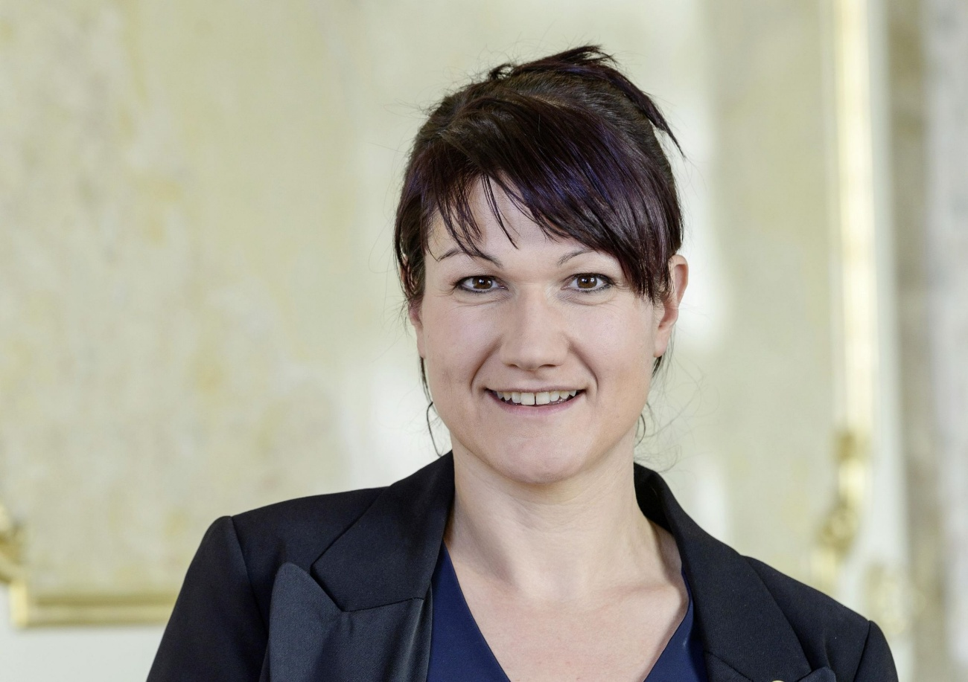
The newly elected FiBL Foundation Council member Christine Badertscher. (Image: parl.ch)

(Frick, 2 October 2026) At the end of August, the FiBL Foundation Council unanimously elected Christine Badertscher as a new member of the board. The Bernese National Councillor has served in the Federal Parliament since 2019. Before that, she worked for organisations including the Swiss Farmers’ Union and the Swiss aid organisation Swissaid. She grew up on an organic farm in the Oberaargau region of Bern and remains closely connected to agriculture to this day – for example, as president of the Oberaargau Farmers’ Association and as a board member of Hochstamm Suisse.
Bernard Lehmann, Chair of the FiBL Foundation Council, is delighted with this new appointment: “Christine Badertscher combines in-depth knowledge of agriculture with experience in politics and international cooperation. I am convinced that, thanks to her broad experience in Swiss and global agriculture, as well as her ability to develop pragmatic ecological solutions within her political sphere of influence, she will contribute greatly to the further development of FiBL,” says Lehmann.
Christine Badertscher is also looking forward to her new role: “I am delighted to be able to contribute to this body in future, because FiBL’s work combines two issues that are particularly close to my heart: agriculture – especially organic farming – and international cooperation.” Badertscher takes up her post with immediate effect.
Anyone wishing to find out more about her views on agricultural policy can listen to an interview with Christine Badertscher and Markus Ritter, President of the Swiss Farmers’ Union, on agricultural policy after 2030 in the FiBL podcast ‘FiBL Focus’.
FiBL contact
Adrian Krebs, media spokesperson for FiBL in Switzerland,
Tel +41 62 865 50 32, Mobile +41 79 500 88 52, Email adrian.krebs@fibl.org
Link
FiBL Focus podcast episode with Christine Badertscher and Markus Ritter (german only):
https://www.fibl.org/de/infothek/meldung/podcast-nachhaltig-und-pragmatisch-zur-neuen-agrarpolitik
This media release online
You can find this media release, including images, online at
www.fibl.org/en/info-centre/media.html.
About FiBL
FiBL is the world’s leading research institute in the field of organic farming. As a systems research institute, FiBL has stood for interdisciplinary excellence, close collaboration with practitioners and a comprehensive exchange of knowledge across the value chain for over 50 years – in dialogue with civil society and policymakers. Around 500 staff members work at FiBL locations in Switzerland, Germany, Austria, France, and Brussels. www.fibl.org

