Media release
FiBL supports Ukraine’s presence at Biofach 2026 for the 13th consecutive year
Ukraine will be represented at Biofach for the 13th consecutive year, demonstrating its resilience and continued commitment to the development of organic agriculture. Recent numbers show that Ukraine is the third largest supplier of organic products to the EU. Switzerland supported the development of the organic market in Ukraine for many years within international projects also implemented by FiBL.

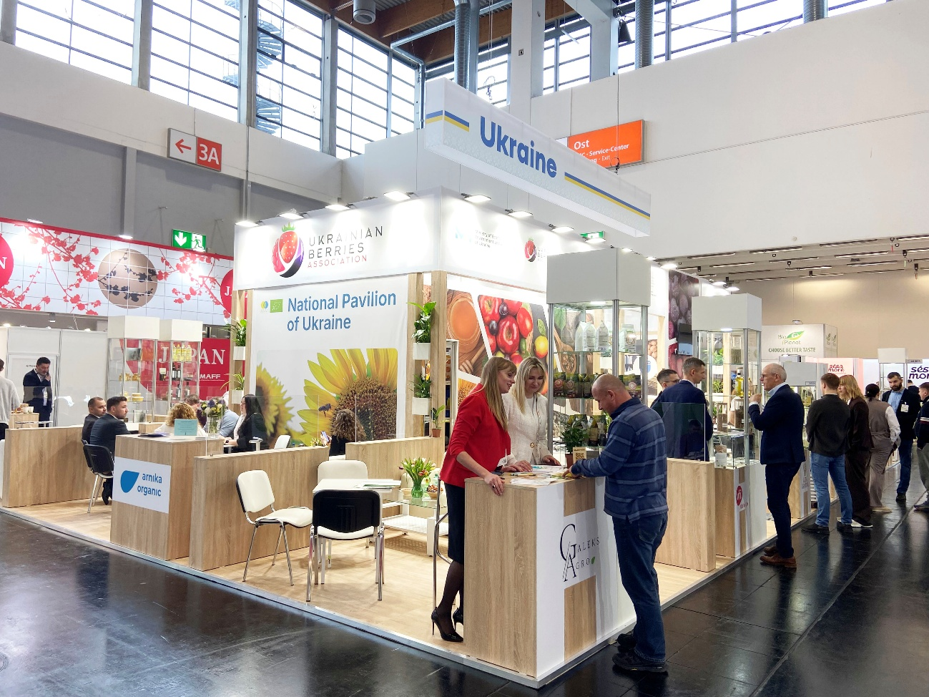
The FiBL stand at Biofach 2026 in Nürnberg. (Photo: Adrian Krebs, FiBL)

(Nürnberg, 10.02.2026) For almost four years, production conditions for agriculture in Ukraine have been severely affected by ongoing Russian aggression and the resulting full-scale war against Ukraine. This winter, Russian attacks on energy infrastructure and the civilian population are harsher than ever. Regardless of this, Ukraine is the third largest supplier of organic products to the EU (2024) and has consistently remained among the top five supplying countries over the past six years, confirming its position as a reliable producer and supplier of high-quality organic food. The Dashboard on Ukrainian organic exports provides detailed data on export volumes of certified organic products from Ukraine, broken down by product groups and specific product categories.
26 exporters participate at the National Pavillion of Ukraine
This year, 26 leading Ukrainian exporting companies will participate in the trade fair, showcasing their products within the 160 m² of the National Pavilion of Ukraine, located at Stand 4A-625. The range of organic products presented includes frozen and dried berries and fruits, nuts, seeds, honey, cereals, flakes, porridges, pickles, spreads, juices, beverages, fruit-rolls, chips, vegetable and fruit ingredients, teas, chocolate bars and other products.
Ukraine’s presence at the fair is supported by the Swiss-Ukrainian Programme “Higher Value Added Trade from the Organic and Dairy Sector in Ukraine” (QFTP) and other two Swiss-funded programmes: UNIDO GQSP Ukraine and SIPPO. QFTP is a long-term programme, financed by the Swiss State Secretariat for Economic Affairs SECO started in 2019 and is planned to run until 2026. QFTP is implemented under the leadership of FiBL in Switzerland together with SAFOS.
Ukraine-focused events during Biofach 2026
During the four days of Biofach, a series of events dedicated to Ukraine will take place:
February 11
10-11 pm, NCC Ost, Level 2, Room Oslo – Congress session “Seeds of Peace: Voices from Ukraine Shaping their Future with Organic Agriculture”. Representatives of Ukraine’s public and private sectors will discuss how organic agriculture contributes to resilience, food security, and community recovery under extremely challenging conditions — during the war and in the post-war period. Speakers will also share practical experience and their vision for building a sustainable and reliable food system in Ukraine and beyond.
Link to the event: https://organicinfo.ua/en/events/biofach2026-conference/
February 12
13-14 pm, Biofach Meeting Point BIOimSEH (Hall 7) – Event “Ukraine Talk”. Representatives of the Ukrainian public and private sectors, together with representatives of FiBL and BMLEH, will discuss Ukraine’s organic sector, providing an overview of key achievements and challenges, and exploring opportunities to strengthen long-term value added partnerships that are needed to secure success and develop it further with a view to the future.
About the stand
The National Pavilion of Ukraine at Biofach 2026 is organised by the Ukrainian Berries Association and the State Institution Entrepreneurship and Export Promotion Office, the national project Diia.Business, under the patronage of the Ministry of Economy, Environment, and Agriculture of Ukraine, and with the support of Switzerland within the framework of three programs:
- the Swiss-Ukrainian Programme Higher Value Added Trade from the Organic and Dairy Sector in Ukraine (QFTP) implemented by the Research Institute of Organic Agriculture (FiBL, Switzerland) in partnership with SAFOSO AG (Switzerland);
- Global Quality and Standards Programme (GQSP Ukraine) implemented by the United Nations Industrial Development Organization (UNIDO);
- Swiss Import Promotion Programme (SIPPO) implemented by the Swiss foundation for technical cooperation Swisscontact.
Contacts
- Tobias Eisenring, FiBL, QFTP project leader,
Phone: +41 62 865 04 20, e-mail tobias.eisenring@fibl.org
- Hanna Kovtun, Communication Expert for QFTP in Ukraine,
Phone: +38 0967774702, e-mail: hanna.kovtun@qftp.org
Links
More information about QFTP:
- Website of the project: https://qftp.org/en/
More information about Ukraine’s participation at Biofach 2026 and the partners:
- State Institution “Entrepreneurship and Export Promotion Office” (EEPO, Ukraine) https://export.gov.ua/history-of-success/ukraina-na-biofach-2026
- Website OrganicInfo.ua https://organicinfo.ua/en/
- Ukrainian Berries Association
https://uaberries.com/en/news/ukraine-at-biofach-2026-26-participants-selected
- National project for entrepreneurship and export promotion https://export.gov.ua/about
- Swiss Import Promotion Programme (SIPPO) https://ukraine.sippo.ch/en
- Consultancy and capacity-building company SAFOSO https://www.safoso.ch/

More information about Ukraine’s performance in organic production
- EU organic imports brief: https://agriculture.ec.europa.eu/system/files/2025-05/analytical-brief-7-eu-organic-imports-brief_en.pdf
- Dashboard on Ukrainian Organic Exports:
https://export.gov.ua/dashboard-on-ukrainian-organic-exports
- Organic Market Study of Ukraine:
https://organicinfo.ua/en/news/ua-organic-export-2024/
https://organicinfo.ua/en/news/organic-domestic-market-2024/

About FiBL
The Research Institute of Organic Agriculture (FiBL) is the world's leading research organisation in the field of organic agriculture. For over 50 years, it has stood for the joint development of knowledge – through exchange, cooperation and joint learning between practitioners, researchers and consultants. With around 500 employees at locations in Switzerland, Germany, Austria, France and Brussels, FiBL works internationally with partners from research, consulting, agriculture and politics. www.fibl.org

