Media release
Strengthening FiBL in Brussels: New joint leadership
The European FiBL office in Brussels is now led by Steffen Reese, who until a few months ago was Executive Director of the international organic association Naturland, and Carla Pinho, who has been working as a research manager at FiBL since 2018. With this line-up, the research institute is convinced that it will be able to develop an even greater strength for its work in Brussels.
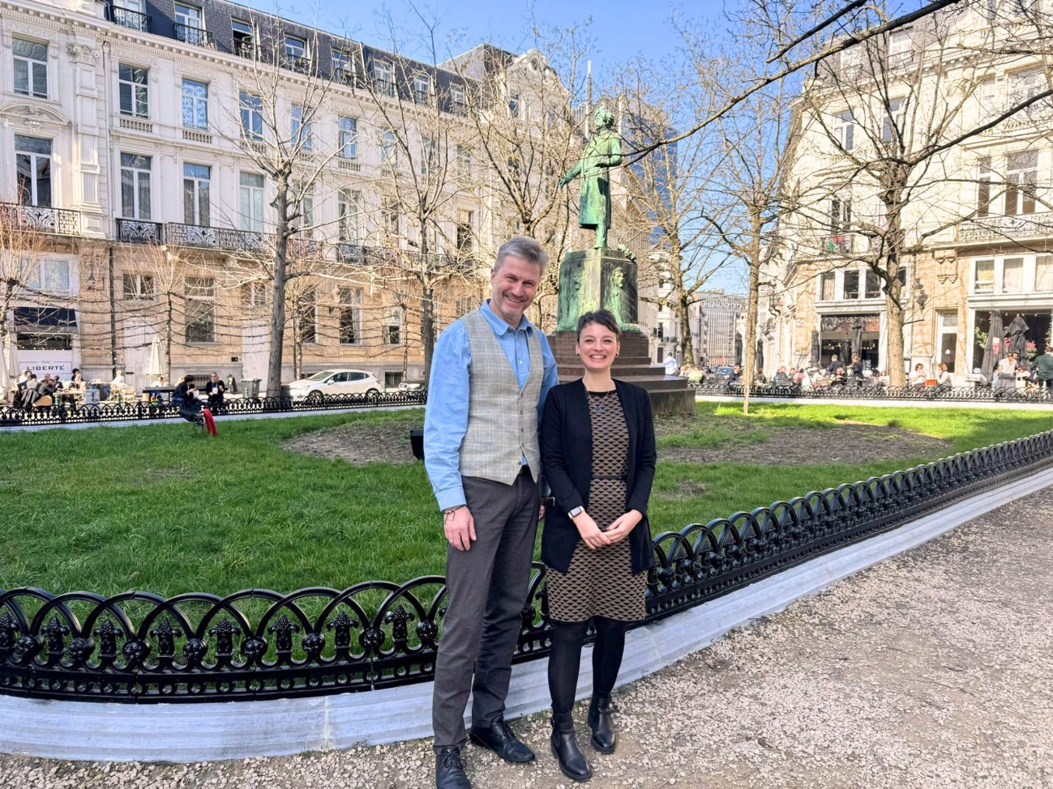
Steffen Reese and Carla Pinho, the new management team at FiBL in Brussels. (Photo: FiBL, Selene Capalbo)

(Frick, 1 April 2026) The Reseach Institute of Organic Agriculture (FiBL) has been running a representative office in Brussels since 2017 to make the institute’s extensive knowledge more accessible to policymakers and stakeholders. From 1 April 2026, Steffen Reese and Carla Pinho are taking over from Bram Moeskops, who left FiBL at the end of last year, in a joint leadership role.
Expanding the reach of FiBL in Brussels
Jürn Sanders, President of FiBL in Brussels, is looking forward to the future collaboration. “Our team in Brussels has been doing outstanding work for many years. With the new leadership, we will expand our reach even further to bring our research findings into the political dialogue in a targeted manner.”
Steffen Reese, who will be responsible for the Policy Dialogue division as Co-Managing Director and will thus be the first point of contact for political stakeholders in Brussels, was Executive Director of the international organic association Naturland for over two decades and played a key role in shaping its successful development. He is regarded as a proven expert in sustainable agricultural systems, innovations in organic standards and certification schemes, as well as in ecological, social and fair value chains – both regionally and globally.
Excellent network of funding bodies
Carla Pinho is taking on the role of Co-Managing Director, heading up the Research Management division. She brings extensive experience at the interface between science and management to her new role and has an excellent network of contacts to relevant funding bodies at the European level.
FiBL contact
- Jürn Sanders, President of FiBL in Brussels
Tel +41 62 865 17 41, email juern.sanders@fibl.org
Link
- fibl.org: Website of FiBL in Brussels
This media release online
You can find this press release, including images, online at
www.fibl.org/en/info-centre/media.
About FiBL
The Research Institute of Organic Agriculture (FiBL) is the world's leading research organisation in the field of organic agriculture. For over 50 years, it has stood for the joint development of knowledge – through exchange, cooperation and joint learning between practitioners, researchers and consultants. With around 500 employees at locations in Switzerland, Germany, Austria, France and Brussels, FiBL works internationally with partners from research, consulting, agriculture and politics. www.fibl.org

