Media release
Global organic market hits all-time high in 2024 – Farmland holds steady at 99 million hectares
In 2024, global retail sales of organic food and drink rose to 145.0 billion euros, underlining resilient consumer demand across major markets. At the same time, the global organic farming area remained close to 99 million hectares, providing continuity in the production base. According to the latest figures presented today at Biofach, the United States remained the world’s largest market, while Switzerland recorded the highest per capita consumption and the highest organic market share worldwide.
(Frick/Bonn, February 10, 2026) These latest statistics are published in “The World of Organic Agriculture: Statistics and Emerging Trends 2026” and will be presented by the Research Institute of Organic Agriculture FiBL and IFOAM – Organics International on February 10, 2026, from 4 to 5 pm at Biofach, the world’s leading trade fair for organic food, held in Nuremberg, Germany.
Consumers are spending more on organic food and drink across key markets, sending a clear signal to producers, processors, and retailers that demand remains resilient. The global retail sales of organic food and drink rose to 145.0 billion euros in 2024 (increase of 6.9 billion euros). In 2024, the United States remained the largest market (60.4 billion euros), followed by Germany (17 billion euros) and China (15.5 billion euros).
Switzerland recorded the highest per capita consumption worldwide at 481 euros per person and the highest organic market share globally at 12.3 percent of total food sales in 2024.
On the production side, organic farmland remained broadly stable at 98.9 million hectares, indicating continuity in the global production base. Australia had the largest organic agricultural area (53.0 million hectares), and Liechtenstein had the highest organic farmland share (43.5 percent).
The number of organic producers reached 4.8 million worldwide.
In 2024, combined organic imports into the EU and the United States reached 5.9 million metric tons, reflecting strong market pull and increasingly connected supply chains (up 12.3 percent, by 0.6 million metric tons). The largest exporters to the EU and U.S. markets were Mexico, Ecuador, and Canada.

About the publication
The World of Organic Agriculture 2026: Statistics and Emerging Trends is the leading global reference for organic sector data on land area, producers, markets and international trade, compiled by FiBL in cooperation with IFOAM – Organics International and national data partners.
Publication and data
The yearbook, jointly published by FiBL and IFOAM – Organics International, is supported by the Swiss State Secretariat for Economic Affairs (SECO), the Coop Sustainability Fund, Naturland e.V. and NürnbergMesse, the organiser of Biofach. Data was collected from 183 countries.
Contacts
- Helga Willer, Research Institute of Organic Agriculture FiBL
Ackerstrasse 113, 5070 Frick, Switzerland
Phone +41 79 218 06 26
helga.willer@fibl.org, www.fibl.org
- Ravi R. Prasad, IFOAM – Organics International
Charles-de-Gaulle-Strasse 5, 53113 Bonn, Germany
r.prasad@ifoam.bio, www.ifoam.bio
This media release online
This media release and graphs can be accessed online at https://www.fibl.org/en/info-centre/media.html.
Download “The World of Organic Agriculture”
The yearbook can be downloaded at https://shop.fibl.org (item number 1861) and from https://orgprints.org/id/eprint/56638.
Graphs and infographics (see also following pages) can be downloaded at https://www.organic-world.net/yearbook/yearbook-2026.html.

About FiBL
The Research Institute of Organic Agriculture FiBL is the world's leading research organisation in the field of organic agriculture. For over 50 years, it has stood for the joint development of knowledge – through exchange, cooperation and joint learning between practitioners, researchers and consultants. With around 500 employees at locations in Switzerland, Germany, Austria, France and Brussels, FiBL works internationally with partners from research, consulting, agriculture and politics. www.fibl.org
Sessions at the Biofach Congress
Session “The World of Organic Agriculture – Latest Statistics”
Tuesday, February 10, 2026, 4 to 5 pm CET, Room Istanbul (NCC East), Forum Biofach, Biofach Congress, NürnbergMesse
  - Ravi Prasad, IFOAM – Organics International, Germany, Facilitator
  - Helga Willer, Research Institute of Organic Agriculture FiBL, Switzerland
  - Sahar Brahim, IFOAM – Organics International, Germany
  - Amarjit Sahota, Ecovia Intelligence, UK
Info: https://www.organic-world.net/yearbook/yearbook-2026/launch.html
Session “Global Organic Market Overview”
Wednesday, February 11, 2026, 1:15 to 2:45 pm CET, Room St. Petersburg (NCC East), Forum Biofach, Biofach Congress, NürnbergMesse
  - Ravi R. Prasad, Director, IFOAM – Organics International: Facilitator
  - Helga Willer, Scientist, Research Institute of Organic Agriculture FiBL, Switzerland
  - David Amudavi, Executive Director, Biovision Africa Trust, Kenya
  - Tom Chapman, Co-CEO, Organic Trade Association, USA
  - Julia Lernoud, World Board of IFOAM – Organics International, Argentina
  - Tia Loftsgard, Executive Director, Canada Organic Trade Association, Canada
  - Joanna Wierzbicka, Deputy Director, IFOAM – Organics Europe, Belgium
  - Youting Zhang, Co-founder, Organic and Beyond, China
Info: https://www.organic-world.net/yearbook/yearbook-2026/launch.html
Yearbook “The World of Organic Agriculture” at a glance
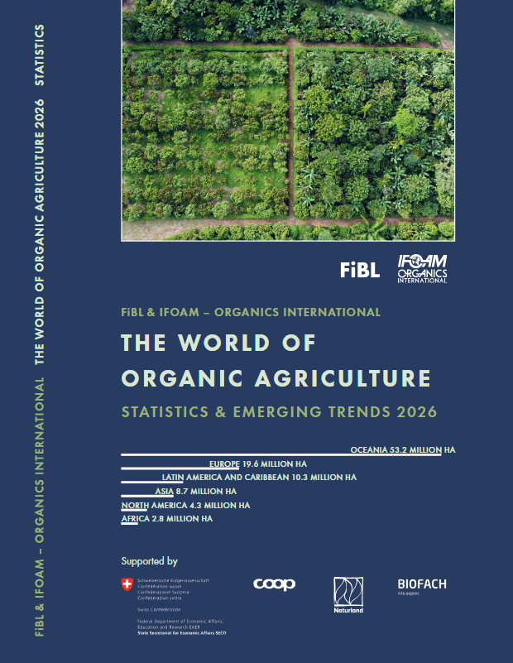
The yearbook “The World of Organic Agriculture - Statistics and Emerging Trends 2026” (350 pages) presents the results of the annual survey on organic agriculture worldwide and has numerous tables, graphs, maps and infographics. It includes reports from experts on the organic sector and information on emerging trends across all regions and selected countries. It also provides background information on standards and legislation, policy support, and the global market for organic food.
Further information and download link are available at www.organic-world.net/yearbook/yearbook-2026.html.
Data collection
Data on organic agriculture are collected annually by FiBL in collaboration with many partners worldwide. The results are published jointly with IFOAM – Organics International. The activities are supported by the Swiss State Secretariat of Economic Affairs SECO, the Coop Sustainability Fund, Naturland e.V. and NürnbergMesse, the organiser of the Biofach organic trade fair.
Book citation
Willer, Helga, Bernhard Schlatter and Jan Trávníček (Eds.) (2026): The World of Organic Agriculture. Statistics and Emerging Trends 2026. Research Institute of Organic Agriculture FiBL, Frick, and IFOAM – Organics International, Bonn. Available at www.organic-world.net/yearbook/yearbook-2026.html
Where to download
The book can be downloaded at https://shop.fibl.org (order number 1861) and from https://orgprints.org/id/eprint/56638/.
Online database and interactive infographics
The data is available online at https://statistics.fibl.org.

Organic Agriculture: Key Indicators and Top Countries
Indicator | World | Top countries
Countries with organic activities | 2024: 183 countries
Organic agricultural land | 2024: 98.9 million hectares  (2000: 15 million hectares) | Australia (53.0 million hectares)  India (4.0 million hectares)  Argentina (3.9 million hectares)
Organic share of total agricultural land | 2024: 2.1 % | Liechtenstein (43.5 %)  Austria (27.2 %)  Uruguay (23.1 %)
Development of organic agricultural land 2023/2024 | -176'000 hectares (ha); -0.2 % | US: +1'153'391 ha (+56.0 %),  Guatemala: + 241'744 ha (+193.0 %)  China: + 169'350 ha (+5.0 %)
Wild collection and further non-agricultural areas | 2024: 25.5 million hectares  (2000: 5.6 million hectares) | Finland (6.9 million hectares)  China (3.3 million hectares)  Zambia (2.5 million hectares)
Producers | 2024: 4.8 million producers  (2000: 252’000 producers) | India (2'363'607)  Uganda (404'246)  Ethiopia (203'258)
Organic retail sales | 2024: 145.0 billion euros  (2000: 15.2 billion euros) | US (60.4 billion euros)  Germany (17.0 billion euros)  China (15.5 billion euros)
Per capita consumption | 2024: 17.7 euros | Switzerland (481 euros)  Denmark (373 euros)  Austria (292 euros)
Number of affiliates of IFOAM – Organics International | 2025: 593 affiliates | Germany: 73 affiliates  India: 39 affiliates  USA: 36 affiliates  Italy: 24 affiliates  Switzerland: 22 affiliates
Source: FiBL survey 2026, based on national data sources, data from certifiers and IFOAM – Organics International
Infographics
