Media release
Europe’s organic market sets another record in 2024 – Farmland stable at 19.6 million hectares
In 2024, organic retail sales in Europe rose to 58.7 billion euros, signalling renewed consumer confidence across key markets. Germany remained Europe’s largest market, while Switzerland stood out with the highest per capita consumption and the highest organic market share worldwide. At the same time, Europe’s organic farming area remained stable.
(Frick/Bonn, February 10, 2026) These latest statistics are published in “The World of Organic Agriculture: Statistics and Emerging Trends 2026” and will be presented by the Research Institute of Organic Agriculture FiBL and partners on February 10, 2026, from 5 to 6 pm at Biofach, the world’s leading trade fair for organic food, held in Nuremberg, Germany.
In 2024, Germany remained the largest organic market in Europe (17.0 billion euros), followed by France (12.2 billion euros) and Italy (5.2 billion euros). Europe’s organic retail sales reached 58.7 billion euros (EU: 49.5 billion euros), increasing by 4.1 percent in Europe and 3.6 percent in the European Union. Switzerland recorded the highest per capita consumption worldwide at 481 euros per person and the highest organic market share worldwide at 12.3 percent of total food sales in 2024.
Organic farmland in Europe remained at 19.6 million hectares (EU: 18.1 million hectares), with an organic share of 3.9 percent in Europe and 11.1 percent in the EU. The countries with the largest organic agricultural areas in Europe were Spain (2.9 million hectares), France (2.7 million hectares) and Italy (2.5 million hectares). Liechtenstein continued to have the highest organic land share worldwide (43.5 percent).
International trade strengthened further. In 2024, the EU imported approximately 2.64 million metric tons of organic agri-food products, with the Netherlands, Germany and Belgium the largest importers by volume; Ecuador remained the leading supplier, and tropical fruit – especially bananas – dominated import volumes.
Contacts
- Helga Willer
Research Institute of Organic Agriculture FiBL
Ackerstrasse 113, 5070 Frick, Switzerland
Phone +41 (0)79 218 06 26
helga.willer@fibl.org, www.fibl.org
- Diana Schaack
Agricultural Market Information Company (AMI)
Dreizehnmorgenweg 10, 53175 Bonn, Germany
Phone +49 228 33805-0
diana.schaack@ami-informiert.de, www.ami-informiert.de
Download, infographics and online databases
- Download the statistical yearbook “The World of Organic Agriculture 2026”
https://www.organic-world.net/yearbook/yearbook-2026.html
- Infographics
www.organic-world.net/yearbook/yearbook-2026/infographics.html
- FiBL statistics on organic agriculture worldwide
https://statistics.fibl.org
Links
- www.fibl.org: Website of the Research Institute of Organic Agriculture FiBL
- www.ami-informiert.de: Website of AMI, the Agricultural Market Information Company
- www.biofach.de: Website of BIOFACH
This media release online
This media release and infographics can be accessed online at https://www.fibl.org/en/info-centre/media.html.

Session “The European Market for Organic Food” at the BIOFACH Congress
Tuesday, February 10, 2026, 5:00 to 6:00 pm CET, Room Shanghai (NCC East), Forum Biofach, BIOFACH Congress, NürnbergMesse
Speakers
- Marine Bré-Garnier, Agence Bio, France
- Lee Holdstock, Soil Association Certification, UK
- Dr. Susanne Padel, Facilitator, Germany
- Diana Schaack, AMI Agricultural Market Information Company, Germany
- Prof. Dr. Francesco Solfanelli, Università Politecnica delle Marche, Italy
- Jan Trávníček, Czech Organics, Czech Republic
- Dr. Helga Willer, Research Institute of Organic Agriculture FiBL, Switzerland
- Prof. Dr. Raffaele Zanoli, Università Politecnica delle Marche, Italy
More information: https://biofach.fibl.org/en/biofach-all/biofach-2026#c77884
Acknowledgements
The European data collection was conducted within the framework of the OrganicTargets4EU project, funded by the European Union (Grant No. 101060368) and the Swiss State Secretariat for Education, Research and Innovation (SERI) (Grant No. 22.00155). The work presented here is part of the global survey on organic agriculture, supported by the Swiss State Secretariat for Economic Affairs, the Coop Sustainability Fund, Naturland e.V., and NürnbergMesse/Biofach. The views and opinions expressed in this media release do not necessarily reflect those of the aforementioned supporters.
About FiBL
The Research Institute of Organic Agriculture FiBL is the world’s leading research organisation in the field of organic agriculture. For over 50 years, it has stood for the joint development of knowledge – through exchange, cooperation and joint learning between practitioners, researchers and consultants. With around 500 employees at locations in Switzerland, Germany, Austria, France and Brussels, FiBL works internationally with partners from research, consulting, agriculture and politics.
www.fibl.org

Europe and the European Union: Key indicators 2024
Indicator | Europe | European Union | Top 3 countries in Europe
Organic farmland | 19.6 million hectares (ha) | 18.1 million ha | Spain (2.9 million ha)  France (2.7 million ha)  Italy (2.5 million ha)
Organic share  of total farmland | 3.9 % | 11.1 % | Liechtenstein (43.5 %)  Austria (27.2 %)  Estonia (22.5 %)
Development of organic farmland, 2023-2024 | -0.93 million ha | +0.12 million ha | Romania (+0.09 million ha)  Italy (+0.06 million ha)  Poland (+0.06 million ha)
Development of organic farmland | -0.5 % | +0.7 % | Bulgaria (+34.0 %)  Ireland (+24.0 %)  Luxembourg (+15.7 %)
Land use | Arable crops: 8.4 million ha; Permanent crops: 2.4 million ha; Permanent grassland: 8.4 million ha | Arable crops: 7.7 million ha;  Permanent crops: 2.3 million ha;  Permanent grassland: 7.9 million ha
Top arable crop groups | Cereals: 2.5 million ha;  Green fodder: 2.4 million ha;  Oilseeds: 0.6 million ha | Cereals: 2.2 million ha;  Green fodder: 2.2 million ha;  Dry pulses: 0.5 million ha | Largest arable areas:  France (1.4 million ha)  Italy (1.2 million ha)  Germany (0.9 million ha)
Top permanent crop groups | Olives: 0.6 million ha;  Nuts: 0.5 million ha;  Grapes: 0.5 million ha | Olives: 0.6 million ha;  Grapes: 0.5 million ha;  Nuts: 0.4 million ha | Largest permanent crop areas:  Spain (0.9 million ha)  Italy (0.6 million ha)  France (0.2 million ha)
Wild collection area | 10.0 million ha | 7.4 million ha | Finland (6.9 million ha)  Russia (1.5 million ha)  Albania (0.5 million ha)
Producers | 490'637 | 438'447 | Italy (87'042);  France (61'886);  Greece (58'691)
Processors | 93'978 | 88'977 | Italy (24'844)  Germany (21'915)  France (20'493)
Importers | 8'384 | 7'057 | Germany (1'894)  France (1'163)  Switzerland (791)
Retail sales | 58.7 billion euros | 49.5 billion euros | Germany (17.0 billion euros) France (12.2 billion euros)  Italy (5.2 billion euros)
Development of retail sales 2023-2024 | +4.1 % | +3.6 % | Norway (+21.3 %)  Luxembourg (+20.2 %)  Hungary (+13.9 %)
Organic share of the total market | No data | 4.5 % | Switzerland (12.3 %)  Denmark (11.6 %)  Austria (11.4 %)
Per capita consumption | 70 euros | 110 euros | Switzerland (481 euros)  Denmark (373 euros)  Austria (292 euros)
EU organic imports |  | 2.64 million metric tons (MT) | Netherlands (0.93 million MT)  Germany (0.43 million MT) Belgium (0.31 million MT)
Exports to EU |  | Bananas (0.73 million MT)  Oilcakes (0.21 million MT)  Sugar (0.16 million MT) | Ecuador (0.40 million MT)  China (0.24 million MT)  Ukraine (0.20 million MT)
Source: FiBL-AMI survey 2026
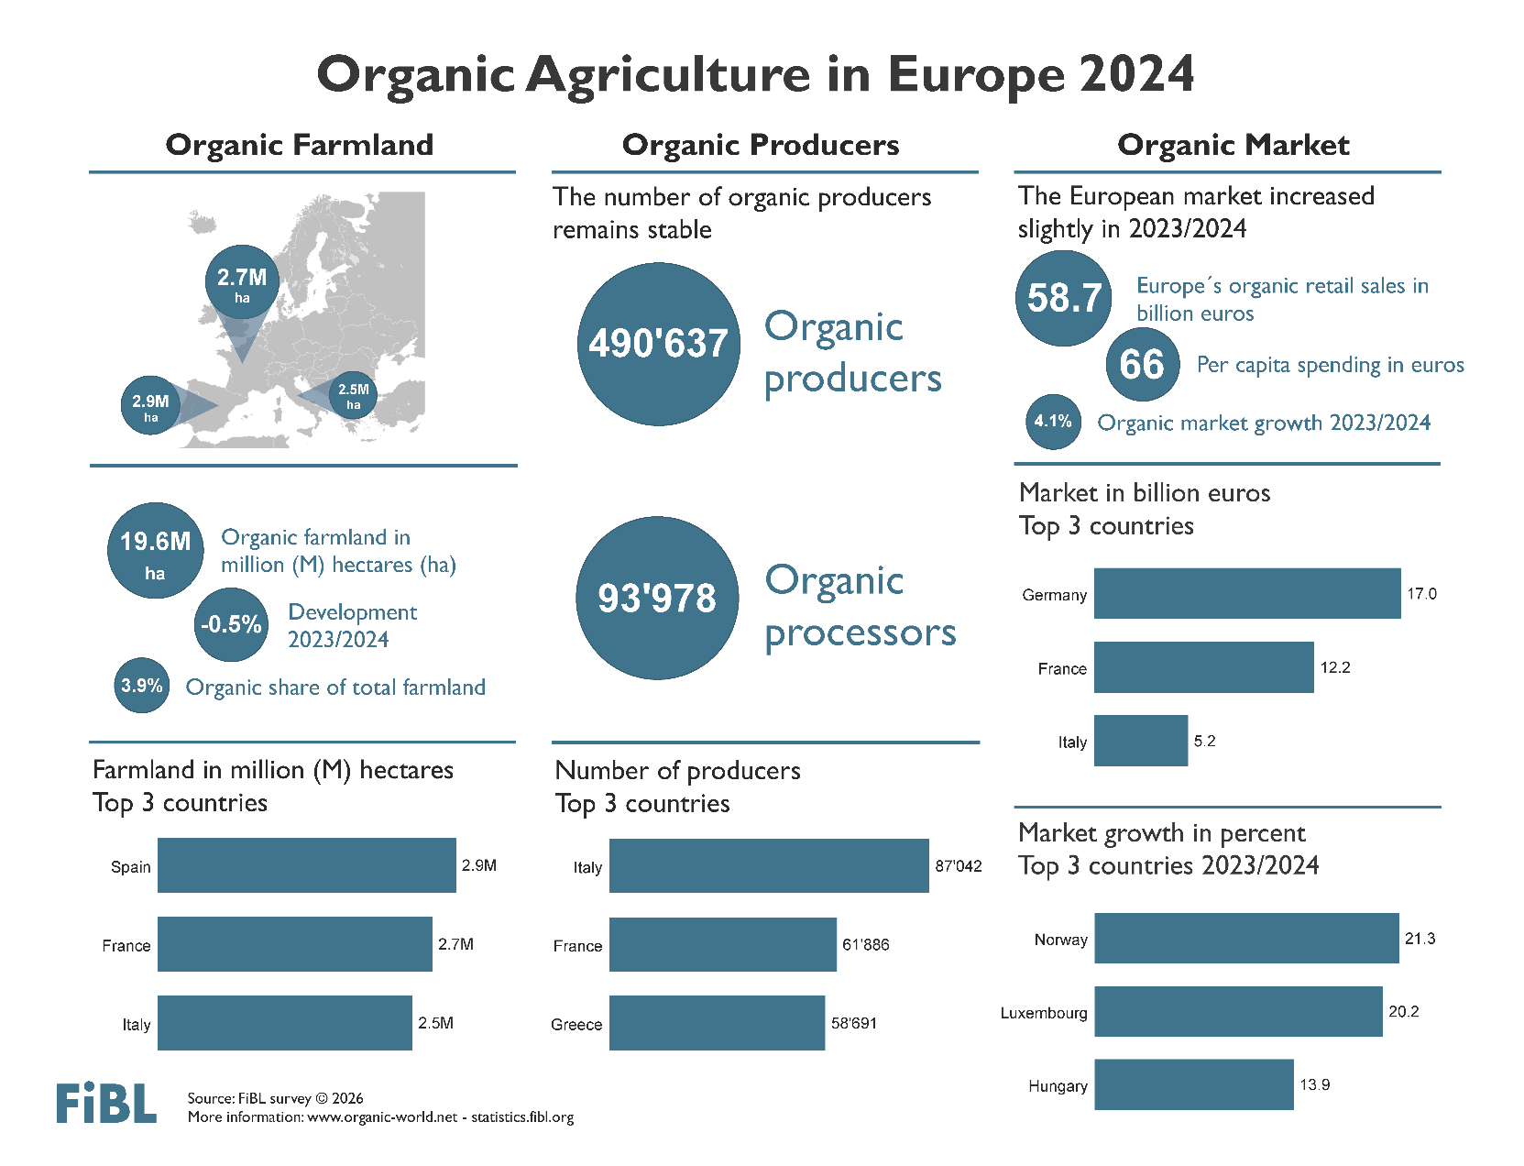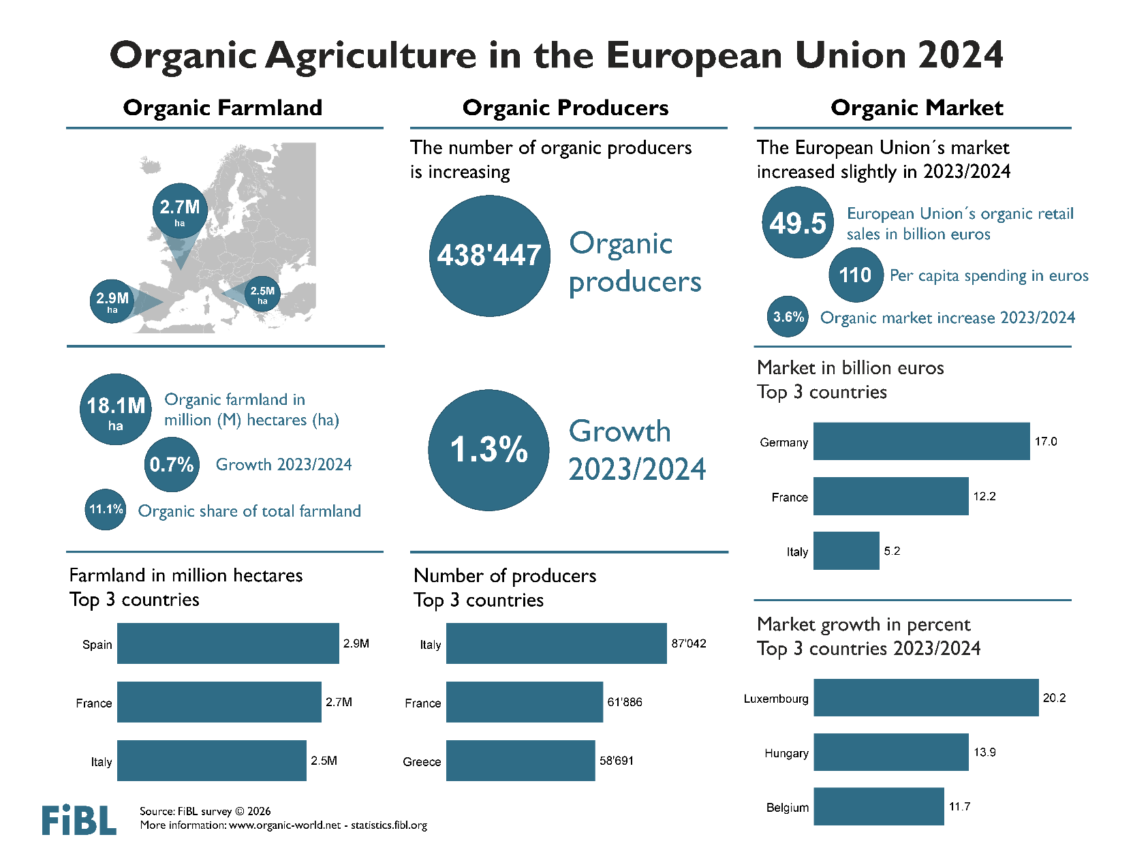

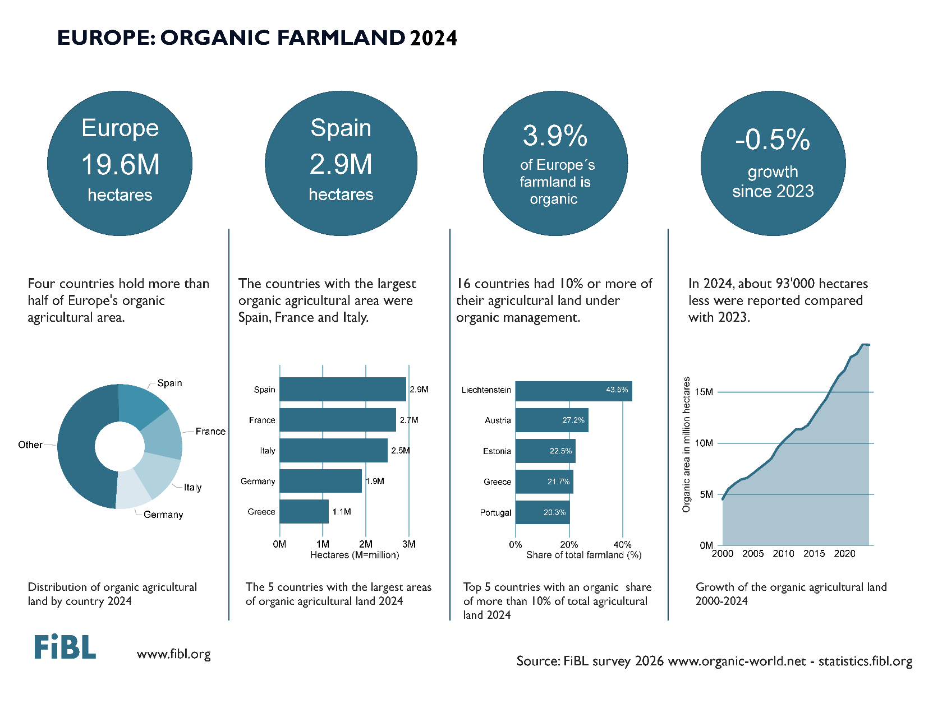
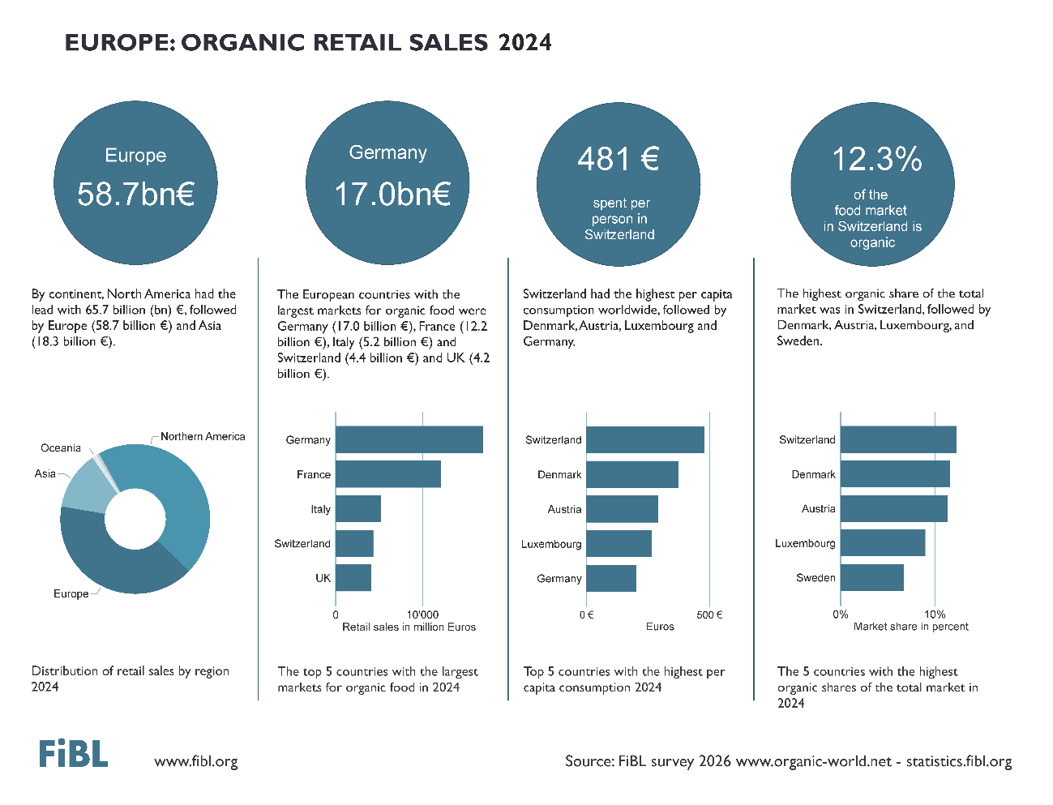

Please note that the 2024 data for the European cover the 27 countries that were members of the European Union in 2024.

