Media release

Swiss support for South Korea's organic efforts

There is great interest in organic farming in South Korea, but the area under cultivation is still small. In order to better exploit this potential, the Research Institute of Organic Agriculture FiBL has signed a further Memorandum of Understanding between FiBL and the South Korean National Institute of Agricultural Sciences (NAS) and the Rural Development Administration (RDA) to further strengthen cooperation.

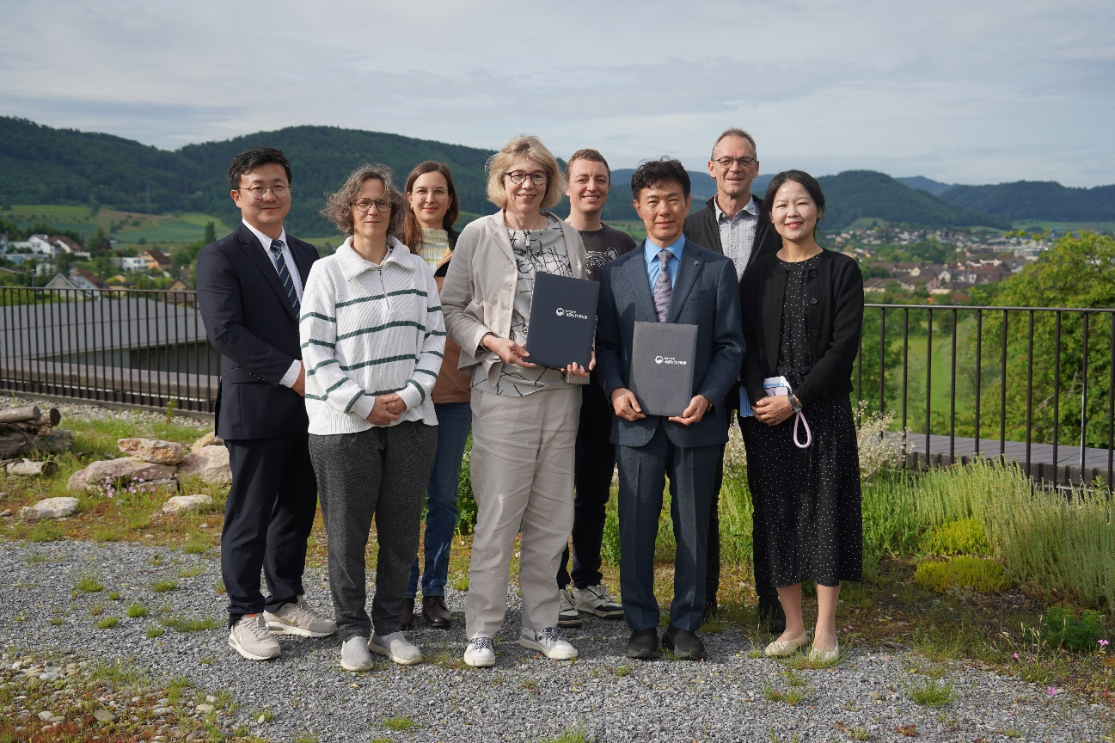

The signing of the Memorandum of Understanding was attended by Sangjae Lee, Head of the Department of Agroecology at NAS, and Beate Huber, Vice-Chair of the Management Board of FiBL Switzerland, as well as other researchers from both institutions. (Photo: FiBL, Andreas Basler)

(Frick, 28.05.2025) With a share of only around 2.4 percent, organic farming has remained marginal in South Korea. However, in light of climate change and a growing demand for organic products, the government wants to promote the sector in a targeted manner. Even so, the expansion faces numerous challenges, particularly when it comes to adapting organic farming methods to local conditions. In order to progress, South Korea is drawing on international knowledge exchange.

FiBL Switzerland and the South Korean NAS have been working together for ten years on projects to develop site-specific strategies. On May 28, 2025, the two institutions officially confirmed their collaboration by signing a Memorandum of Understanding, taking it to a new level. In the future, the exchange of knowledge will be even more intensive, with a particular focus on smart farming and climate farming.

Potential of organic in South Korea

South Korea has a very intensive agricultural sector with small and very specialised farms. These are often only one to three hectares in size, each with one main crop such as garlic, ginger, chili, ginseng, apples or cherries. Customers particularly value large and beautiful fruit and will pay the equivalent of six francs for an apple. However, many pesticides are currently used to produce these products.

Despite evident consumer demand for healthy and organically products in South Korea, the practical implementation of organic farming methods has so far been largely ineffective. FiBL sees the greatest opportunities for development in the introduction of adapted crop rotations, greater diversification of farms and the targeted promotion of organic plant protection measures.

Shared experiences in fruit growing

FiBL and South Korea have been carrying out joint projects in the field of fruit growing for ten years. The South Korean partners were the RDA and the Gyeongsangbuk-do Agricultural Research and Extension Services (GBARES). Topics included flower strips in apple production, apple varieties and biological plant protection strategies. The South Korean peninsula, with its hilly landscape, has similar climatic conditions to Central Europe. FiBL benefits from exchanging varieties and additional test areas for organic plant protection products, while South Korea benefits from FiBL's knowledge. Two further joint projects focusing on plant protection in stone fruit and on smart farming and climate farming are in preparation. In addition, South Korean students regularly work at FiBL as part of an exchange program.

Future prospects

The signing of the Memorandum of Understanding on May 28, 2025, marks an important milestone in the cooperation between South Korea and Switzerland. Hans-Jakob Schärer, Co-Head of the Plant Protection and Phytopathology Group at FiBL and responsible for cooperation with South Korea, says: "This partnership will not only improve agricultural practice in both countries, but also make an important contribution to global sustainability."

FiBL contacts

* Hans-Jakob Schärer, Co-leader of the Plant Protection Group, FiBL Switzerland  
  Tel: +41 62 865 72 09, E-Mail: [hans-jakob.schaerer@fibl.org](mailto:hans-jakob.schaerer@fibl.org)
* Franziska Hämmerli, Media Spokesperson, FiBL Switzerland  
  Tel: +41 62 865 72 80, E-Mail: [franziska.haemmerli@fibl.org](mailto:franziska.haemmerli@fibl.org)

Supporters/Donors

* South Korean state

Partners

* National Institute of Agricultural Sciences NAS and Rural Development Administration (RDA)
* Gyeongsangbuk-do Agricultural Research and Extension Services (GBARES)
* Korean Agency of Education, Promotion and Information Service in Food, Agriculture, Forestry and Fisheries EPIS

Links

* orgprints.org: Article ["An apple for eight francs"](https://orgprints.org/id/eprint/33485/1/Bioaktuell_4_2018_H.J.Schaerer.pdf) (in German)
* rda.go.kr: [Website of the RDA](https://www.rda.go.kr/foreign/ten2/index.jsp)
* fibl.org: News ["Together with Korea: Organic strategies for fruit growing"](https://www.fibl.org/en/info-centre/news/fibl-and-korean-partners-organic-strategies-for-fruit-orchards)
* fibl.org: News ["FiBL and Korean Agency collaborate on promoting Smart Farming for organic agriculture"](https://www.fibl.org/en/info-centre/news/fibl-and-korean-agency-collaborate-on-promoting-smart-farming-for-organic-agriculture)

This press release on the Internet

You can find this press release including pictures on the Internet at <https://www.fibl.org/en/info-centre/media>

Further images for download

Images are available at the following link: <https://biomedia.picturepark.com/s/PMn4aChU>

About FiBL

The Research Institute of Organic Agriculture FiBL is one of the world's leading research institutions in the field of organic agriculture. FiBL's strengths are interdisciplinary research, joint innovations with farmers and the food industry, and rapid knowledge transfer. The FiBL Group currently comprises FiBL Switzerland (founded in 1973), FiBL Germany (2001), FiBL Austria (2004), ÖMKi (Hungarian Research Institute of Organic Agriculture, 2011), FiBL France (2017) and FiBL Europe (2017), which is jointly supported by the five national institutes. Around 400 employees work at the various locations.

[www.fibl.org](http://www.fibl.org)