Media release

New faces on the Management Board of FiBL Switzerland
The management committees of FiBL Switzerland are undergoing a reshuffle: Sabine Douxchamps, Malta Fazzari, Anet Spengler and Richard Tüscher are joining the research institute's management team as four new members.
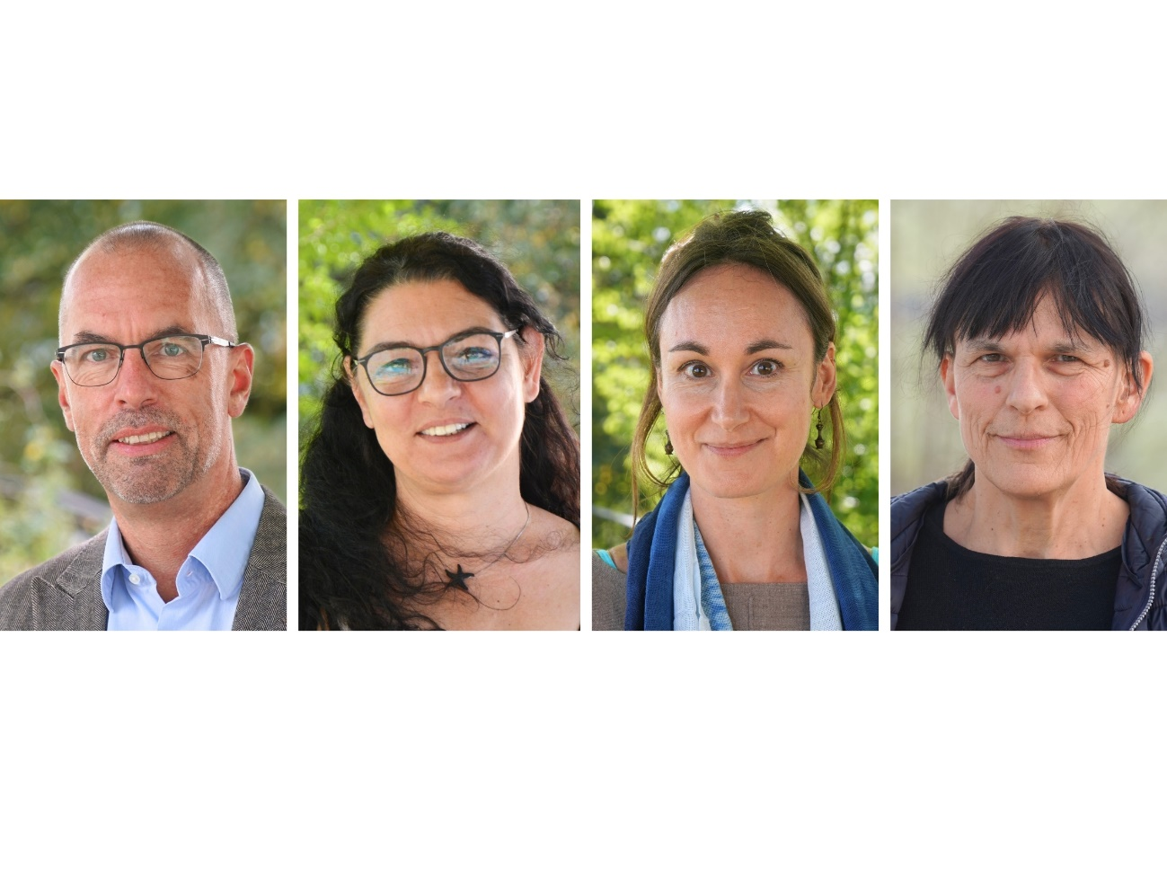
From left to right: Richard Tüscher, Malta Fazzari, Sabine Douxchamps and Anet Spengler. (Photos: FiBL)

(Frick, 24 September 2025) The management of the Research Institute of Organic Agriculture FiBL has four new members. This means that the committees that run FiBL are once again at full strength.
Executive Committee once again has three members
With Richard Tüscher taking up his post as Head of the Department of Finances & Infrastructure on 1 September 2025, the Executive Committee is once again complete. Together with Jürn Sanders and Beate Huber, Richard Tüscher completes the three-member Executive Committee. As a trained business economist, he brings over thirty years of experience in senior positions in finance, IT and internal services. "I am very much looking forward to contributing my knowledge, experience and passion to the further development of FiBL."
New department with a focus on human resources
On 2 June 2025, Malta Fazzari, a qualified labour lawyer with many years of management experience in human resources (HR), took over as head of the newly established Department of Human Resources & Administration. "For me, people are the focus. With the new HR structure, I want not only to modernise processes, but also to contribute to a working environment in which everyone feels seen, supported and valued."
Handover in international cooperation
In the Department of International Cooperation, Beate Huber is handing over the reins to Sabine Douxchamps. Beate Huber will leave the department on 31 October to focus on her work on the Executive Committee.
Sabine Douxchamps brings a wealth of experience in research and in the development and management of interdisciplinary programmes in an international working environment. After completing her doctorate at ETH Zurich in 2010, she worked in Latin America, Africa and South-East Asia, among other places. "I look forward to supporting FiBL and our partners in placing agroecology and organic farming at the heart of the transformation of food systems. In doing so, we will ensure a successful future for people and nature in the Global South."
New co-head of Livestock Sciences
In February, Anet Spengler took over the co-management of the Department of Livestock Sciences from Florian Leiber. Together with Michael Walkenhorst, she now co-manages the department. After thirteen years at the helm of the department, Florian Leiber is looking forward to having more resources for his research work.
Anet Spengler is well known to the FiBL team. She has been conducting research at FiBL in the areas of livestock husbandry and breeding for more than twenty years. Outside FiBL, she is active as a teacher in specialist training courses, as a course leader and as an author. "By moving into management at FiBL, I am following my desire to also get involved at a strategic and entrepreneurial level."
FiBL contacts
- Beate Huber, Vice-Chairwoman of the Management Board, FiBL Switzerland
Tel +41 62 865 04 25, email beate.huber@fibl.org
- Franziska Hämmerli, Media Spokesperson, FiBL Switzerland
Tel +41 62 865 72 80, email franziska.haemmerli@fibl.org
Links
fibl.org: The Executive Board of FiBL Switzerland
fibl.org: Sabine Douxchamps, staff page
fibl.org: Malta Fazzari, staff page
fibl.org: Anet Spengler, staff page
fibl.org: Richard Tüscher, staff page
This media release online
This media release and pictures can be accessed online at www.fibl.org/en/info-centre/media.html.
About FiBL
The Research Institute of Organic Agriculture FiBL is one of the world's leading research institutions in the field of organic agriculture. FiBL's strengths are interdisciplinary research, joint innovations with farmers and the food industry as well as rapid knowledge transfer. The FiBL Group currently includes FiBL Switzerland (founded in 1973), FiBL Germany (2001), FiBL Austria (2004), ÖMKi (Hungarian Research Institute of Organic Agriculture, 2011), FiBL France (2017) and FiBL Europe (2017), which is jointly supported by the five national institutes. More than 400 employees work at the various locations. www.fibl.org

