Media release

SustainSahel presents key innovations for a sustainable African agriculture

The five-year EU project SustainSahel has shown that simple agroecological practices can boost yields up to 40 percent and build resilience to climate change while being economically feasible. The project led by the Research Institute of Organic Agriculture FiBL presents a wealth of educational materials and experience that need to be scaled up to pave the way for Africa’s sustainable development.

Ein Bild, das Gras, draußen, Pflanze, Baum enthält.

Integrating local tree species like *Faidherbia albida* retains water, improves degraded soils and

provides animal fodder. (Photo: SustainSahel, Alain Audebert)

(Frick, 29.09.2025) From 2020 to 2025, the EU-funded SustainSahel project supported smallholder farmers in the Sahel region, tackling land degradation and climate stress. Led by FiBL, the project demonstrated that agroecological practices are both effective and economically feasible. At seven pilot sites researchers and farmers worked hand in hand with institutions from Mali, Senegal, Burkina Faso, France, Germany, and Switzerland. More than 5000 farmers were involved representing thousands of hectares across different rainfall zones in the Sahel zone.

Farming practices with impact

Harun Cicek, project leader from the FiBL Department of International Cooperation, states: “We found that simple practices like mulching, composting, and integrating local trees and shrubs can boost yields by up to 40 percent. Furthermore, these measures improve soil and water management and provide fodder and medicinal resources.”

Lead farmers are crucial to yield improvement

A highlight was the “lead farmer” model: Farmers trained in field schools passed their knowledge to 20 to 40 peers, creating a strong multiplier effect. Adoption of these practices led to yield increases of 150 to over 300 kilograms per hectare, translating to gains of up to 40 percent, and improved production stability even under climate stress.

Ein Bild, das draußen, Himmel, Gras, Gelände enthält.
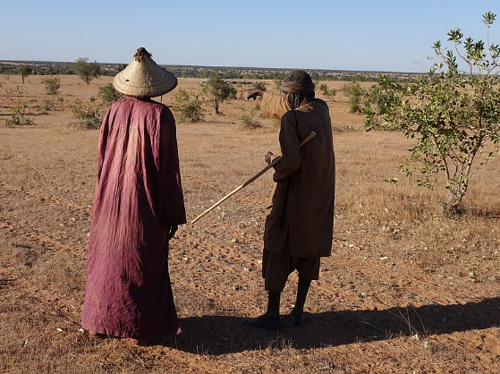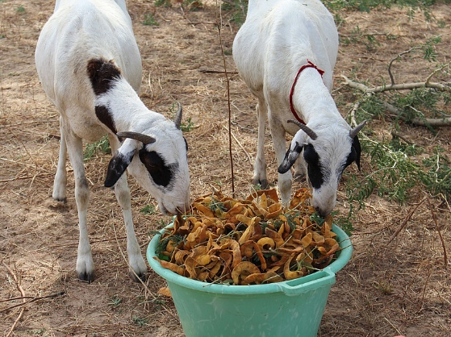Ein Bild, das Säugetier, Gras, draußen, Hund enthält.

Farmer-to-farmer learning has proven to be

the most efficient way of knowledge transfer.

(Photo: FiBL, Fernando Sousa)

Local medicinal trees and shrubs improve

animal health. They are for example effective

against nematode infections in goats. (Photo:

FiBL, Harun Cicek)

Ein Bild, das Gelände, draußen enthält.
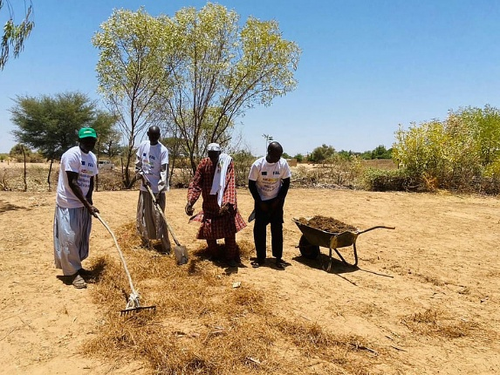Ein Bild, das draußen, Himmel, Person, Gelände enthält.

Governments are urged to integrate

agroecological and agroforestry practices into

their strategies. (Photo: FiBL, Harun Cicek)

Mulching is the practice of covering soil with

a layer of organic material like tree litter and

crop residues. This improves water retention

and suppresses weed. (Photo: Sustain Sahel,

Lilian Beck)

Key recommendations for the future

At the closing workshop in May in Dakar, Senegal, concrete recommendations for stakeholders were compiled:

* **For farmers:** Adopt agroecological and organic farming. Necessary information and know-how can be found in the manuals and educational materials on the project website.
* **For policymakers:** Integrate agroecology into agricultural and environmental strategies; revise land codes to secure tree rights for farmers; invest in extension and supply chains; fund participatory research and transition support.
* **For researchers**: Deepen knowledge of tree-crop interactions, soil-water dynamics, and carbon storage; strengthen monitoring by using drones and satellite data; study adoption barriers and socio-economic impacts.

Agroecology is the future for Africa

In May 2025, SustainSahel led the organization for a large-scale collaborative conference titled “Agroecological transition of food systems in Africa.” Together with eight other EU-Africa projects they provided compelling evidence: organic and agroecological farming are proven, scalable solutions for a sustainable African future.

Links

* + - Sustain Sahel project website: <https://www.sustainsahel.net/>
    - Final recommendations to farmers: <https://www.sustainsahel.net/news/final-recommendations-to-farmers.html>
    - Final recommendations to policy makers: <https://www.sustainsahel.net/news/final-recommendations-to-policy-makers.html>
    - Final recommendations to researchers: <https://www.sustainsahel.net/news/final-recommendations-to-researchers.html>
    - Sustain Sahel manuals and educational materials: <https://www.sustainsahel.net/communications/publications.html>
    - Conference briefing “Agroecological transition of food systems in Africa”: <https://conference.sustainsahel.net/fileadmin/conference-sustainsahel/documents/Policy_briefing.pdf>

Videos

* Sustain Sahel YouTube channel: <https://www.youtube.com/@sustainsahel>
* Conference video “Agroecology is the future for Africa”: <https://www.youtube.com/watch?v=zeWeD0dT76E>

FiBL contacts

* Harun Cicek, FiBL, Deputy Leader Group Agroecosystem Innovation & Adoption  
  Phone [+41 62 865-0456](mailto:+41%2062%20865-0456), e-mail [harun.cicek@fibl.org](mailto:harun.cicek@fibl.org)
* Gian Nicolay, FiBL, Department of International Cooperation, Group Policy & Sector Development

Phone +41 62 865-0454, e-mail gian.nicolay@fibl.org

Supporters

This project has received funding from the European Union’s Horizon 2020 sustainable food security programme.

Partners

* [Access Agriculture (AA), Benin](https://www.sustainsahel.net/partners/aa-be.html)
* [African Forum for Agricultural Advisory Services (AFAAS), Burkina Faso](https://www.sustainsahel.net/partners/afaas-ug.html)
* [Association of Professional Farmer Organisations (AOPP), Mali](https://www.sustainsahel.net/partners/aopp-ml.html)
* [Agricultural Research Centre for International Development (CIRAD), France](https://www.sustainsahel.net/partners/cirad-fr.html)
* [The Peasant Confederation of Faso (CPF), Burkina Faso](https://www.sustainsahel.net/partners/cpf-bf.html)
* [Ecological Monitoring Centre (CSE), Senegal](https://www.sustainsahel.net/partners/cse-sn.html)
* [National Council for Consultation and Rural Cooperation (CNCR), Senegal](https://www.sustainsahel.net/partners/cncr-sn.html)
* [Institute of Environment and Agricultural Research (INERA), Burkina Faso](https://www.sustainsahel.net/partners/inera-bf.html)
* [Institute of Rural Economy (IER), Mali](https://www.sustainsahel.net/partners/ier-ml.html)
* [International Institute of Tropical Agriculture (IITA), Kenya](https://www.sustainsahel.net/partners/iita-ky.html)
* [Rural Polytechnic Institute (IPR/IFRA), Mali](https://www.sustainsahel.net/partners/ipr-ml.html)
* [Senegalese Institute of Agricultural Research (ISRA), Senegal](https://www.sustainsahel.net/partners/isra-sn.html)
* [National Research Institute for Sustainable Development (IRD), France](https://www.sustainsahel.net/partners/ird-fr.html)
* [Nazi BONI University (UNB), Burkina Faso](https://www.sustainsahel.net/partners/ubd-bf.html)
* [University of Hohenheim, Germany](https://www.sustainsahel.net/partners/uhoh-de.html)
* [University of Kassel, Germany](https://www.sustainsahel.net/partners/uni-kassel-de.html)

This media release online

This media release and pictures can be accessed online at [www.fibl.org/en/info-centre/media.html](https://www.fibl.org/en/info-centre/media.html).

Images for download

Images are available under the following link: <https://biomedia.picturepark.com/s/lCZF8Yjy>

About Sustain Sahel

SustainSahel project's full name is 'Synergistic use and protection of natural resources for rural livelihoods through systematic integration of crops, shrubs and livestock in the Sahel'. The overall goal of SustainSahel is to promote practices which enhance soil quality and yields, build resilience towards climate change, and contribute to food security and better livelihoods. The project's approach is embedded within the themes of agroecology, organic agriculture and elements of conservation agriculture. SustainSahel has 17 partners from 9 countries, representing the European and African continents. The project is coordinated by FiBL and is funded under Horizon 2020, the European Union's framework programme for research and innovation.

www.sustainsahel.net

About FiBL

The Research Institute of Organic Agriculture FiBL is one of the world's leading research institutions in the field of organic agriculture. FiBL's strengths are interdisciplinary research, joint innovations with farmers and the food industry as well as rapid knowledge transfer. The FiBL Group currently includes FiBL Switzerland (founded in 1973), FiBL Germany (2001), FiBL Austria (2004), ÖMKi (Hungarian Research Institute of Organic Agriculture, 2011), FiBL France (2017) and FiBL Europe (2017), which is jointly supported by the five national institutes. More than 400 employees work at the various locations.

[www.fibl.org](http://www.fibl.org)