Media release
Organic agriculture in the tropics: a contributor to local livelihoods
A recent paper from the Research Institute of Organic Agriculture FiBL demonstrates that organic production systems in the tropics are as profitable as conventional systems. The paper emphasises that organic farming does not solely rely on main cash crops for export to generate income. Associated and rotational crops play a crucial role in enhancing farm profitability. The paper is based on data from 12 years of long-term organic trials in Bolivia, India, and Kenya, and offers new insights into the art and science of organic farming in the tropics.
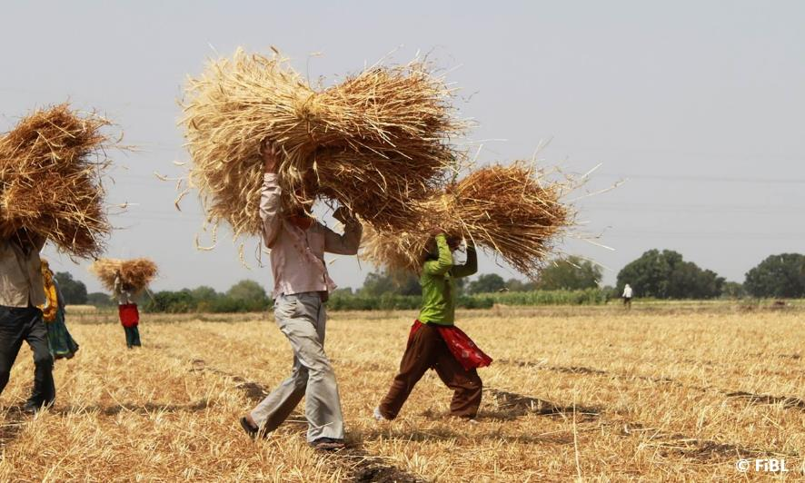
Associated and rotational crops contribute to farm profitability in the tropics. The picture shows the harvest of a wheat crop, a rotational crop in cotton production in India. (Photo: FiBL, Dionys Forster)

(Frick, April 25, 2024) A newly published paper provides an alternate narrative for organic agriculture in the tropics. While organic production systems are often depicted as non-competitive in terms of generating disposable income and export-oriented with not enough focus on local needs, new data provides a different perspective.
The new paper is based on 12 years of data from four long-term experiments comparing conventional and organic farming systems across three continents. The paper shows that organic agriculture can generate disposable income for farmers that is equal to conventional agriculture. Farmers cultivate additional non-export crops for local consumption in rotation with cash crops (cacao in Bolivia, cotton in India, maize in Kenya). The contribution of these additional crops provides equal amounts of disposable income for farmers while at the same time providing important ecosystem services. Up until now, these non-export crops have been largely overlooked.
Additionally, the study highlights that crop diversification leads to more stable incomes and more varied food sources for farmers. “The emphasis should shift from a singular focus on main cash crops to a more comprehensive understanding that considers the entire spectrum of crops within a farming system over a longer period,” said Amritbir Riar, first author of the study and senior scientist at the Research Institute of Organic Agriculture FiBL.
The SysCom trials - Globally unique
The data presented in this paper was collected in the four trials of the SysCom project (Farming Systems Comparison in the Tropics). These long-term trials have been running for 17 years and are located in tropical zones on three continents: Africa, Asia, and South America. The cropping systems in all trials involve one main crop (cacao, cotton, and maize, respectively) and associated crops, which are managed under site-specific conventional farming and organic management systems. To obtain an overview of organic farming compared to conventional farming, the long-term experimental design is useful in assessing the performance of a whole system over time.
The long-term SysCom trials continue to provide novel and valuable insights into the performance and potential of organic agriculture in the tropics, relevant to stakeholders from farmers to policymakers. For more information on the trials, please visit the SysCom website: https://systems-comparison.fibl.org.
FiBL contacts
- Amritbir Riar, Group Leader Resilient Cropping Systems, Department of International Cooperation, FiBL Switzerland
Phone +41 62 865 72 88, e-mail amritbir.riar@fibl.org
- Elsa Kanner, Group Project Communication, Department of Extension, Training, & Communication, FiBL Switzerland
Phone +41 62 865 04 99, e-mail elsa.kanner@fibl.org
Supporters/Donors
    - Coop Sustainability Fund
    - Liechtenstein Development Service (LED)
    - Biovision
    - Swiss Agency for Development and Cooperation (SDC)
Link
https://systems-comparison.fibl.org
References
Riar, A., Goldmann, E., Bautze, D., Rüegg, J., Bhullar, G.S., Adamtey, N., Schneider, M., Huber, B., Armengot, L. (2024) Farm gate profitability of organic and conventional farming systems in the tropics, International Journal of Agricultural Sustainability, 22:1, DOI: 10.1080/14735903.2024.2318933, download: https://www.tandfonline.com/doi/full/10.1080/14735903.2024.2318933
This media release online
This media release and pictures can be accessed online at www.fibl.org/en/info-centre/media.html.
About FiBL
The Research Institute of Organic Agriculture FiBL is one of the world's leading research institutions in the field of organic agriculture. FiBL's strengths are interdisciplinary research, joint innovations with farmers and the food industry as well as rapid knowledge transfer. The FiBL Group currently includes FiBL Switzerland (founded in 1973), FiBL Germany (2001), FiBL Austria (2004), ÖMKi (Hungarian Research Institute of Organic Agriculture, 2011), FiBL France (2017) and FiBL Europe (2017), which is jointly supported by the five national institutes. More than 400 employees work at the various locations. www.fibl.org
Further images
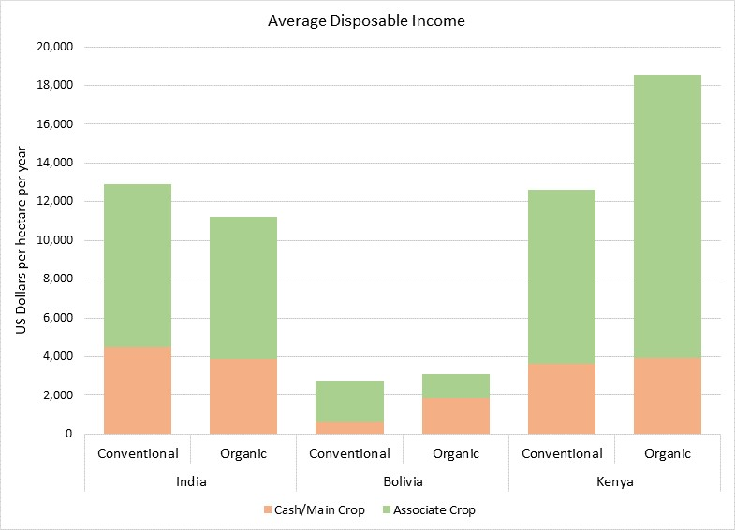
Average disposable incomes compared: Organic versus conventional farming in India, Bolivia and Kenya. (Graph: FiBL)

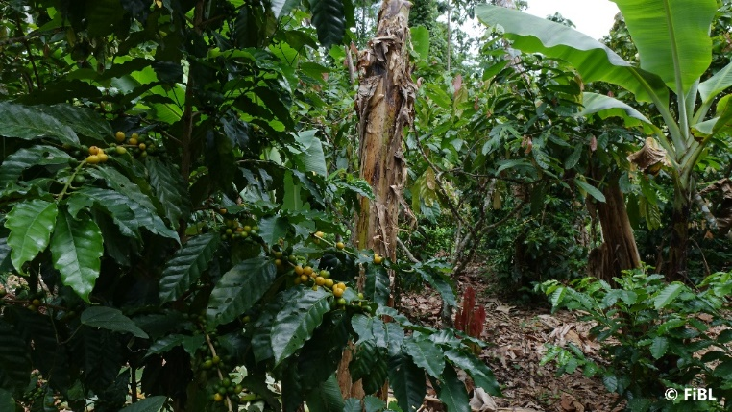
Organic production systems (like the cacao agroforestry system in Bolivia pictured above) are just as profitable as conventional systems through the interplay of cash crops with associated crops (e.g. bananas, curcuma, ginger, maize, peach palm and other fruit trees). (Photo: FiBL, Johanna Rüegg)

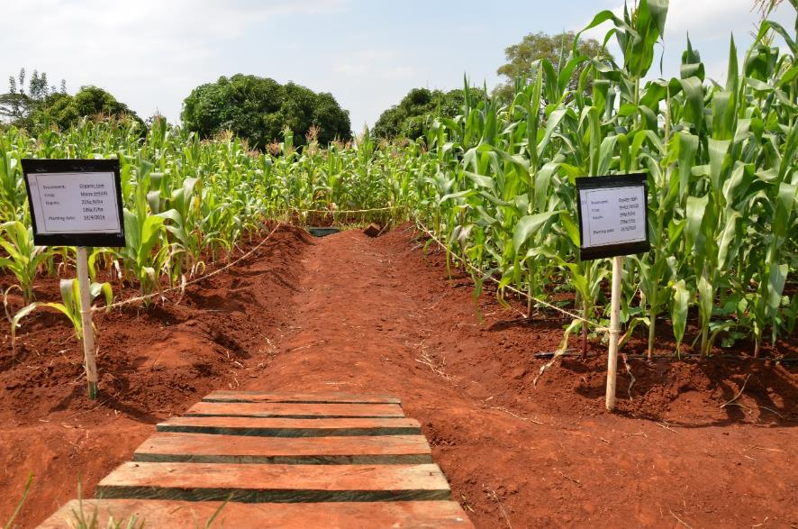
In Kenya, the cropping systems involves maize as the main crop, and legumes, vegtables and potatoes as associated crops, which are highly important for the income and nutrition of the local population. (Photo: FiBL, Franziska Hämmerli)

