New faces on the Foundation Council and the Management Board at FiBL Switzerland

Farmer and member of the Cantonal Parliament Colette Basler and Coop manager Marc Muntwyler were appointed to the Foundation Council of FiBL Switzerland. In addition, former professor and UN mandate-holder Martina Bozzola has been appointed Head of the Department of Food System Sciences and former Syngenta and ETH researcher Stefano Torriani has been appointed Head of the Department of Crop Sciences.

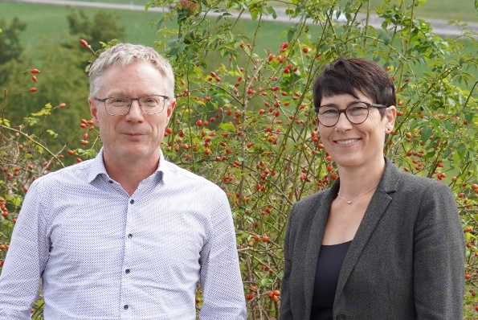 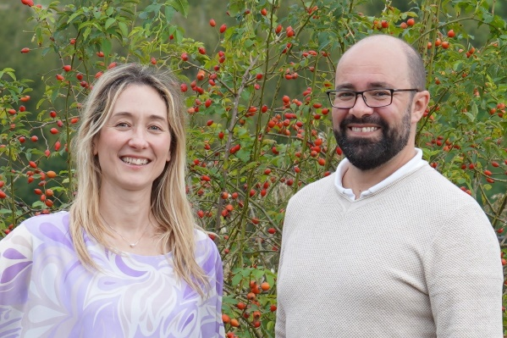

Marc Muntwyler, Colette Basler (Photo: FiBL) Martina Bozzola, Stefano Torriani (Photo: FiBL)

(Frick, 26.09.2024) The Foundation Council members of FiBL Switzerland steer the institute and perform valuable voluntary work, often serving long tenures. This is true for Ralf Bucher and Roland Frefel, who are leaving the Foundation Council after around eight years despite enjoying their work immensely. FiBL welcomed Marc Muntwyler as a successor in June and now welcomes Colette Basler in September.

Marc Muntwyler new to the Foundation Council as a representative of the retail trade

Marc Muntwyler has held management positions at Coop for around twenty years. As Head of Sustainability and Economic Policy, he brings a wealth of experience in the food industry and a desire to work towards a better future to the Foundation Council: "I want to help my two daughters, and of course everyone else, to live in a more sustainable world in which we use resources more sparingly than we have done in recent decades."

Colette Basler ensures that the Foundation Council is well rooted in the region

Another new member of the Foundation Council is the farmer and member of the Cantonal Parliament of Aargau Colette Basler. Together with her husband, she runs a 33-hectare IP-Suisse farm (IP-Suisse is the Swiss Association of Integrated Producing Farmers) with 40 dairy cows, young cattle and arable farming in Zeihen in Fricktal. Basler is a qualified secondary school teacher and has worked in the profession for many years. Subject to election, she will take over as President of the Aargau Teachers' Association in a few weeks' time. She is also in the leadership of the Aargau Farmers' Association, where she holds the role of Vice President.

Colette Basler has known FiBL for a long time and is proud that her canton succeeded in bringing the research institute to Frick. "FiBL is an important player in mastering the challenging further development of the agriculture and food sector," says Basler. With her excellent network in society and (agricultural) politics, she will fulfil the important function of liaising with the local canton on the Foundation Council.

New faces at the head of two departments

The FiBL Management Board also has new faces with the appointment of two department heads: Martina Bozzola and Stefano Torriani.

Professor, researcher and sustainability specialist Martina Bozzola

In Martina Bozzola, FiBL Switzerland has had a person with an impressive CV at the head of the Department of Food System Sciences since the beginning of September. The 42-year-old previously worked for around six years as Associate Professor of Economics of Agriculture, Food, and Health at Queen's University Belfast. She has also worked in various research and academic institutions in Switzerland and at the International Trade Centre, a joint organisation of the World Trade Organisation (WTO) and the United Nations (UN).

She was attracted to FiBL by the prospect of working at a world-class research institute on sustainable agriculture. "Here I can conduct research into organic and sustainable food and agricultural systems in an interdisciplinary environment and support a dynamic team in a specialised field that is very close to my heart," says Bozzola. "What's more, FiBL's location in Switzerland fits in well with my home base in Zurich."

Stefano Torriani - a global research and market economy network

Stefano Torriani took over as Head of the Department of Crop Sciences at FiBL Switzerland on 16 September. He previously worked at Syngenta for around ten years, most recently as "Global Lead Fungicide Resistance Management and Scientific Expert Bioscience" and for a further ten years at the Swiss Federal Institute of Technology (ETH) in basic research.

What drew the 44-year-old from a crop protection company to a non-profit research institute? "I've been waiting a few years for the right opportunity to make an effective contribution to the current and future challenges facing organic agriculture. FiBL, with its close practical focus, has the right infrastructure and philosophy to make this possible," says Torriani. Conventional farmers should also benefit from this. "I have experienced the challenges of conventional farming myself. I am therefore convinced that organic solutions should not just be an alternative, but must establish themselves as a leading technology."

FiBL contacts

* Beate Huber, Vice-chairwoman of the Management Board FiBL Switzerland   
  Tel +41 62 865 04 25, e-mail [beate.huber@fibl.org](mailto:beate.huber@fibl.org)
* Franziska Hämmerli, Media spokesperson FiBL Switzerland   
  Tel +41 62 865 72 80, e-mail [franziska.haemmerli@fibl.org](mailto:franziska.haemmerli@fibl.org)

Links

* fibl.org: The Foundation Council of FiBL Switzerland  
  <https://www.fibl.org/en/locations/switzerland/about-us-ch/foundation-council>
* fibl.org: Martina Bozzola, employee page  
  <https://www.fibl.org/en/about-us/team/bozzola-martina>
* fibl.org: Stefano Torriani, employee page  
  <https://www.fibl.org/en/about-us/team/torriani-stefano>

This press release on the Internet

You can find this press release including images on the Internet at <https://www.fibl.org/en/info-centre/media>.

About FiBL

The Research Institute of Organic Agriculture FiBL is one of the world's leading research institutions in the field of organic agriculture. FiBL's strengths are interdisciplinary research, joint innovations with farmers and the food industry, and rapid knowledge transfer. The FiBL Group currently comprises FiBL Switzerland (founded in 1973), FiBL Germany (2001), FiBL Austria (2004), ÖMKi (Hungarian Research Institute of Organic Agriculture, 2011), FiBL France (2017) and FiBL Europe (2017), which is jointly funded by the five national institutes. Around 400 employees work at the various locations. [www.fibl.org](https://www.fibl.org/)