Media release
Joint international support for Ukraine’s presence
at world-leading organic fair Biofach 2024
10 years after its first presence at Biofach in 2014, the 2024 edition of the fair will bring together 40 exporters from Ukraine's organic sector. A high-level policy delegation accompanies the presence. At the congress, female leaders of the organic sector will give insight into challenges of the current situation.
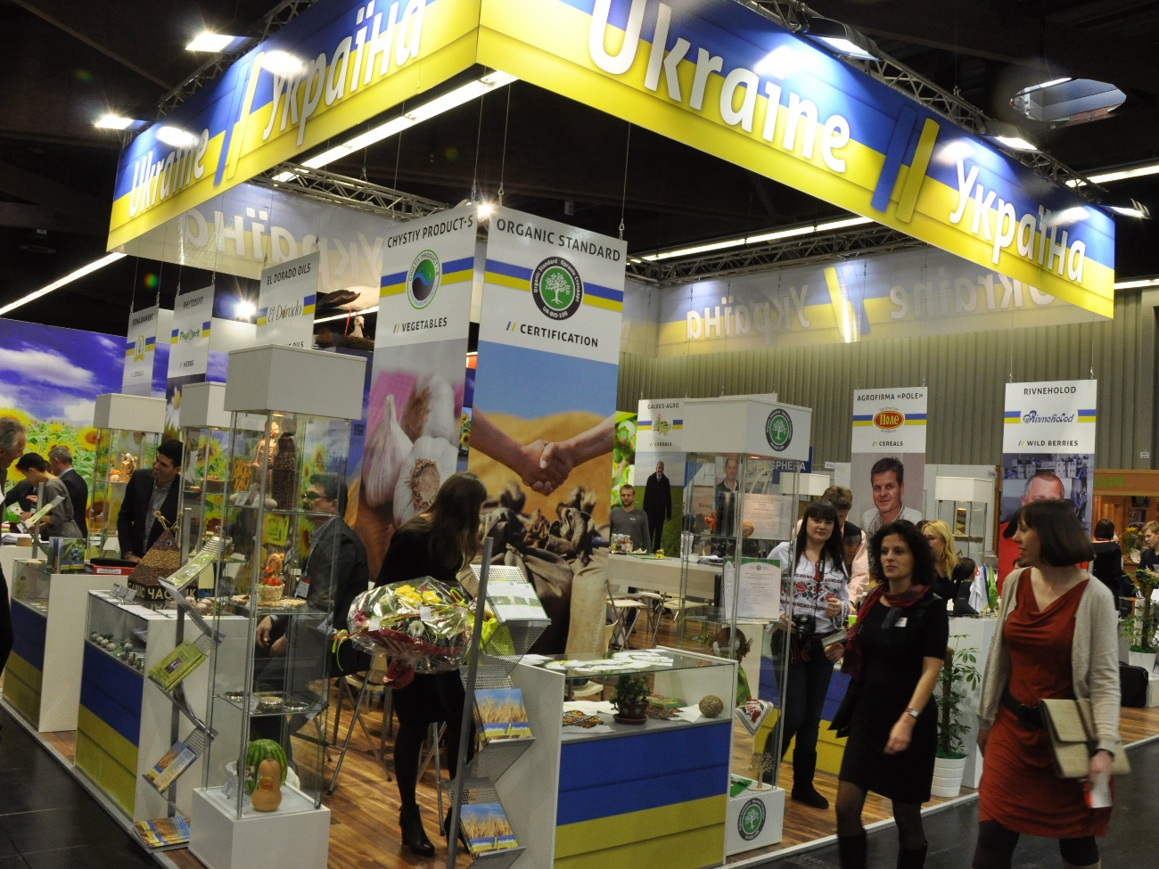
Ten years ago, in 2014, Ukraine had its first exhibition with the National Pavilion of Ukraine at Biofach, supported by Switzerland. Photo: FiBL, Adrian Krebs

(Frick, 08.02.2024) Between February 13 and 16, 2024, the organic community will again meet in Nuremberg (Germany) at Biofach, the world's leading trade fair for organic food. Regional, national and international stakeholders from the entire organic value chain, including service providers and poliсy makers will gather here to network and consolidate their joint vision for a more sustainable future.
Under the patronage of the Ministry of Agrarian Policy and Food of Ukraine (MAPF), Ukraine’s presence at Biofach 2024 is supported by multiple partners; the Swiss-Ukrainian Quality Food Trade Program (QFTP), funded by the Swiss State Secretariat for Economic Affairs (SECO); the German-Ukrainian Cooperation in Organic Farming (COA), funded by the German Federal Ministry for Food and Agriculture (BMEL); the Western NIS Enterprise Fund (WNISEF), funded by the U.S. government via USAID; and the EBRD’s Small Business Impact Fund and the Import Promotion Desk (IPD), funded by the German Federal Ministry for Economic Cooperation and Development (BMZ).
Bringing together 40 Ukrainian organic exporters
This year’s support involves bringing together approximately 40 Ukrainian exporters as well as a high-level Ukrainian policy delegation to present the sector’s key actors at the Biofach Congress. ”We are delighted that our support has helped so many companies from Ukraine to present their organic products at Biofach this year”, said Tobias Eisenring, Program Director of the Swiss Program QFTP and Dr. Stefan Dreesmann, head of the German project COA.
“Bringing Ukrainian exporters to Biofach is essential to promoting sustainable trade and creating more and better jobs by strengthening the business competitiveness and capacities of Ukrainian SMEs in the organic sector”, underlines Andrii Lytvyn, Deputy Director for Export Promotion of the Ukrainian State Institution Entrepreneurship and Export Promotion Office (EEPO). EEPO, the Ukrainian Berries Association and Import Promotion Desk jointly organize the Ukrainian Pavilion with 40 Ukrainian exporters at this year’s Biofach.
At the end of 2022, Ukraine had a surface of certified organic land of 263’619 ha, representing 0.6% of its total agricultural land. In 2022, Ukraine exported 245’600 tons of goods with a total value of almost 219 million USD and became the third largest importing country to the EU. Therefore, the stability of the European organic market strongly depends on the reliability and strength of Ukrainian suppliers.
A high-level policy delegation from Ukraine at Biofach
This year, in addition to Ukrainian producers, Biofach will also host a high-level policy delegation from Ukraine with representatives from the Ukrainian parliament, the Ministry of Agrarian Policy and Food of Ukraine, the State Service of Ukraine for Food Safety and Consumer Protection, and the state institution “Entrepreneurship and Export Promotion Office” (EEPO, Ukraine). During the fair, they will have the opportunity to network with policymakers and experts in the organic sector from all over the world.
Since 2023, the Ukrainian organic legislation has been fully implemented. Last year, with the support of international projects focused on technical assistance to Ukraine, important milestones were reached: the accreditation of Ukraine’s first organic certification body “Organic Standard” and the publication of two state registers of organic certification bodies and organic operators. More than 160 organic operators are already certified according to the Ukrainian organic law (in addition to EU organic regulations), and organic products labelled with Ukraine’s organic logo are available in Ukraine. The alignment of Ukrainian organic legislation to the EU regulation is the main objective for 2024.
The long-standing collaboration between the Swiss and German projects, together with other national and international partners from the EU, the US and Canada, has supported Ukrainian public and private actors in strengthening Ukraine's organic sector. This support will continue, notwithstanding the war perpetrated by the Russian Federation.
How female leaders of the organic sector change the world
On Tuesday, February 14, from 13h00 – 14h30, the Swiss and the German projects will organize a session at the Biofach congress titled ”At the front-line - women in Ukraine are changing the world” in room Shanghai (NCC Ost). Six female leaders of the Ukrainian organic sector from business, policy and civil society will present insights on achievements and challenges confronting the organic sector in Ukraine under the current conditions of war.
“A brand-new gender study will be presented, highlighting the important role of women in the organic sector of Ukraine”, explains Olena Deineko from the Organic Initiative Public Association. Dr. Stefan Dreesmann, project leader of COA points out another highlight: a cutting-edge video that will impressively portray Ukrainian female leaders and pioneers of the organic movement.
Women comprise 54% of Ukraine's population and 47% of its labor force. Over 60% of all Ukrainian women have higher education and many areas of civil life can only be sustained with their efforts. This is also true for organic farming and food security.
The event will serve as an excellent platform to inform all participants of Biofach about the challenges and opportunities of the organic sector in Ukraine.
Contacts
- Tobias Eisenring, Swiss-Ukrainian Quality Food Trade Program (QFTP), FiBL Switzerland, Phone +41 62 865 04 25, e-mail tobias.eisenring@fibl.org, www.qftp.org
- Dr. Stefan Dreesmann, German-Ukrainian Cooperation in Organic Farming (COA), Phone +49 152 539 77 131, e-mail Stefan.Dreesmann@gopa-afc.de, www.coa-ukraine.com/en/
- Adrian Krebs, Media spokesperson, FiBL Switzerland
Phone +41 62 865 50 32, +41 79 500 88 52, e-mail adrian.krebs@fibl.org
Information
- Visit us at the Ukrainian National Pavilion in hall 4A-511 and the Ukrainian stand in hall 4A-421. The list of all exporters can be found here:
https://organicinfo.ua/en/news/ukraine-at-Biofach-2024/
- Session at Biofach congress: “At the front-line - women in Ukraine are changing the world” Wednesday, February 14, from 13h00 – 14h30, room Shanghai (NCC Ost).
https://www.biofach.de/en/congress-events/programme-overview
Links
- Ukrainian Ministry of Agrarian Policy and Food of Ukraine (MAPF), https://minagro.gov.ua/en/napryamki/organic-production/labelling-organic-products
- Ukrainian State Institution Entrepreneurship and Export Development Office (EEPO), https://imp.export.gov.ua/505-organic_food and https://imp.export.gov.ua/793-the_national_pavilion_of_ukraine_at_biofach_2024
- Ukrainian Berries Association, www.uaberries.com/en/about-association
Supporters
- Organic Trade 4 Development in Eastern Europe (OT4D), www.organictrade4development.org
- Western NIS Enterprise Fund (WNISEF), funded by the U.S. government via USAID, www.wnisef.org
- European Bank for Reconstruction and Development (EBRD), www.ebrd.com/knowhow/ukraine
- Import Promotion Desk (IPD), funded by the German Federal Ministry for Economic Cooperation and Development (BMZ), www.importpromotiondesk.com
Partners
- Organic Initiative, www.organicinitiative.org.ua/en
This media release online
This media release and pictures can be accessed online at www.fibl.org/en/info-centre/media.html.
Images for download
Images are available under the following link: https://organicinfo.ua/en/news/ukraine-at-Biofach-2024/
About FiBL
The Research Institute of Organic Agriculture FiBL is one of the world's leading research institutions in the field of organic agriculture. FiBL's strengths are interdisciplinary research, joint innovations with farmers and the food industry as well as rapid knowledge transfer. The FiBL Group currently includes FiBL Switzerland (founded in 1973), FiBL Germany (2001), FiBL Austria (2004), ÖMKi (Hungarian Research Institute of Organic Agriculture, 2011), FiBL France (2017) and FiBL Europe (2017), which is jointly supported by the five national institutes. Around 400 employees work at the various locations. www.fibl.org
FiBL has a Quality Food Trade Program (QFTP) office in Kyiv, Ukraine, with 12 local staff. www.qftp.org/en

