Pathways to carbon-neutral
organic farming in Switzerland
A study by FiBL in coordination with Bio Suisse
Summary
Markus Steffens, Marie Dittmann, Maike Krauss, Stefan Baumann, Alice Dind, Andreas Fliessbach, Mirjam Holinger, Hans-Martin Krause, Florian Leiber, Adrian Müller, Johanna Rüegg, Sibylle Stöckli, Knut Schmidtke
14 March 2022
- Introduction
In the light of increasingly evident, human-induced climate change, low-carbon production and consumption patterns are essential for society as a whole and must be pursued by all sectors of the economy. The farming sector, and in particular organic farming with its focus on sustainability, must also face up to this necessity. The study on pathways to carbon-neutral organic farming in Switzerland («Wege zu einer klimaneutralen Biolandwirtschaft in der Schweiz») is the first to show for a specific domestic organic farming sector, in this case Switzerland‘s, the measures that would have to be taken in the sector, but also on the part of consumers, in order to achieve carbon neutrality in the sense of net zero greenhouse gas (GHG) emissions (Figure 1).
- How to achieve net zero GHG emissions?
Carbon neutrality in the sense of «net zero» is defined and achieved as follows: For a farm, economic sector, company or individual product, all GHG emissions – generally methane (CH₄), nitrous oxide (N₂O) and carbon dioxide (CO₂) – are first measured or calculated. Assuming that a quarter of all agricultural land in Switzerland is farmed organically in 2040, organic farming in Switzerland will be responsible for approximately 1.5 million tonnes of CO₂ equivalents in that year (Figure 1). This calculation takes into account the GHG emissions generated on the farms. In order to achieve «net zero» for these reported emissions, there are three points of leverage in agricultural production:
- Reducing GHG emissions.
- Compensating for unavoidable GHG emissions through permanent carbon (C) storage in agriculture’s own sphere of influence (carbon sequestration).
- Compensating for unavoidable GHG emissions by means of renewable energy generation.
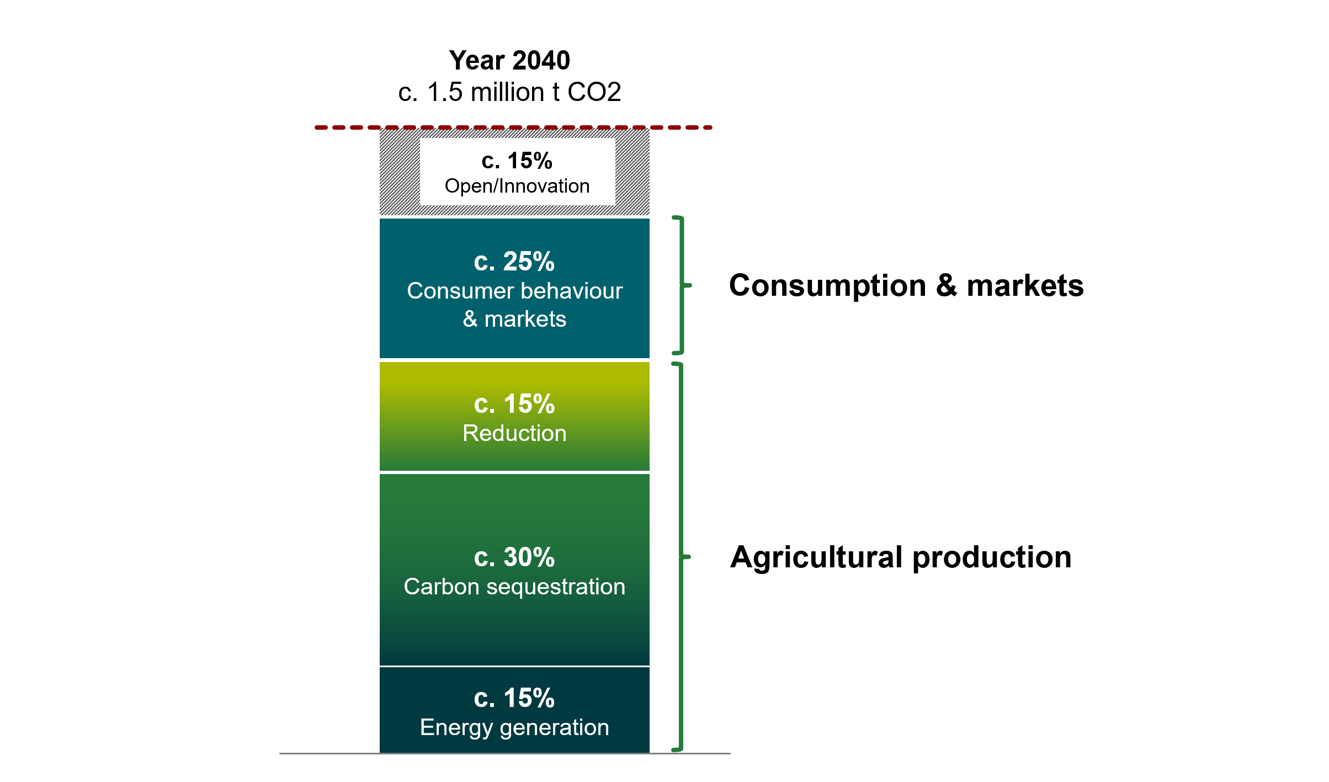
Figure 1: A possible pathway to net zero emissions in organic farming in Switzerland by 2040, including the food system.
The results of the study on pathways to carbon-neutral organic farming in Switzerland show the following:
- According to the current state of knowledge, the organic farming sector can reduce its greenhouse gas emissions by approximately 15% and offset 45% of its emissions, using the above three levers. This will require a wide range of actions and considerable effort on the part of farmers.
- Adjustments in consumer behaviour can reduce agricultural GHG emissions by a further 25%. This requires in particular a lower consumption of livestock-based foods by following the recommended food pyramid diet, and reductions in food waste and food losses.
- Further innovation in agriculture and consumption is also needed by 2040 to achieve the remaining 15% of the target.

It must be emphasised that net zero is particularly challenging in agriculture in general and in organic agriculture in particular. This is mainly due to the fact that the biological and chemical processes underlying agricultural production inevitably lead to GHG emissions: Soils in receipt of nitrogenous fertilisers inevitably emit nitrous oxide and cattle emit methane during digestion. Unlike in the energy sector, where in principle a decarbonisation pathway to renewable energy with zero emissions can be achieved (gross – without the need for offsets), this is therefore not possible in agriculture, and efforts will always be needed to offset the remaining unavoidable emissions as part of a net-zero strategy. Moreover, a number of other aspects, such as animal welfare, are key concerns in organic agriculture. The decision taken by Bio Suisse in autumn 2021 to ban the killing of male chicks, for example, will likely increase emissions. This makes it all the more important if net-zero targets are to be attained in agriculture that all those involved in the food system, i.e. agriculture, processing and consumption, work together in order to really exploit all opportunities for reducing avoidable emissions.
From this starting point, the study sets out possible pathways to a carbon-neutral Swiss organic farming sector, including guidance for practical action. In addition, the study compiles and critically assesses current knowledge on the key reduction and compensation actions.
- Reductions in GHG emissions
Consistent implementation of a wide range of measures would allow organic farms in Switzerland to achieve roughly a 15% reduction in GHG emissions. Farms have different options here depending on their location and enterprises. These must be taken into account in the implementation.
  - GHG emission reductions in livestock farming
The GHG emissions from the Swiss organic farming sector‘s livestock enterprises (ruminants, pigs, poultry) are estimated at 0.65 million tonnes of CO₂ equivalents. This quantity is the starting point for the reduction potential available in this sector.

Table 1: Estimated greenhouse gas emissions from the different livestock populations in t CO₂-eq per year
 | No. of animals | Enteric methane | Methane from faeces | Nitrous oxide | Totals
Small ruminants | 123’635 | 31’379 | 982 | 6’230 | 38’592
Cattle | 202’552 | 469’777 | 92’180 | 44’795 | 606’752
Pigs | 29’412 | 1’467 | 1’525 | 257 | 3’250
Poultry | 1'122’919 | 577 | 249 | 233 | 1’059
Totals |  | 505’201 | 94’936 | 51’515 | 649’652

Digestive processes in ruminants: CH₄ produced in the digestive tract of cattle accounts for the largest share of GHG emissions from the livestock sector (approx. 0.47 million t CO₂-eq.).
Under experimental conditions, feeding measures can achieve GHG emissions reductions in the order of 5 to 10%. However, most of the feeding measures that could be implemented in organic farming are associated with significant effort, land requirements for the production of feedstuffs, and considerable cost. This can compromise the cost-benefit ratio of such measures. The integration of pasture plants containing secondary ingredients (tannins, possibly essential oils) has a low reduction potential, but is easy to implement and delivers additional benefits (biodiversity, animal welfare and health, and milk quality).
Specific measures to reduce emissions at herd level include, for example, a coupling of milk and meat production, an extension of the animals’ useful life or a shortening of their unproductive life phases. Here, too, the reduction potential is around 10% of these emissions.
Dung/manure: Apart from enteric CH₄ generation, CH₄ and N₂O emissions from livestock manure are the second largest GHG source from livestock in Swiss organic agriculture (0.09 and 0.04 million t CO₂ eq., respectively). The following can contribute to reducing these emissions:

- Low-nitrogen feeding
- Short storage time
- Slurry covers/methane digesters
- Acidification of slurry
- Cool storage of manure/slurry
As the chemical processes underlying GHG emissions are very complex, only approximate estimates can be given for the reduction potential of individual measures. The total potential is estimated at around 15% of these emissions.
  - GHG emission reductions in crop production
In the soil, the greenhouse gases CO₂, N₂O and CH₄ are generated by metabolic activities of soil microorganisms. In aerated soils CH₄ is mineralised; it is emitted only in waterlogged situations and is quantitatively less relevant.
Of greater significance are the N₂O emissions: Organic farming is responsible for approximately 12% of Switzerland's agricultural N₂O emissions. The greatest reduction potential can be found in vegetable production and permanent grassland. This is due to the comparatively high amounts of nitrogen applied in organic farming. Overall, measures in crop production offer a reduction potential of between 10 and 15% of the corresponding GHG emissions.
Reactive nitrogen: Reductions in the amount of reactive nitrogen in the soil-plant system in general and improved synchronisation of N supply and N demand contribute to reducing N₂O emissions. This is helped by the following measures:
- Split slurry applications, and applying only to crops that are actively uptaking nitrogen
- Using drag-hose systems
- Growing legumes in mixtures with non-legumes
- Avoiding green manure crops that are winter-killed
- Removing crop residues with a narrow C/N ratio
- Not working wet soils.
Compaction: Soil compaction promotes the formation of N₂O and CH₄. Wet soils should not be tilled and market development towards lighter machinery should be supported.
  - GHG reductions by means of reduced energy consumption
Energy consumption and the associated emissions can be lowered by switching to the most renewable energy sources possible, reducing energy-intensive means of production and focusing on best practice in terms of energy efficiency in applications, building conversions and new acquisitions. The additional leverage provided by measures of this nature is not very significant and is estimated to be in the lower single-digit percentage range.
- Compensation by means of carbon sequestration
The permanent sequestration of organic matter is a key measure to compensate for GHG emissions from agriculture within its own sphere of influence. In the farming sector, several options are available to this end:
- Sequestration of organic matter in soil organic matter
- Incorporation of plant-based biochar
- Establishment of agroforestry systems
It is estimated that the Swiss organic farming system as a whole could sequester and thus compensate approximately 30% of its GHG emissions by means of these measures (Figure 1).
Soil organic matter (humus): The accumulation and stabilisation of soil organic matter are influenced by the following measures:
- Application of livestock farm waste
- Optimisation of crop rotations (inclusion of grass-clover leys, catch crops and undersown crops)
- Crop residue management and reduced tillage
It should be noted that soils can only store a limited amount of organic matter and this must be continuously replenished with new organic matter from livestock farm waste, crop residues and root residues. If measures are halted or the humus content in the soil is reduced due to the changing climate, gains in soil organic matter can be lost again within just a few years. Moreover, the potential to store organic matter differs between different soils. The amount that can be sequestered annually decreases as the maximum storage potential is approached. Long-term agronomic trials show that under Swiss organic conditions annual storage rates of 100 kg C per hectare and year can be achieved in the long term.
Plant-based biochar: The production and application of plant-based biochar is a promising but also cost-intensive way of removing atmospheric CO₂ and storing it profitably in soils over the long term. One tonne of biochar contains approximately 75% organic carbon and can thus compensate for about 2.7 tonnes of CO₂ equivalents. It is important that only high-quality plant-based biochar is used (certified to the EBC Standard) to avoid soils being polluted with organic and/or inorganic pollutants. Furthermore, it must be taken into account that there is not an infinite supply of wood as feedstock for pyrolysis (the manufacturing process of plant-based biochar) and wood must be sustainably extracted. Moreover, expedient biochar activation (e.g. co-composting, admixture with livestock farm waste, cascade use in livestock husbandry) must be ensured before it is landspread. The study estimates that sufficient feedstock material can be made available to apply 100 kg of carbon in the form of plant-based biochar per hectare and year on Swiss organic land over the long term.
Agroforestry: These systems offer a wide range of opportunities to store large amounts of organic matter in soils and biomass, to increase biodiversity and to better adapt agricultural production to the level of climate change which can no longer be prevented. Depending on the region and farm type, suitable agroforestry systems can be established at different intensities. In the preliminary study, we assumed that by 2040 around a quarter of Swiss organic farms will have established agroforestry systems on their land and that approximately one tonne of carbon per hectare and year can be stored in the biomass.
- Compensation by means of renewable energy generation
The farming sector has at its disposal a large amount of surfaces that can be used to install photovoltaic (PV) systems for the generation of renewable energy.
Photovoltaics: PV in particular is well applicable in Switzerland because of the country’s high number of sunshine hours. With an average roof area of 200 m² per organic farm, approximately 1% of the annual GHG emissions generated by organic farming in Switzerland could be offset by 2040.
Agri-photovoltaics: In addition to rooftops, in the near future orchards, arable land and grassland may also be possible sites, resulting in a form of dual land use referred to as agri-photovoltaic systems (APV). In addition to GHG compensation and additional income generation, APV systems deliver other positive impacts on agricultural production, especially in terms of climate change adaptation. In field trials, for example, higher yields were achieved in drought years under APV systems than outside of the systems. However, ground-mounted systems need space and alter the scenic qualities of the landscape. On the other hand, own energy production in combination with electrification and downsizing of equipment allow for further independence from external suppliers and a substantial reduction of the farms’ carbon footprint. If 7,500 ha of land on Swiss organic farms were equipped with APV, this could compensate 15% of GHG emissions. Such a step would involve approximately 3% of the agricultural area under organic management in Switzerland in 2040.
When offsetting GHG emissions through renewable energy generation, it is important to note that the offsetting performance depends directly on the CO₂ emissions load of the electricity mix used. As long as fossil fuels are used to generate the electricity, a significant amount of GHG emissions can be offset. The higher the share of renewables in the electricity mix, the less GHG emissions can be offset with APV plants.
- Climate resilience
Some of the measures, in particular the accumulation and stabilisation of soil organic matter, the establishment of agroforestry systems and the use of agri-photovoltaic systems, help to ensure that agriculture is better adapted to the predicted impacts of climate change. Thereby, in addition to mitigating climate change, these measures have other benefits that can ensure yield and supply stability in the future.
- Conclusions
Proceeding from the baseline data on organic agriculture and climate change mitigation as compiled for this study, a variety of scenarios were modelled to appraise the conditions for achieving carbon-neutral organic agriculture by 2040 and to identify the greatest challenges en route.
On-farm measures will allow for emissions reductions in the order of 15%. In addition, there is a potential to offset approximately 30% of emissions by means of carbon sequestration (soil organic carbon, plant-based biochar and agroforestry). This requires the full-coverage application of measures to increase soil organic matter and the widespread practice of agroforestry. A further 15% of emissions could be offset through the production of renewable energy (especially agri-photovoltaics). Based on these assumptions and calculations, the farming sector can contribute a total of up to 60% to target attainment (Figure 1).
A key contribution to achieving net zero GHG emissions in agricultural production must also be made on the consumer side and in the markets. The study shows that changes here can reduce emissions by about 25% (Figure 1). This would be achieved through reductions in food waste and changes in dietary habits (following the food pyramid concept), and through circular food systems. It would be accompanied by a decrease in the consumption of livestock-based foods and an increase in the consumption of organically produced plant-based foods. In this system, livestock would be primarily fed feed that does not compete directly with food production. The production of feedstuffs such as grain, soya and fodder maize would thus be greatly reduced (feed no food). Reductions in food waste and food losses would also contribute to reducing the carbon footprint. With regard to the transformation of the food system, cooperation and support for relevant structures on the part of the markets and by means of policy measures will be indispensable.
In addition, new innovations will need to be established in the agri-food sector to address the remaining 15% share needed for target attainment. Research and advisory services are called upon here to do their utmost.
The preliminary study shows that carbon-neutral organic agriculture is achievable by 2040, but that this will involve major and new challenges and all stakeholders in the entire food system will need to cooperate. However, carbon-neutral organic agriculture also offers opportunities, as consistent climate change mitigation boosts consumer confidence in the food produced in this manner. Consistent climate action will therefore contribute not only to maintaining the added value in Swiss organic farming, but also to continuously expanding it.

CO₂ equivalents (abbreviated to CO₂-eq.): The different GHGs CO₂, CH₄ and N₂O differ in their warming potential. In order to compare the radiative forcing of all GHGs and because CO₂ is by far the most important GHG across all sectors, its potential is set equal to 1. Accordingly, CH₄ has a 24-fold and N₂O a 298-fold higher potential to warm the atmosphere than CO₂. The different atmospheric lifetimes of GHGs are also taken into account in this calculation of potentials.

