Media release
Beate Huber new in the FiBL Board of Directors 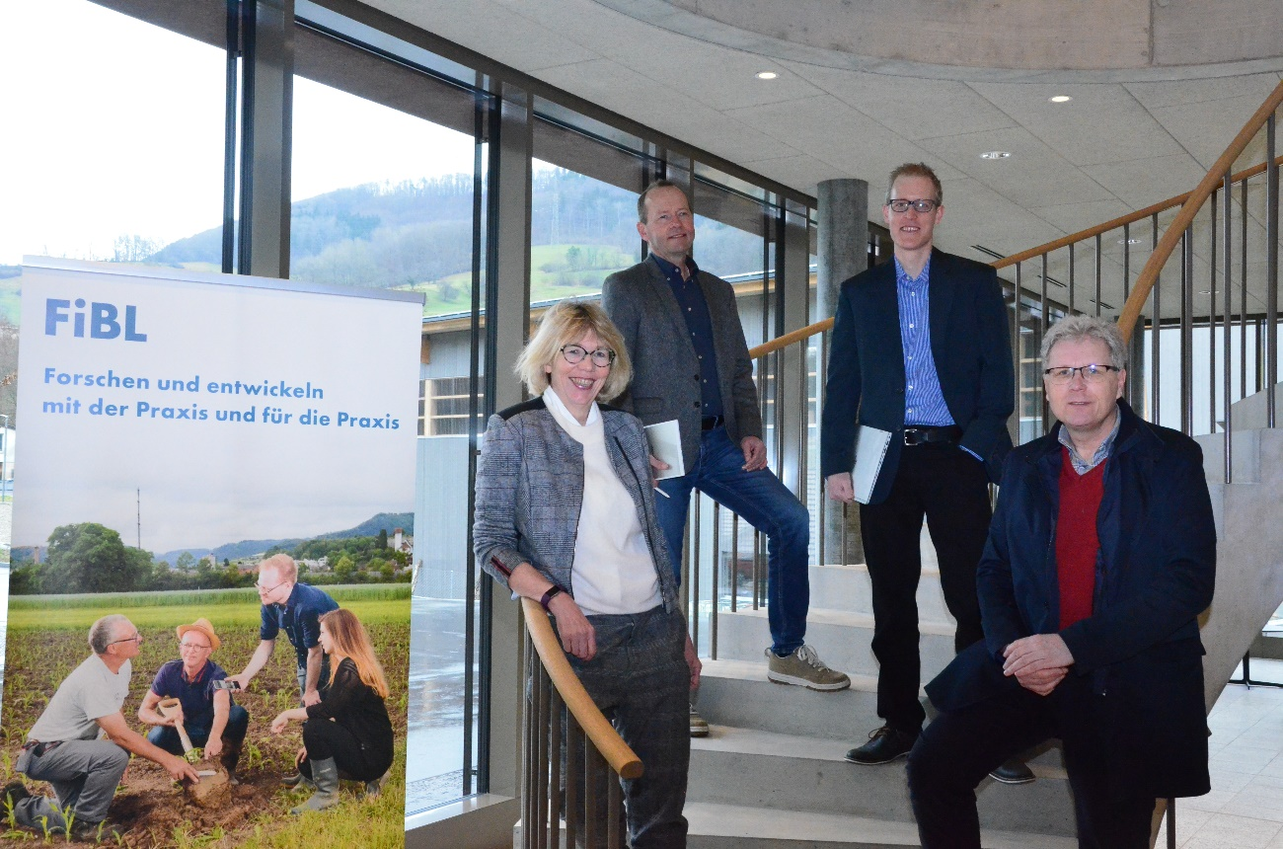
The Research Institute of Organic Agriculture FiBL announces a change in the Board of Directors: Beate Huber takes over the rotating position from Lucius Tamm, who served as Director of Cooperations in the three-member FiBL Board of Directors for the past two years. Huber heads the Department of International Cooperation and will take up her new role as Director in April 2022.
(Frick, 08.03.2022) Beate Huber has been at FiBL since 2002, she was appointed to the Executive Board in 2009 as Head of the Department of International Cooperation, she is President of FiBL Europe and was Deputy Director of FiBL Switzerland from 2017 to 2020. She has supported the Board of Directors in matters of corporate culture for the past two years, during which time she has always been in close exchange with the tripartite board and therefore knows what to expect in her new role: "I am very much looking forward to the new challenge as Director at FiBL Switzerland. The high level of identification of our staff with FiBL, our innovative strength and the healthy and stable growth of the institute are cornerstones of our corporate culture, which I would like to further strengthen," explains Huber. She is also keen to anchor FiBL even more firmly internationally. The previous management was very pleased with Huber's unanimous nomination by the Executive Board, and the Foundation Council has placed its trust in her: "We are convinced that Beate will be the ideal addition to the management team and will make a valuable contribution with her many years of international experience and her open nature," explains Foundation Council President Martin Ott.
Innovative management model has proven its worth
On April 1, 2020, Knut Schmidtke, Marc Schärer and Lucius Tamm took over the management of FiBL Switzerland as a broad and competent team with an innovative and dynamic management model. While Schmidtke (Director of Research, Extension and Innovation) and Schärer (Director of Finance, Resources and Administration) took up their duties as permanent members of the Board of Directors, Tamm assumed the rotational position as Director of Cooperations. This position is always filled by a head of a department at FiBL Switzerland in order to keep the departments well anchored in the management. This model has proved its worth over the past two years, and together the Board of Directors has successfully led FiBL through a period of change - with major challenges such as the Corona pandemic, the new building at the Frick site, and the institute's strong growth phase.
Tamm, head of the Department of Crop Sciences, was exceptionally committed to the expansion and development of FiBL as part of his directorship. Now that he has successfully completed his work in the Board of Directors, he will be able to devote more time to his department again: "I am delighted that I will now have more time again to devote to my passion, research, and to working with my colleagues in the Department of Crop Sciences". Director collegue Schmidtke emphasizes that Tamm's high reputation in research, his experience and his winning personality have left a strong mark on FiBL: "We are extremely grateful to Lucius Tamm for his great commitment and the extremely successful collaboration in the Board of Directors. He made a significant contribution to the forward-looking development of the institute and will continue to do so as a member of the Executive board."
Now, in line with the rotation principle, Tamm will hand over his position in the Directorate to his successor Beate Huber on April 1, 2022, as planned. Tamm will continue to be a member of FiBL's Executive Board as Head of the Department of Crop Sciences.
Contacts
- Seraina Siragna, Head of Corporate Communication and media spokesperson, FiBL Switzerland, Phone +41 62 865 63 90, e-mail seraina.siragna@fibl.org
This media release online
This media release can be accessed online at www.fibl.org/en/info-centre/media.html.

Pictures
You can access the pictures with the following link https://biomedia.picturepark.com/s/DbwXBntR.
About FiBL
The Research Institute of Organic Agriculture FiBL is one of the world's leading research institutions in the field of organic agriculture. FiBL's strengths are interdisciplinary research, joint innovations with farmers and the food industry as well as rapid knowledge transfer. The FiBL Group currently includes FiBL Switzerland (founded in 1973), FiBL Germany (2001), FiBL Austria (2004), ÖMKi (Hungarian Research Institute of Organic Agriculture, 2011), FiBL France (2017) and FiBL Europe (2017), which is jointly supported by the five national institutes. Around 280 employees work at the various locations. www.fibl.org

