Media release 17 February 2021
Global organic area continues to grow
Over 72.3 million hectares of farmland are organic
The latest data on organic farming worldwide will be presented by the Research Institute of Organic Agriculture FiBL and IFOAM – Organics International at BIOFACH, the world’s leading trade fair for organic food. The statistics yearbook “The World of Organic Agriculture” will be launched on Wednesday, 17 February 2021, from 4 to 4.45 pm (CET) at this year’s digital edition of BIOFACH eSpecial 2021.
(Frick, 17 February 2021) According to the latest FiBL survey on organic agriculture worldwide, organic farmland increased by 1.1 million hectares, and organic retail sales continued to grow, as shown by the data from 187 countries (data as of the end of 2019). The 22nd edition of the study “The World of Organic Agriculture” published by FiBL and IFOAM – Organics International shows a continuation of the positive trend seen in the past years. This annual survey on organic agriculture worldwide is supported by the Swiss State Secretariat for Economic Affairs (SECO), the International Trade Centre (ITC), the Sustainability Fund of Coop Switzerland and NürnbergMesse, the organizers of the BIOFACH fair.
The global organic market continues to grow
The global market for organic food reached 106 billion euros in 2019. The United States is the leading market (44.7 billion euros), followed by Germany (12.0 billion euros) and France (11.3 billion euros). In 2019, many major markets continued to show strong growth rates; for example, the French market increased by more than 13 percent. Danish and Swiss consumers spent the most on organic food (344 and 338 euros per capita, respectively). Denmark had the highest organic market share, with 12.1 percent of its total food market.
3.1 million organic producers worldwide
In 2019, 3.1 million organic producers were reported. India continues to be the country with the highest number of producers (1’366’000), followed by Uganda (210’000), and Ethiopia (204’000). The majority of small-scale producers are certified in groups based on an internal control system.
Steady increase of organic farmland
A total of 72.3 million hectares were organically managed at the end of 2019, representing a growth of 1.6 percent or 1.1 million hectares compared to 2018. Australia has the largest organic agricultural area (35.7 million hectares), followed by Argentina (3.7 million hectares), and Spain (2.4 million hectares). Due to the large area of organic farmland in Australia, half of the global organic agricultural land is in Oceania (36.0 million hectares). Europe has the second largest area (16.5 million hectares), followed by Latin America (8.3 million hectares). The organic area increased in all continents compared to 2018, except in Asia (mainly due to a drop in organic farmland reported from China) and Oceania.
Ten percent or more of the farmland is organic in 16 countries
Globally, 1.5 percent of farmland is organic. However, many countries have far higher shares. The countries with the largest organic share of their total farmland are Liechtenstein (41.0 percent), Austria (26.1 percent) and São Tomé and Príncipe (24.9 percent). Some states in India are or aspire to be 100 % organic in the coming years. In sixteen countries, 10 percent or more of all agricultural land is organic.
Global organic statistics show ongoing engagement with transparency in the organic sector
“The global organic statistics have proven useful for international development cooperation programs and supporting strategies for organic agriculture and markets, and they are crucial for monitoring the impact of these activities. This publication shows our ongoing engagement with transparency in the organic sector”, says Louise Luttikholt, IFOAM – Organics International Executive Director. Knut Schmidtke, Director of Research, Extension & Innovation of FiBL Switzerland, adds “The yearbook is an outstanding reflection of the level of trust people around the world have in organic agriculture and its importance for nutrition, the environment and sustainable development.”
COVID-19 has resulted in a significant increase in demand for organic products in many countries but also challenges: “We expect to see the effect of the pandemic on the development of the sector with the 2020 data to be ready in a year’s time”, says Helga Willer, who is in charge of the yearbook at FiBL.

More information
“The World of Organic Agriculture” – How to order/download
The book can be ordered (30 euros + postage; affiliates of IFOAM – Organics International: 20 euros) or downloaded at shop.fibl.org (order number 1150). Graphs and infographics can be downloaded at www.organic-world.net/yearbook/yearbook-2021.html.
Book citation
Willer, Helga, Jan Trávníček, Claudia Meier, Bernhard Schlatter (Eds.) (2021): The World of Organic Agriculture. Statistics and Emerging Trends 2021. Research Institute of Organic Agriculture FiBL, Frick, and IFOAM – Organics International, Bonn. Available at www.organic-world.net/yearbook/yearbook-2021.html.
Online database
Tables and interactive infographics with details on crops, markets, and international trade, as well as explanations about the data can be found on FiBL’s statistics website statistics.fibl.org.
Contacts
- Dr. Helga Willer, FiBL, Ackerstrasse 113, 5070 Frick, Switzerland
Phone +41 (0)79 218 06 26, helga.willer@fibl.org, www.fibl.org
- Louise Luttikholt, IFOAM – Organics International, Charles-de-Gaulle-Strasse 5, 53113 Bonn, Germany
Phone +49 (0)1575 769 11 01, l.luttikholt@ifoam.bio, www.ifoam.bio
Programme of the session “The World of Organic Agriculture – Statistics and Emerging Trends” at BIOFACH eSPECIAL 2021
Wednesday, 17 February 2021, 4:00 to 4:45 pm (CET), Livestream 3
- Louise Luttikholt, IFOAM – Organics International, Moderator
- Barbara Jäggin, Swiss State Secretariat for Economic Affairs (SECO)
- Dr. Helga Willer, FiBL: Latest data on organic agriculture worldwide
- Cornelia Kirchner, IFOAM – Organics International: Standards and regulations
- Amarjit Sahota, Ecovia Intelligence, UK: The global market for organic food
More information at https://www.biofach.de/en/biofach-congress/programme.

Statistics sessions at the BIOFACH eSPECIAL 2021 at a glance
Wednesday, 17 February 2021
- The World of Organic Agriculture
4 to 4.45 pm, Livestream 3
- The European market for organic food
5 to 6 pm, Livestream 5
Thursday, 18 February 2021
- Global Organic Market Overview – facts, trends and opportunities
2 to 3.30 pm, Livestream 3
Supporters of the yearbook “The World of Organic Agriculture”
- Swiss State Secretariat for Economic Affairs (SECO), Berne, Switzerland, https://www.seco.admin.ch
- International Trade Centre (ITC), Geneva, Switzerland, http://www.intracen.org
- Coop Sustainability Fund, Coop, Basel, Switzerland,
https://www.actions-not-words.ch/en.html
- NürnbergMesse, the organizers of the BIOFACH fair, Nuremberg, Germany, https://www.nuernbergmesse.de/
This media release online
This media release and graphs can be accessed online at https://www.fibl.org/en/info-centre/media.html.
About FiBL
The Research Institute of Organic Agriculture FiBL is one of the world’s leading institutes in the field of organic agriculture. FiBL’s strengths lie in its interdisciplinary research, innovations developed jointly with farmers and the food industry, and rapid knowledge transfer. FiBL employs some 300 staff at its various locations.
www.fibl.org

Yearbook "The World of Organic Agriculture" at a glance
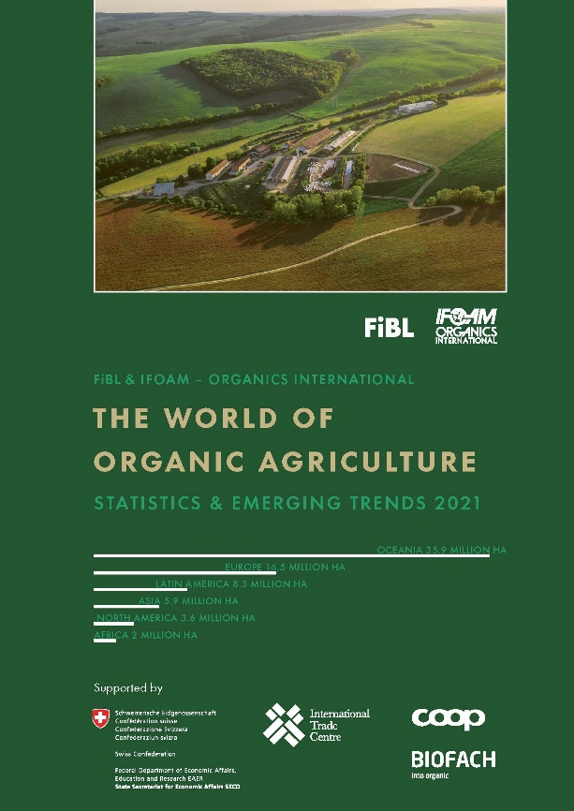
About "The World of Organic Agriculture"
The yearbook (336 pages) presents the results of the annual survey on organic agriculture worldwide and has numerous tables, graphs, maps and infographics. Furthermore, it contains reports authored by experts on the organic sector and emerging trends in all regions and selected countries. In addition, background information on standards and legislation, policy support, and the global market for organic food is provided. Further information and download are available at www.organic-world.net/yearbook/yearbook-2021.html.
Data collection
The data on organic agriculture is collected annually by FiBL in collaboration with various partners from around the world.
The results are published jointly with IFOAM – Organics International. The activities are supported by SECO, ITC, the Coop Sustainability Fund, and NürnbergMesse, the organizers of the BIOFACH fair.
Book citation
Willer, Helga, Jan Trávníček, Claudia Meier, Bernhard Schlatter (Eds.) (2021): The World of Organic Agriculture. Statistics and Emerging Trends 2021. Research Institute of Organic Agriculture (FiBL), Frick, and IFOAM – Organics International, Bonn. Available at www.organic-world.net/yearbook/yearbook-2021.html.
“The World of Organic Agriculture” – How to order/download
The book can be ordered (30 Euros + postage; affiliates of IFOAM – Organics International: 20 Euros) or downloaded at shop.fibl.org (order number 1150).
Online database
The data is available online at statistics.fibl.org.
Organic Agriculture: Key Indicators and Top Countries 2019
Indicator | World | Top countries
Countries with organic activities | 2019: 187 countries
Organic agricultural land | 2019: 72.3 million hectares  (1999: 11 million hectares) | Australia (35.7 million hectares)  Argentina (3.7 million hectares)  Spain (2.4 million hectares)
Organic share of total agricultural land | 2019: 1.5 % | Liechtenstein (41.0 %)  Austria (26.1 %)  São Tomé and Príncipe (24.9 %)
Wild collection and further non-agricultural areas | 2019: 35.1 million hectares  (1999: 4.1 million hectares) | Finland (4.6 million hectares)  Zambia (3.2 million hectares)  Namibia (2.6 million hectares)
Producers | 2019: 3.1 million producers  (1999: 200’000 producers) | India (1'366'226)  Uganda (210’353)  Ethiopia (203'602)
Organic market | 2019: 106.4 billion euros  (2000: 15.1 billion euros) | US (44.7 billion euros)  Germany (12.0 billion euros)  France (11.3 billion euros)
Per capita consumption | 2019: 14.0 euros | Denmark (344 euros)  Switzerland (338 euros)  Luxembourg (265 euros)
Number of countries with organic regulations | 2019: 108 countries
Number of affiliates of IFOAM – Organics International | 2020: 719 affiliates | Germany: 79 affiliates  India: 52 affiliates  USA: 48 affiliates  Italy: 46 affiliates
Source: FiBL survey 2021, based on national data sources, data from certifiers and IFOAM – Organics International
Infographics
