Media release
International FiBL cotton project honoured with research prize
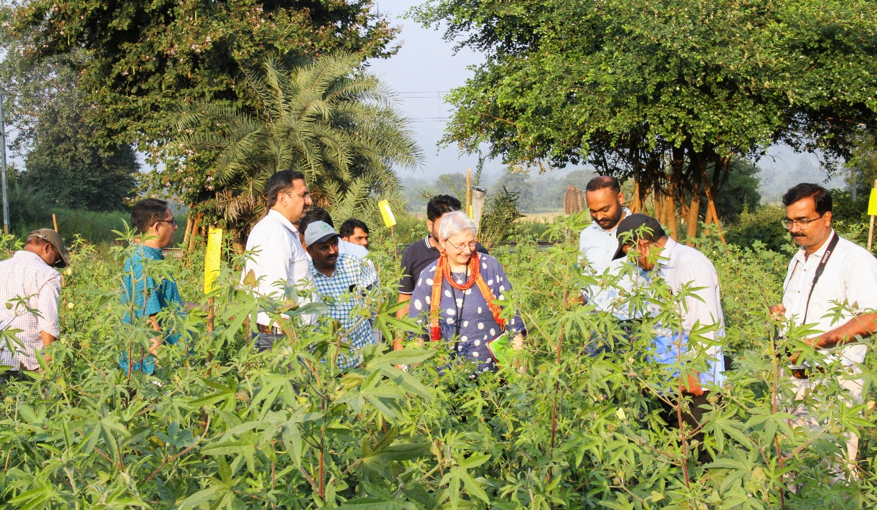
The FiBL project Green Cotton/Seeding the Green Future of the Department of International Cooperation was presented with the SFIAR Award. At the award ceremony on 15 December 2021, Amritbir Riar, Monika Messmer and Tanay Joshi were honoured for their achievements in the project and their commitment across the entire organic cotton value chain in India.
(Frick, 16.12.2021) The Swiss Forum for International Agricultural Research (SFIAR) offers an annual award for graduates and scientists from a Swiss institution active in agricultural research for development. At yesterday's digital award ceremony, Amritbir Riar, Monika Messmer, Tanay Joshi and their partners in India won the SFIAR Team Award for their project Green Cotton/Seeding the Green Future.
The Green Cotton/Seeding the Green Future project began in 2013 and works to close gaps in India’s organic cotton value chain. Local traders hardly offer GMO-free cotton seeds anymore, which endangers smallholder farmers' income security and seed sovereignty. Therefore, the project aims to expand the supply of robust, genetically unmodified seed. Eight varieties are already being grown on an experimental basis. "We are building on the experience of the first phase of the introduction of participatory cotton breeding (Green Cotton) and initiating further participatory breeding programmes in India in order to be able to close the seed gap and secure the seed supply chain for organic cotton farmers", explains Monika Messmer, project initiator and expert in plant breeding at FiBL.
Amritbir Riar from the Department of International Cooperation at FiBL and project leader is delighted about winning the SFIAR Team Award: "This award means a lot to us. The project directly supports smallholder farmers in India and strongly involves them in the research. The transdisciplinary approach along the entire organic cotton value chain makes the project not only unique but also so successful."
Michaela Kuhn was also awarded the SFIAR prize for her Master's thesis, "A Gendered Analysis of Small-Scale Cocoa Production in Uganda", co-supervised by FiBL scientist Lina Tennhardt.
FiBL contacts
- Amritbir Riar, Department of International Cooperation, project leader Green Cotton/Seeding the Green Future, FiBL Switzerland
Phone +41 62 865 72 88, e-mail amritbir.riar@fibl.org
- Monika Messmer, Department of Crop Sciences, project initiator Green Cotton/Seeding the Green Future, FiBL Switzerland
Phone +41 62 865 04 43, e-mail monika.messmer@fibl.org
- Jannick Scherrer, Corporate Communication, FiBL Switzerland
Phone +41 62 865 04 73, e-mail jannick.scherrer@fibl.org
Supporters
- Stiftung Mercator Schweiz
- Foundation OCA (Organic cotton Accelerator), Netherlands
Project partner Seeding the Green Future
- Pratibha Syntex
- Chetna Organic
- CottonConnect
- Action for Social Advancement
- RVSKV Gwalior
- PDKV Akola
- Center for Sustainability
Project partner Green Cotton
- bioRe Association India
- Chetna Organic
- University of Agricultural Science Dharwad
Links
- fibl.org: Green Cotton project website
- fibl.org: Seeding the Green Future project website
- greencotton.org: Green Cotton website
- sgf-cotton.org: Seeding the Green Future website
- sfiar.ch: SFIAR (Swiss Forum for Agricultural Research) website
- sfiar.ch: SFIAR Award
Video
- youtube.com: In the video "Participatory breeding to secure income of organic cotton farmers in India", Amritbir Riar gives an insight into the project and talks about its current status.
This media release online
This media release and pictures can be accessed online at www.fibl.org/en/info-centre/media.html.
About FiBL
The Research Institute of Organic Agriculture FiBL is one of the world's leading research institutions in the field of organic agriculture. FiBL's strengths are interdisciplinary research, joint innovations with farmers and the food industry as well as rapid knowledge transfer. The FiBL Group currently includes FiBL Switzerland (founded in 1973), FiBL Germany (2001), FiBL Austria (2004), ÖMKi (Hungarian Research Institute of Organic Agriculture, 2011), FiBL France (2017) and FiBL Europe (2017), which is jointly supported by the five national institutes. Around 280 employees work at the various locations. www.fibl.org

