Press Release

Zürich/Frick, 10 April 2019

Organic farming drives sustainability in global agriculture
Organic farming is an important role model for changing the current agriculture and food system, argue eleven international experts in the renowned scientific journal Nature Sustainability. They call for coherent policies that support sustainable food systems, incentivize better farming practices, and raise the bar of what is acceptable in farming in the 21st century.
There is broad consensus that the way food is produced and consumed urgently needs to change. Only then can global challenges such as climate change, biodiversity loss and poverty be addressed. However, the approach to achieving this is heavily contested: Is it more promising to make mainstream agriculture gradually more sustainable, or to promote alternative systems like organic farming? According to the experts, both approaches can go hand-in-hand and mutually reinforce each other. This new perspective allows focusing policies on the Sustainable Development Goals (SDGs) that have been adopted by all nations.
“For too long, we have been trapped in heated debates on which technology can feed the world. Transcending ideological barriers and vested interests now need to be at the top of the agenda to accelerate the necessary shift“, says lead author Frank Eyhorn from the Swiss development cooperation organization Helvetas. Co-author Adrian Muller from the Research Institute of Organic Agriculture FiBL adds “We need coherent policies to achieve sustainable food systems. We can no longer afford seemingly cheap food resulting in high environmental costs.”
A paradigm shift is already under way: The UN Food and Agriculture Organisation FAO recently recognized the role of agroecological systems, such as organic farming, in addressing the huge challenges of our current food system. Governments in Germany, Austria, India, and Kyrgyzstan, for example, are implementing policies and action plans to promote organic farming. A critical mass of scientists, farmers, policymakers, businesses, and civil society organizations will be needed for making the change towards sustainable food systems happen at scale.
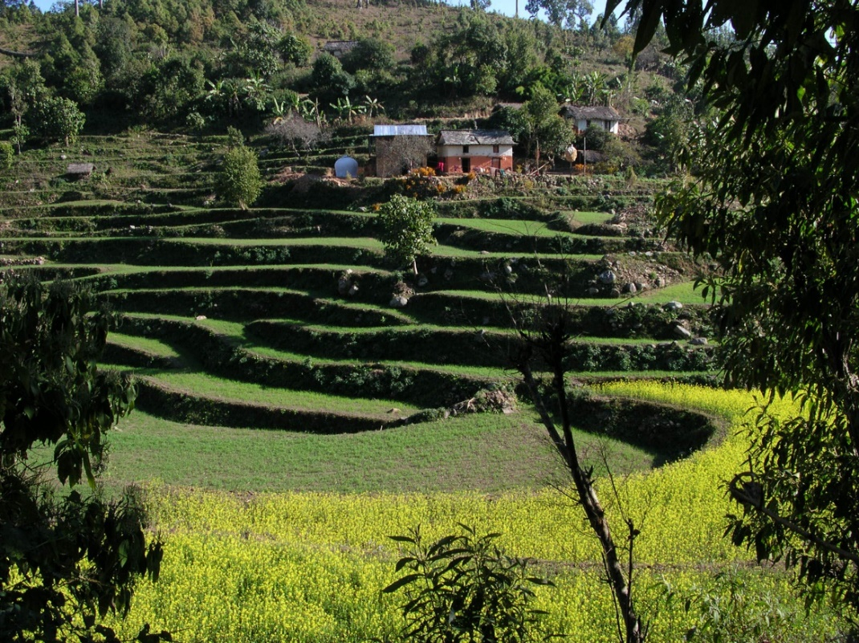
Photo caption: Sustainable agriculture for people and planet – for example at a farm in Nepal. Photo: © Helvetas

Contact:
- Frank Eyhorn, Helvetas Swiss Intercooperation, Switzerland. Phone +41 44 368 65 32, e-mail frank.eyhorn@helvetas.org.
- Adrian Müller, Research Institute of Organic Agriculture FiBL, Switzerland. Phone +41 62 865 72 52, e-mail adrian.mueller@fibl.org.

Further information:
- Link to the original article “Sustainability in global agriculture driven by organic farming”, Nature Sustainability.
- Link to the Nature Sustainability Research Community blog
- Link to the Helvetas webinar page

Authors of the article:
- Frank Eyhorn, Helvetas Swiss Intercooperation, Zurich, Switzerland.
- Adrian Muller, Research Institute of Organic Agriculture FiBL, and Swiss Federal Institutes of Technology Zurich ETHZ, Switzerland.
- John P. Reganold, Washington State University, Pullman, USA.
- Emile Frison, International Panel of Experts on Sustainable Food Systems (iPES Food).
- Hans R. Herren, Millennium Institute, Washington DC, USA.
- Louise Luttikholt, IFOAM – Organics International, Bonn, Germany.
- Alexander Müller, TMG Think Tank for Sustainability, Berlin, Germany.
- Jürn Sanders, Thünen Institut, Braunschweig, Germany.
- Nadia Scialabba, TMG Think Tank for Sustainability, Berlin, Germany.
- Verena Seufert, Institute for Environmental Studies, VU University Amsterdam, The Netherlands.
- Pete Smith, University of Aberdeen, U.K.

About Helvetas
Helvetas is an independent organization for development based in Switzerland. It supports poor and disadvantaged women, men and communities in about thirty developing and transition countries, committed to bringing about real change. Helvetas is active in five working areas: water and infrastructure, skills development and education, sustainable and inclusive economies, governance and peace and environment and climate change. Helvetas engages in emergency relief, reconstruction and rehabilitation. In Switzerland, Helvetas promotes solidarity and participates in the dialogue on development policy. With its own Fairshop, the organization is also committed to fair trade. www.helvetas.org

About FiBL
The Research Institute of Organic Agriculture (FiBL) is one of the world’s leading institutes in the field of organic agriculture. FiBL’s strengths lie in its interdisciplinary research, innovations developed jointly with farmers and the food industry, and rapid knowledge transfer. FiBL employs some 300 staff at its various locations. www.fibl.org

