Media release February 14, 2018

A booming organic sector: more farmers, more land and a growing market

57.8 million hectares of organic agricultural land – the organic market grows to almost 90 billion US Dollars

The latest global data on organic farming worldwide will be presented by the Research Institute of Organic Agriculture FiBL and IFOAM – Organics International at the BIOFACH world organic trade fair 2018 in Nuremberg. The statistical yearbook “The World of Organic Agriculture” will be launched on Wednesday, February 14, 2018, from 4:00 to 4:45 pm in Hall Shanghai, NCC East.

(Frick/Nuremberg, February 14, 2018) The 2018 edition of the study “The World of Organic Agriculture” (data per end of 2016) published by FiBL and IFOAM – Organics International shows that the positive trend seen in the past years continues: Consumer demand for organic products is increasing, more farmers cultivate organically, more land is certified organic, and 178 countries report organic farming activities. The survey is supported by the Swiss State Secretariat for Economic Affairs (SECO), the International Trade Centre (ITC), and NürnbergMesse, the organizers of the BIOFACH fair.

The global organic market continues to grow

The market research company Ecovia Intelligence estimates that the global market for organic food reached 89.7 billion US dollars in 2016 (more than 80 billion euros). The United States is the leading market with 38.9 billion euros, followed by Germany (9.5 billion euros), France (6.7 billion euros), and China (5.9 billion euros). In 2016, most of the major markets continued to show double-digit growth rates, and the French organic market grew by 22 percent. The highest per capita spending was in Switzerland (274 Euros), and Denmark had the highest organic market share (9.7 percent of the total food market).

Almost three million producers worldwide

In 2016, 2.7 million organic producers were reported. India continues to be the country with the highest number of producers (835’200), followed by Uganda (210’352), and Mexico (210’000).

Organic farmland increases by 15 percent to almost 58 million hectares

A total of 57.8 million hectares were organically managed at the end of 2016, representing a growth of 7.5 million hectares over 2015, the largest growth ever recorded. Australia is the country with the largest organic agricultural area (27.2 million hectares), followed by Argentina (3 million hectares), and China (2.3 million hectares).

Almost haft of the global organic agricultural land is in Oceania (27.3 million hectares), followed by Europe (23 percent; 13.5 million hectares), and Latin America (12 percent; 7.1 million hectares).

Ten percent or more of the farmland is organic in fifteen countries

The countries with the largest organic share of agricultural land of their total farmland are the Liechtenstein (37.7 percent), French Polynesia (31.3 percent), and Samoa (22.4 percent). In fifteen countries, 10 percent or more of all agricultural land is organic, a new record.

More information

Download

“The World of Organic Agriculture” 2018 edition, graphs, and infographics can be downloaded at [www.organic-world.net/yearbook/yearbook-2018.html](http://www.organic-world.net/yearbook/yearbook-2018.html)

Online database

Tables with more details on organic land and crops, markets, and international trade, as well as explanations can be found on FiBL’s new statistics website [www.statistics.fibl.org](http://www.statistics.fibl.org)

Contacts

* Dr. Helga Willer, FiBL, Ackerstrasse 113, 5070 Frick, Switzerland  
  Phone +41 (0)79 218 06 26, [helga.willer@fibl.org](mailto:helga.willer@fibl.org), [www.fibl.org](http://www.fibl.org)
* Markus Arbenz, IFOAM – Organics International, Charles-de-Gaulle-Strasse 5, 53113 Bonn, Germany  
  Phone +49 (0)160 8041557, Fax +49 (0)228 9265099, [m.arbenz@ifoam.bio](mailto:m.arbenz@ifoam.bio), [www.ifoam.bio](http://www.ifoam.bio)

Programme of the session “The World of Organic Agriculture – Statistics and Emerging Trends”

Wednesday, February 14, 2018, 4:00 to 4:45 pm, Hall Shanghai (NCC East), NürnbergMesse, Nuremberg

* Markus Arbenz, IFOAM – Organics International, Moderator
* Barbara Jäggin, SECO, Switzerland
* Dr. Helga Willer, FiBL: Latest data on organic agriculture worldwide
* Julia Lernoud, FiBL: Latest data on Voluntary Sustainability Standards worldwide
* Beate Huber, FiBL: Standards and regulations
* Amarjit Sahota, Ecovia Intelligence, UK: The global market for organic food

More information at [www.biofach.fibl.org/en/biofach-2018.html](http://www.biofach.fibl.org/en/biofach-2018.html)

Supporters

* Swiss State Secretariat for Economic Affairs (SECO)
* International Trade Centre (ITC)
* NürnbergMesse, the organizers of the BIOFACH fair

Reference

Helga Willer and Julia Lernoud (Eds.) (2018): The World of Organic Agriculture. Statistics and Emerging Trends 2018. Research Institute of Organic Agriculture (FiBL), Frick and IFOAM – Organics International, Bonn. Available at [www.organic-world.net/yearbook/yearbook-2018.html](http://www.organic-world.net/yearbook/yearbook-2018.html)

This media release online

This media release and graphs can be accessed online at [www.fibl.org/en/media.html](http://www.fibl.org/en/media.html).

About FiBL

The Research Institute of Organic Agriculture FiBL is one of the world’s leading institutes in the field of organic agriculture. FiBL’s strengths lie in its interdisciplinary research, innovations developed jointly with farmers and the food industry, and rapid knowledge transfer. FiBL employs some 280 staff at its various locations.

* Homepage: [www.fibl.org](http://www.fibl.org)
* Video: [www.youtube.com/watch?v=U84NrJlORFc](http://www.youtube.com/watch?v=U84NrJlORFc)

Yearbook "The World of Organic Agriculture"

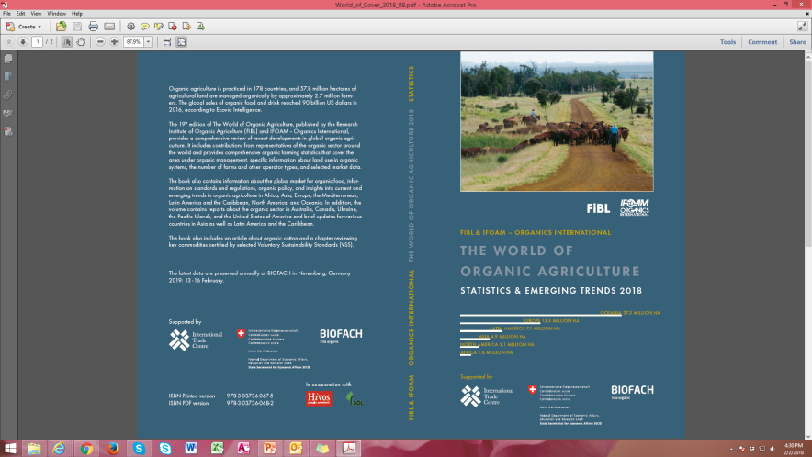About "The World of Organic Agriculture"

The study (352 pages) contains reports, authored by experts, on the organic sector and emerging trends in all regions and selected countries. The statistics are supported with graphs and tables. In addition, background information on issues such as standards and legislation, and an overview of the global market for organic food is provided. The book also contains an article about organic cotton and a chapter reviewing key commodities certified by selected Voluntary Sustainability Standards (VSS). Further information and download is available at [www.organic-world.net/yearbook/yearbook-2018.html](http://www.organic-world.net/yearbook/yearbook-2018.html).

Data collection

The data on organic agriculture is collected annually by the Research Institute of Organic Agriculture FiBL in collaboration with many partners from around the world. The results are published jointly with IFOAM – Organics International. The activities are supported by the Swiss State Secretariat for Economic Affairs (SECO), the International Trade Centre (ITC), and NürnbergMesse, the organizers of the BIOFACH fair. The views expressed in this press release can in no way be taken to reflect the official opinions of SECO, ITC, or NürnbergMesse.

Reference

Helga Willer and Julia Lernoud (Eds.) (2018): The World of Organic Agriculture. Statistics and Emerging Trends 2018. Research Institute of Organic Agriculture FiBL, Frick and IFOAM – Organics International, Bonn

Order book and download

The printed version (30 Euros + postage; affiliates of IFOAM – Organics International: 20 Euros) can be ordered at <https://shop.fibl.org/chen> (order number 1076) and <https://shop.ifoam.bio/>. In the shops as well as at [www.organic-world.net/yearbook/yearbook-2018.html](http://www.organic-world.net/yearbook/yearbook-2018.html), the book is available for download.

Online databases

The data is available online at **statistics.fibl.org**

Pick up your copy at BIOFACH in Hall 1, Stands 1-553 (FiBL) and 1-451 (IFOAM – Organics International)

Key indicators

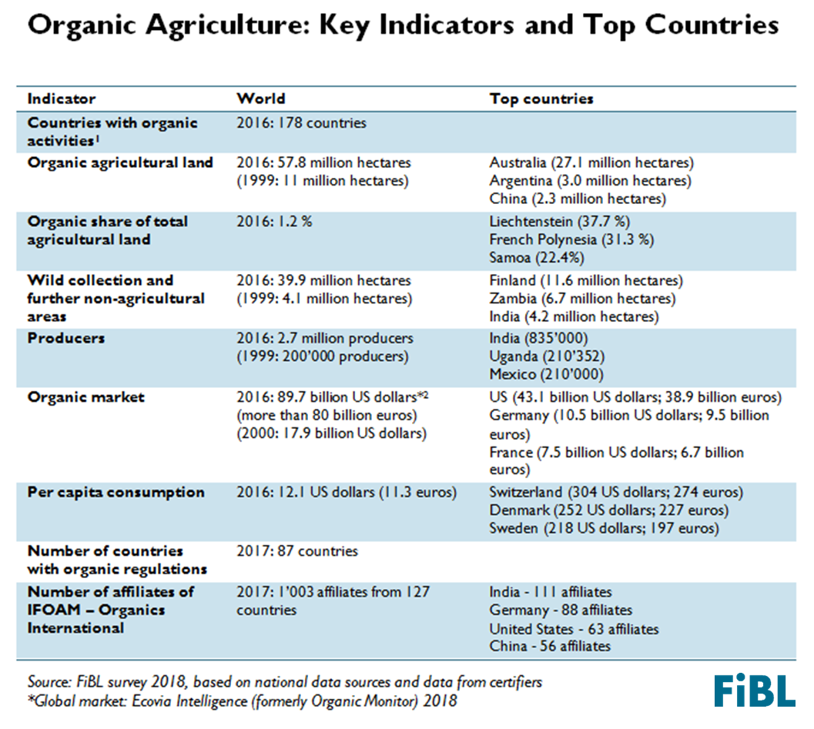

[1]

Graphs

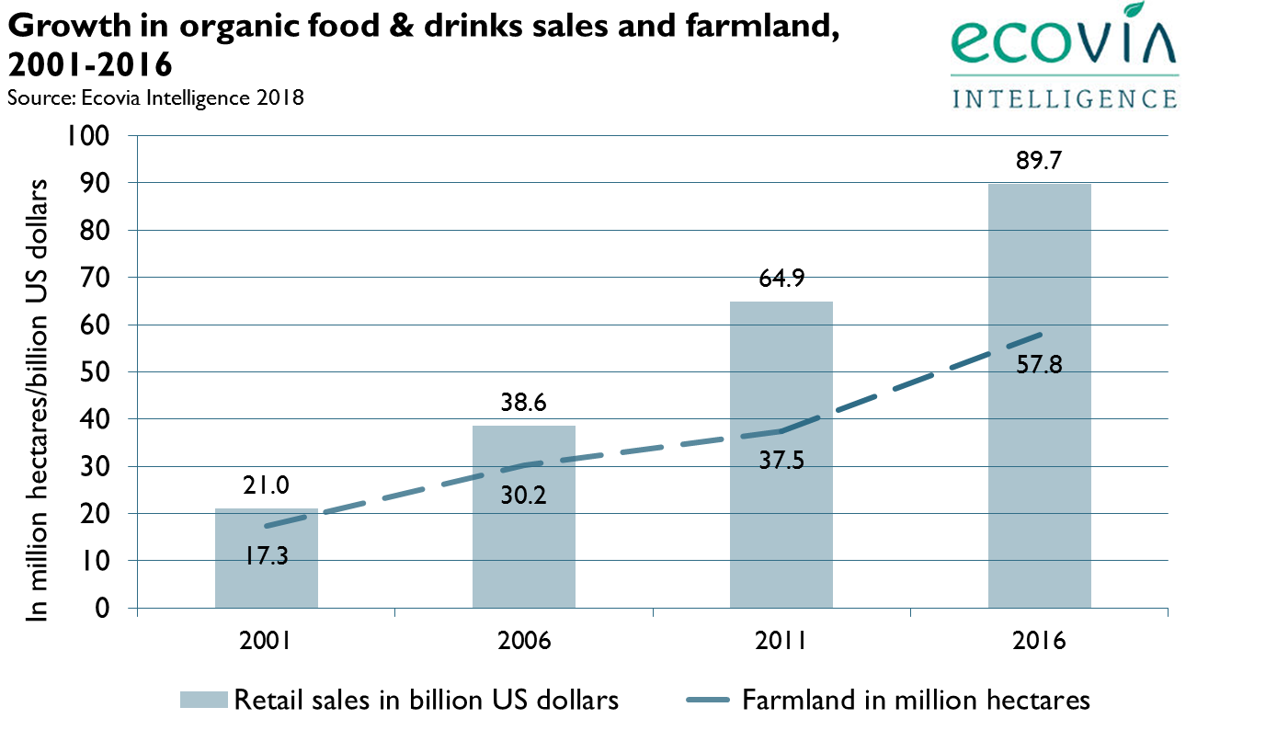

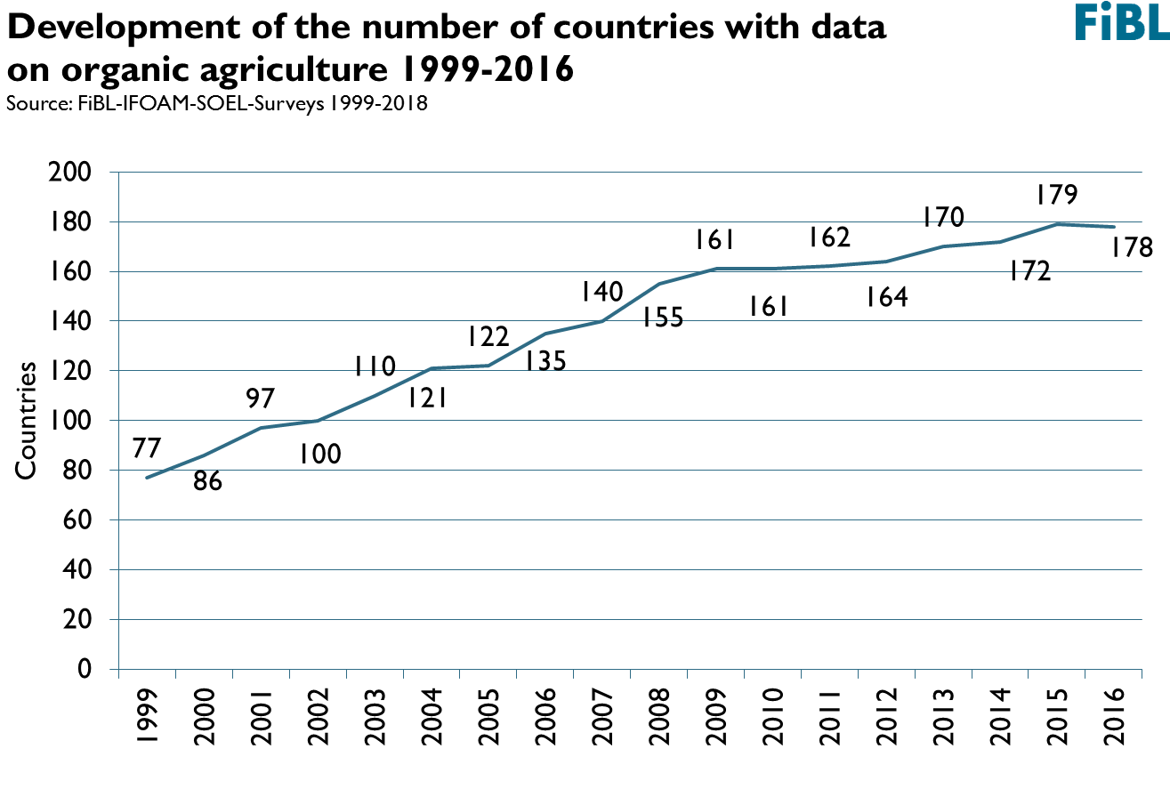





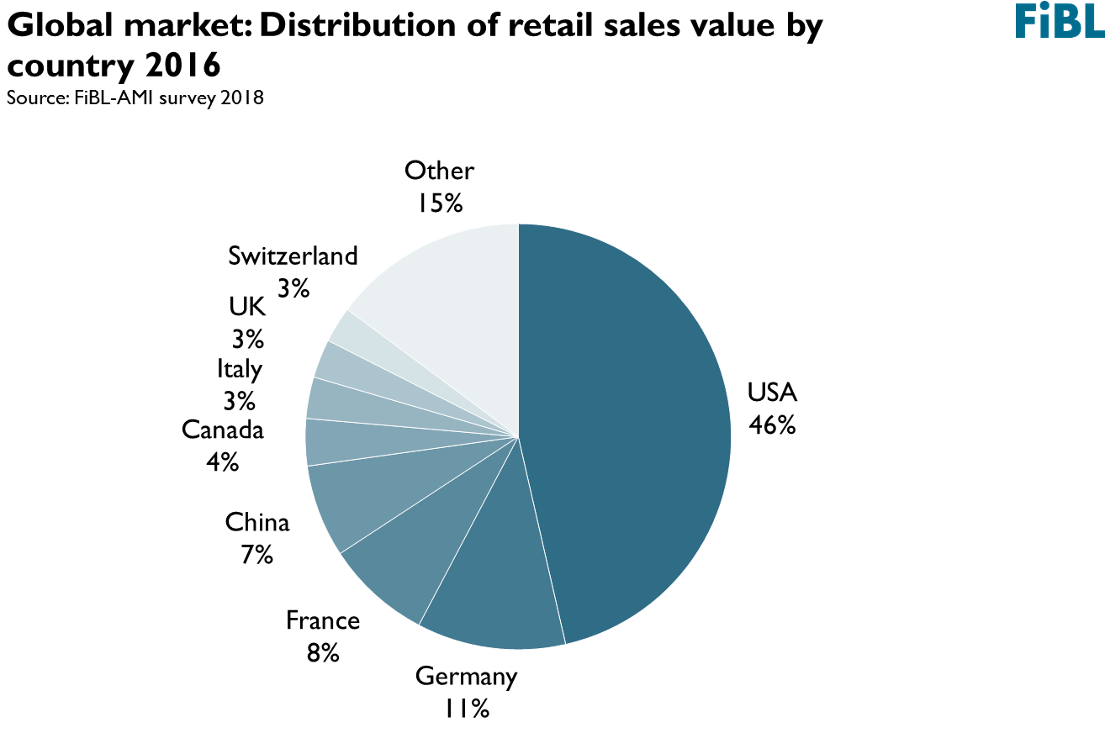

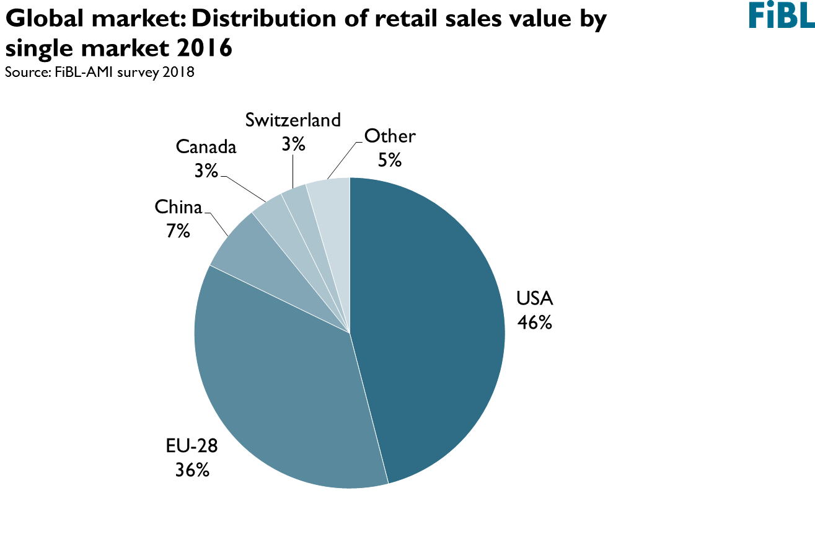



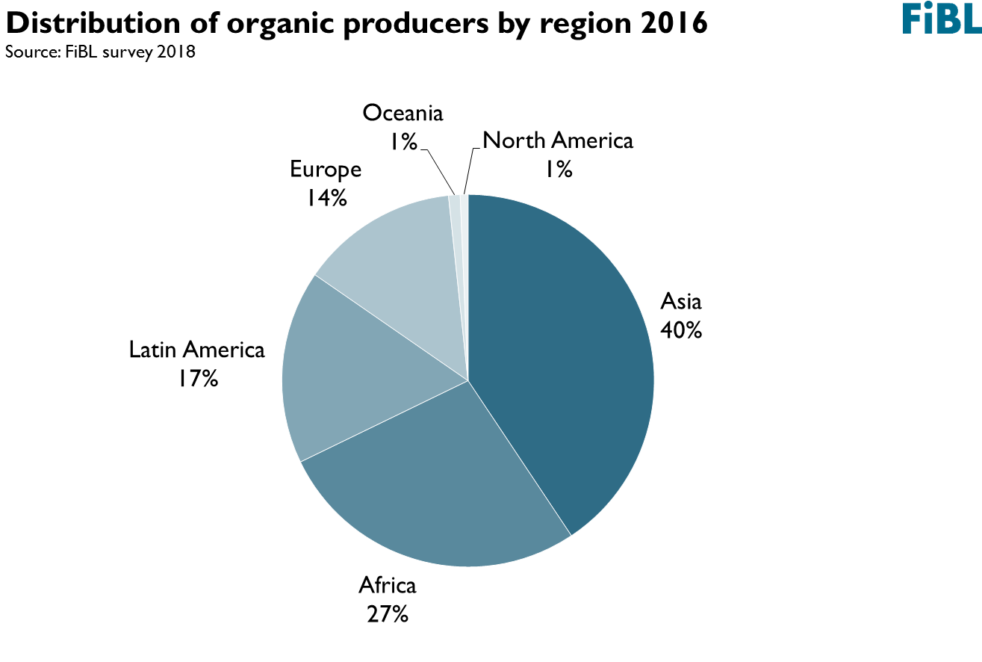

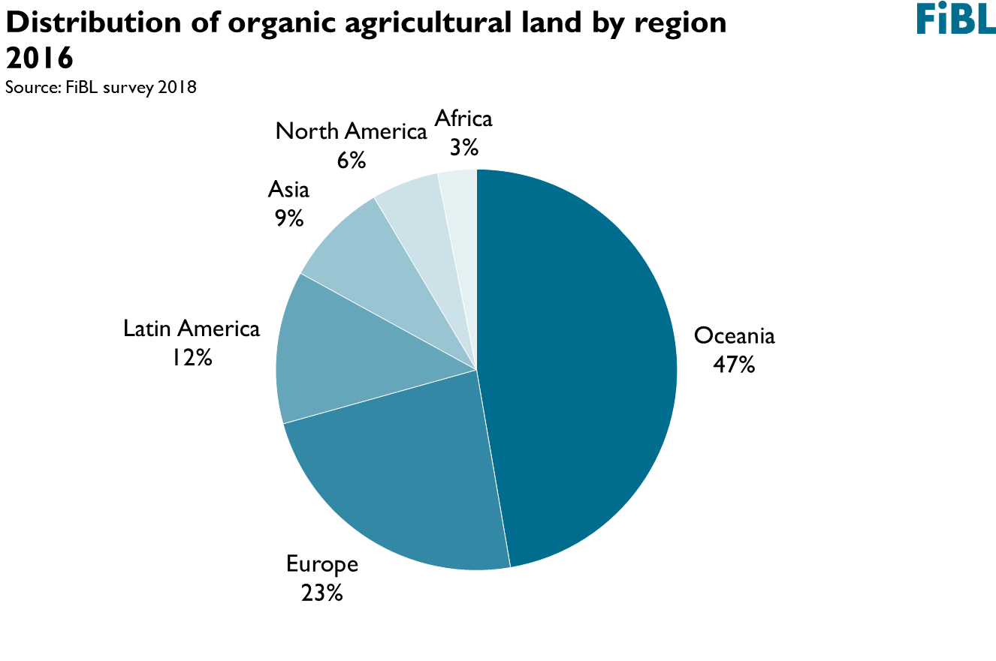



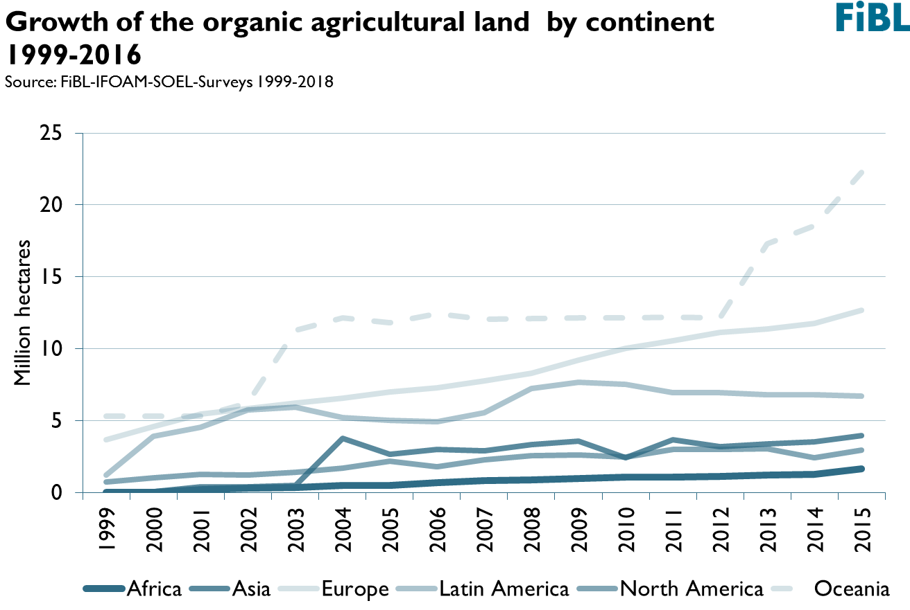

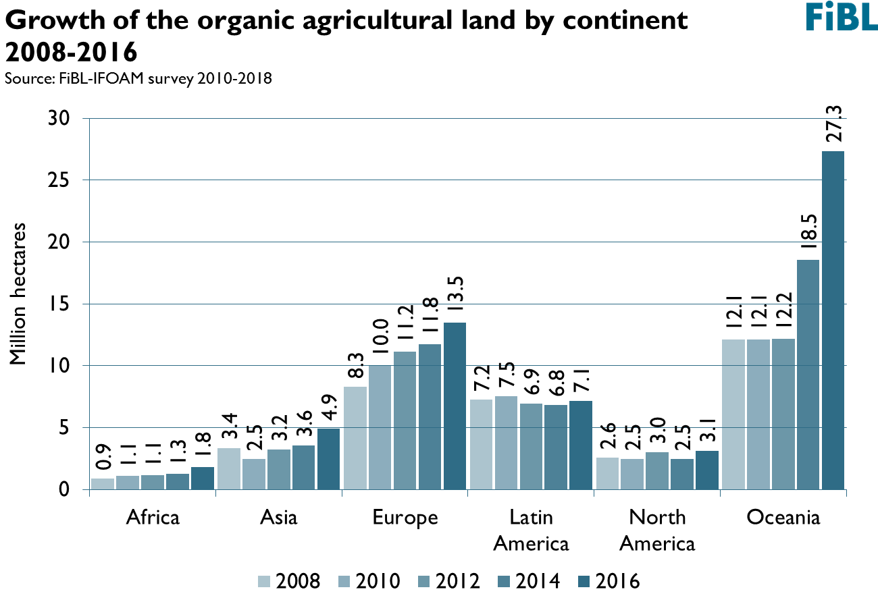





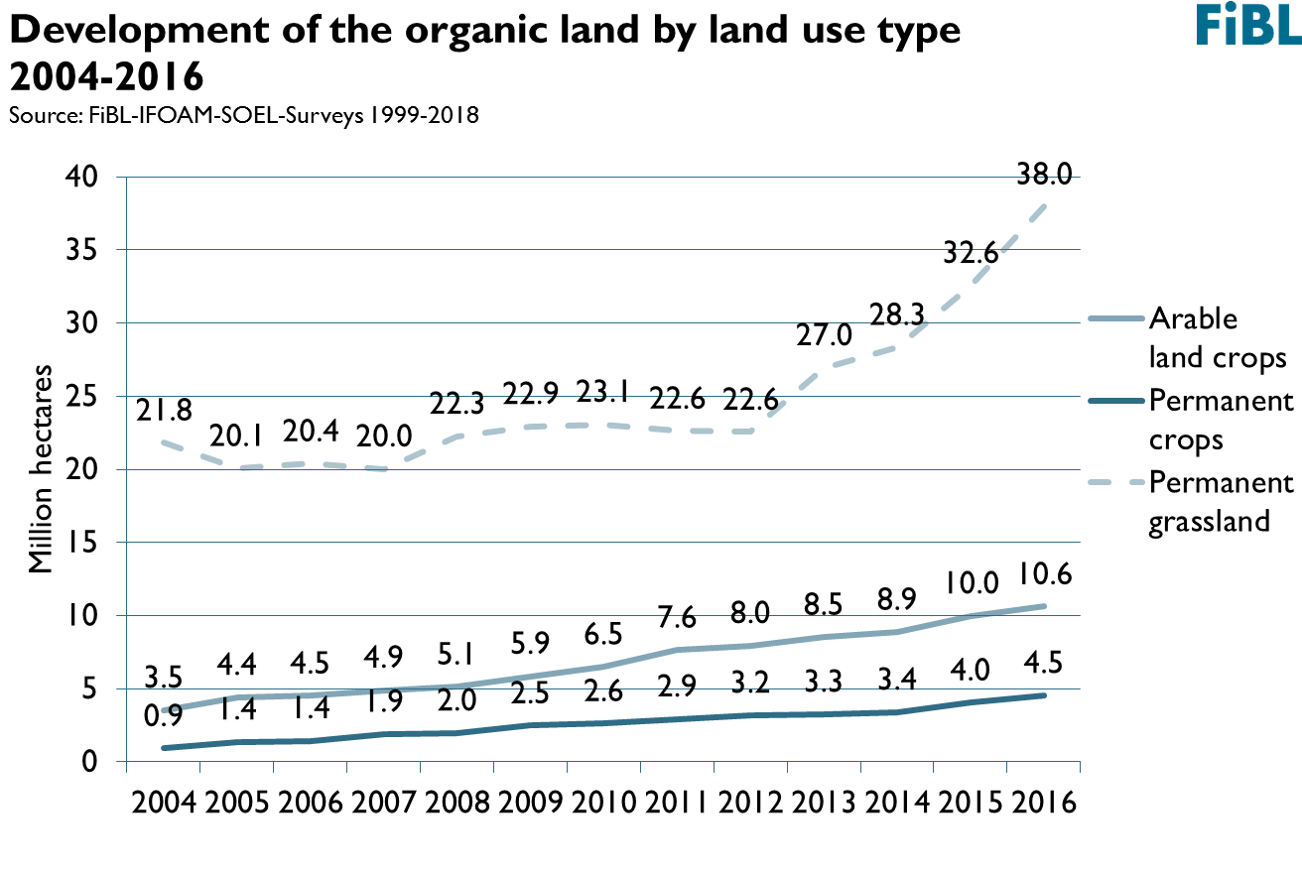

Infographics

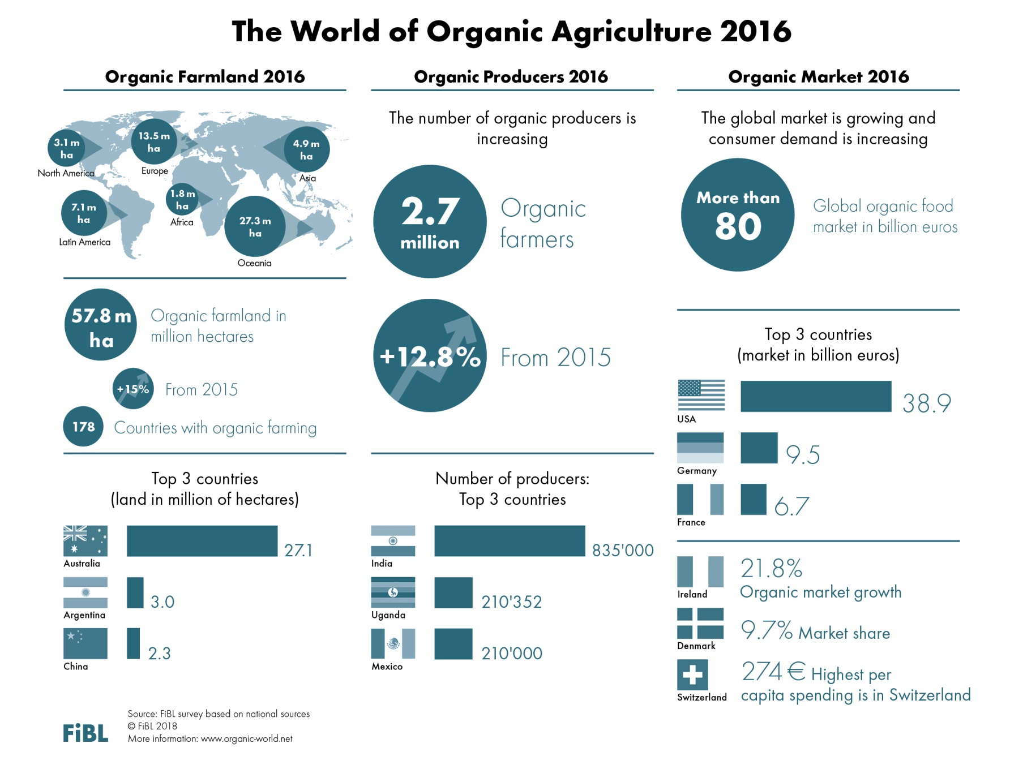

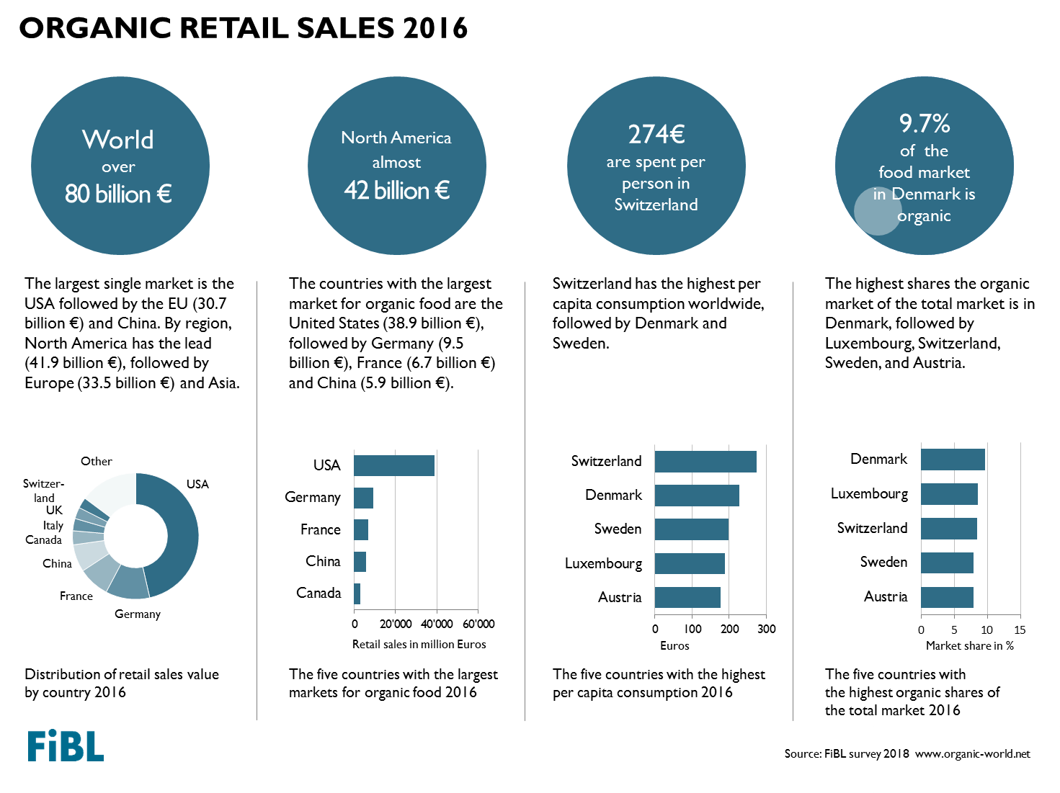

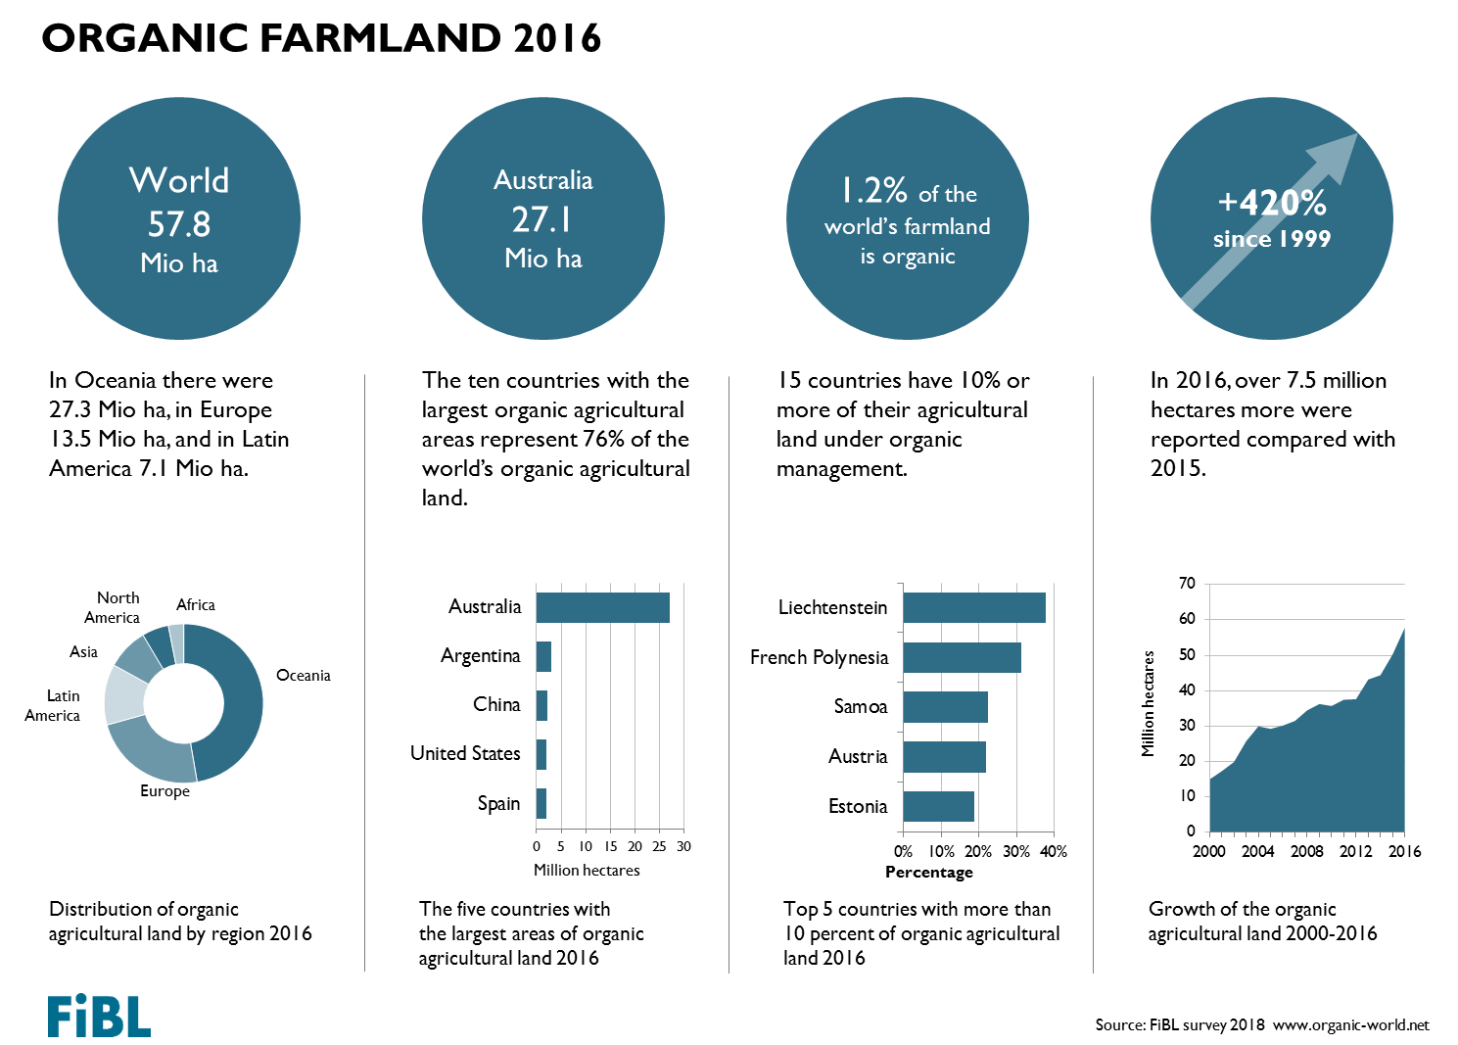

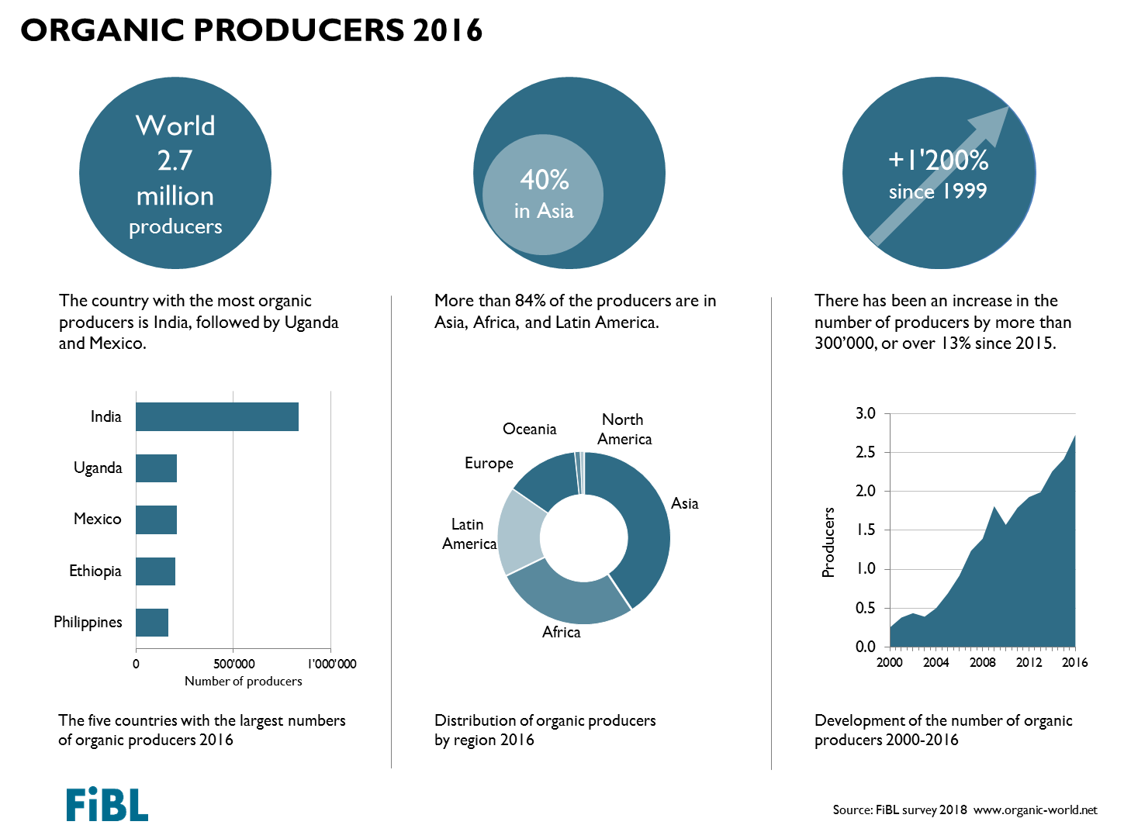

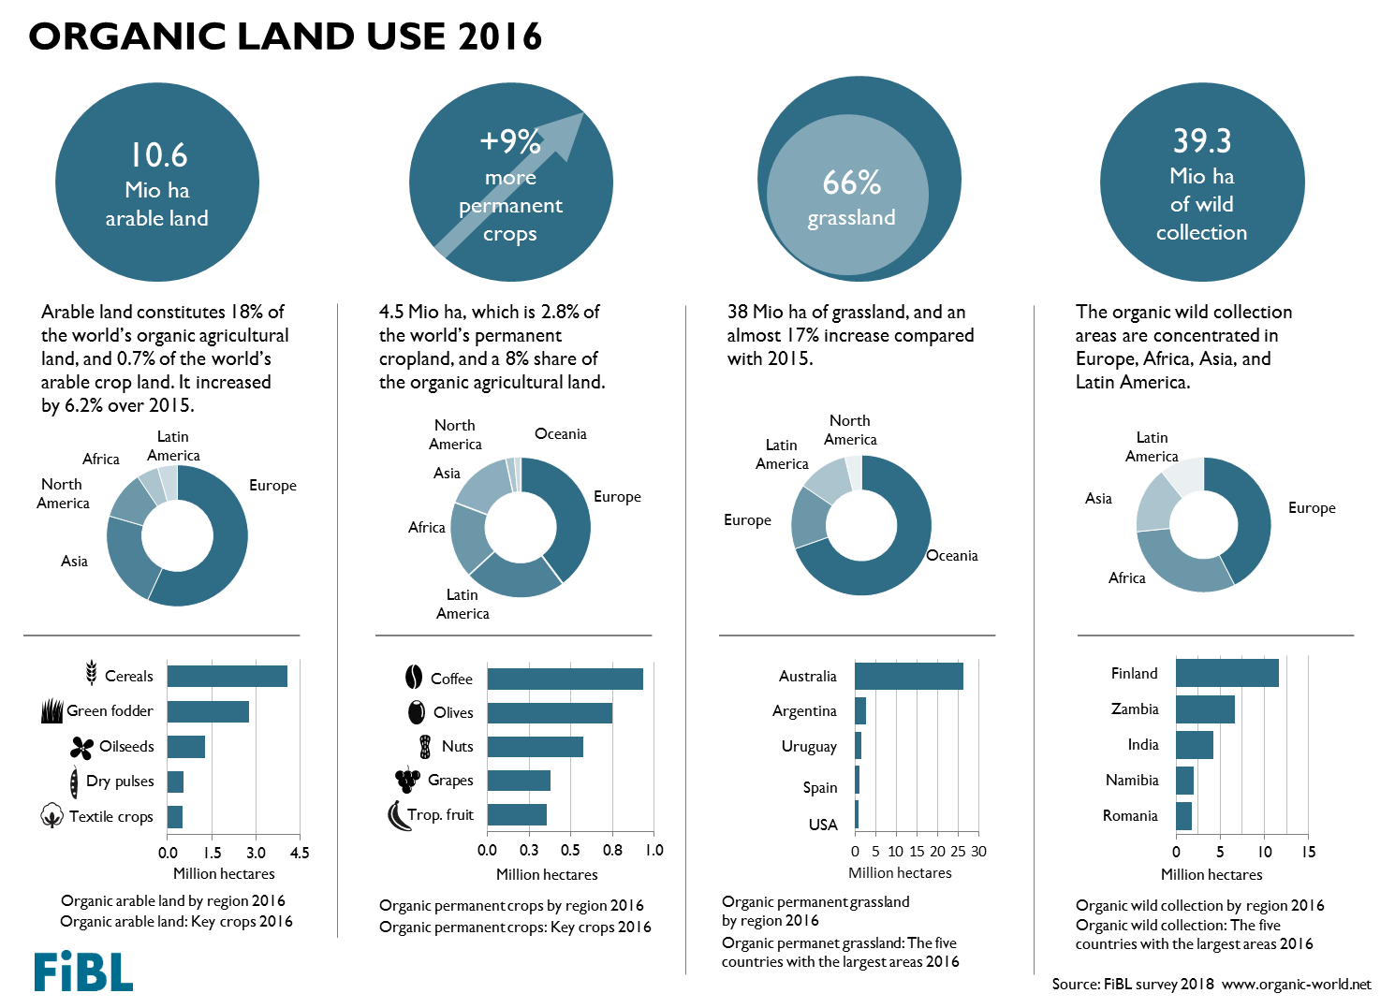

Sessions related to organic data at BIOFACH 2018

Wednesday, 14 February 2018

* The World of Organic Agriculture at BIOFACH 2018  
  4 pm to 4:45 pm, Hall Shanghai (NCC East)
* The European market for organic food at BIOFACH 2018  
  5 pm to 5:45 pm, Room Kiew, (NCC East)
* Innovation networks in the Central Eastern European region for increasing value chain development in the organic sector  
  4 pm to 6 pm, Room Budapest (NCC East)

Thursday, 15 February 2018

* Global Organic Market Overview - facts, trends and opportunities  
  10 am to 11:30 am, Room Istanbul (NCC East)

[www.biofach.fibl.org/en/biofach-2018.html](http://www.biofach.fibl.org/en/biofach-2018.html)

1. According to the Central European Bank, I euro corresponded to 1.1069 US dollars in 2016.