Media kit
The World of Organic Agriculture 2017
February 9, 2017

Table of Contents
Media release of February 09, 2017: Another record year for organic agriculture worldwide
Yearbook "The World of Organic Agriculture"
Key indicators
Graphs
Infographics
Further sessions on organic markets at BIOFACH 2017

BIOFACH and VIVANESS press conference 2017
09. Februar 2017, 10:00 Uhr
denn’s Bio-Markt Nürnberg, Äußere Cramer-Klett-Str. 21, 90489 Nürnberg

Contact
Helga Willer and Julia Lernoud
Research Institute of Organic Agriculture (FiBL)
Ackerstrasse 113, 5070 Frick, Schweiz,
helga.willer@fibl.org and julia.lernoud@fibl.org
www.fibl.org, www.organic-world.net, twitter.com/FiBLStatistics

Media release February 9, 2017

Another record year for organic agriculture worldwide
50.9 million hectares of organic agricultural land – organic market grows to more than 80 billion US Dollars
The latest global data on organic farming worldwide will be presented by the Research Institute of Organic Agriculture (FiBL) and IFOAM – Organics International at the BIOFACH world organic trade fair 2017 in Nuremberg. The statistical yearbook “The World of Organic Agriculture” will be launched on Wednesday, February 15, 2017, from 4.00 to 4.45 pm in Hall Shanghai, NCC East.
(Frick/Nürnberg February 9, 2017) The positive trend seen in the past years continues: Consumer demand is increasing, reflected in the significant market growth of 11 percent in the United States, the world’s largest organic market. More farmers cultivate organically, more land is certified organic, and 179 countries report organic farming activities (up from 172), as shown in the 2017 edition of the study “The World of Organic Agriculture” (data per end of 2015) published by FiBL and IFOAM – Organics International. The survey is supported by the Swiss State Secretariat for Economic Affairs (SECO), the International Trade Centre (ITC), and NürnbergMesse, the organizers of the BIOFACH fair.
The global organic market continues to grow worldwide
The market research company Organic Monitor estimates the global market for organic food to have reached 81.6 billion US dollars in 2015 (approximately 75 billion euros). The United States is the leading market with 35.9 billion euros, followed by Germany (8.6 billion euros), France (5.5 billion euros), and China (4.7 billion euros). In 2015, most of the major markets showed double-digit growth rates The highest per capita spending was in Switzerland (262 Euros), and Denmark has the highest organic market share (8.4 percent of the total food market).
More than two million producers
In 2015, 2.4 million organic producers were reported. India continues to be the country with the highest number of producers (585’200), followed by Ethiopia (203’602), and Mexico (200’039).
More than 50 million hectares of organic farmland
A total of 50.9 million hectares were organically managed at the end of 2015, representing a growth of 6.5 million hectares over 2014, the largest growth ever recorded. Australia is the country with the largest organic agricultural area (22.7 million hectares), followed by Argentina (3.1 million hectares), and the United States of America (2 million hectares).
Forty-five percent of the global organic agricultural land is in Oceania (22.8 million hectares), followed by Europe (25 percent; 12.7 million hectares), and Latin America (13 percent; 6.7 million hectares).
Ten percent or more of the farmland is organic in eleven countries
The countries with the largest share of organic agricultural land of their total farmland are the Liechtenstein (30.2 percent), Austria (21.3 percent), and Sweden (16.9 percent). In eleven countries 10 percent or more of all agricultural land is organic.

More information
Download
“The World of Organic Agriculture” 2017 edition, infographics, online data tables, and an interactive map can be downloaded at
www.organic-world.net/yearbook/yearbook-2017.html.
Contacts
- Dr. Helga Willer, FiBL, Ackerstrasse 113, 5070 Frick, Switzerland, Tel.+41 (0)79 2180626, helga.willer(at)fibl.org, www.fibl.org
- Markus Arbenz, IFOAM – Organics International, Charles-de-Gaulle-Strasse 5, 53113 Bonn, Germany, Tel. +49 (0)160 8041557, Fax +49 (0)228 9265099, m.arbenz(at)ifoam.bio, www.ifoam.bio
Programme of the session “The World of Organic Agriculture – Statistics and Emerging Trends”
Wednesday, February 15, 2017, 4.00 to 4.45 pm, Hall Shanghai (NCC East), NürnbergMesse, Nürnberg
- Markus Arbenz, IFOAM – Organics International, Moderator
- Eduart Rumani, SECO, Swiss Cooperation Office, Albania: The role of sustainability standards in economic development cooperation in Switzerland
- Dr. Helga Willer, FiBL: Latest data on organic agriculture worldwide
- Julia Lernoud, FiBL: Latest data on Voluntary Sustainability Standards worldwide
- Beate Huber, FiBL: Standards and regulations
- Amarjit Sahota, Organic Monitor, UK: The global market for organic food
- More information at www.biofach.fibl.org/en/biofach-2017.html

Yearbook "The World of Organic Agriculture"
About "The World of Organic Agriculture"
The study (336 pages) contains reports, authored by experts, on the organic sector and emerging trends in all regions and selected countries. The statistics are supported with graphs and tables. In addition, background information on issues such as standards and legislation is provided. New additions to this edition are an article on organic cotton from the Textile Exchange and a chapter reviewing the organic and Fairtrade markets. Further information and download is available at www.organic-world.net/yearbook/yearbook-2017.html.
Data collection
The data on organic agriculture is collected annually by the Research Institute of Organic Agriculture (FiBL) in collaboration with many partners from around the world. The results are published jointly with IFOAM – Organics International. The activities are supported by the Swiss State Secretariat for Economic Affairs (SECO), the International Trade Centre (ITC), and NürnbergMesse, the organizers of the BIOFACH fair. The views expressed in this press release can in no way be taken to reflect the official opinions of SECO, ITC, or NürnbergMesse.
Quote
Helga Willer and Julia Lernoud (Eds.) (2017): The World of Organic Agriculture. Statistics and Emerging Trends 2017. Research Institute of Organic Agriculture (FiBL), Frick and IFOAM – Organics International, Bonn
Order book and download
The printed version (25 Euros + postage; affiliates of IFOAM – Organics International: 20 Euros) can be ordered at www.fibl.org/en/shop-en.html (order number 3503) and https://shop.ifoam.bio/
Online databases
The data is available online at http://www.organic-world.net/statistics/statistics-data-tables.html
Pick up your copy at BIOFACH in Hall 1, Stands 1-555 (FiBL) and 1-451 (IFOAM – Organics International)
Key indicators

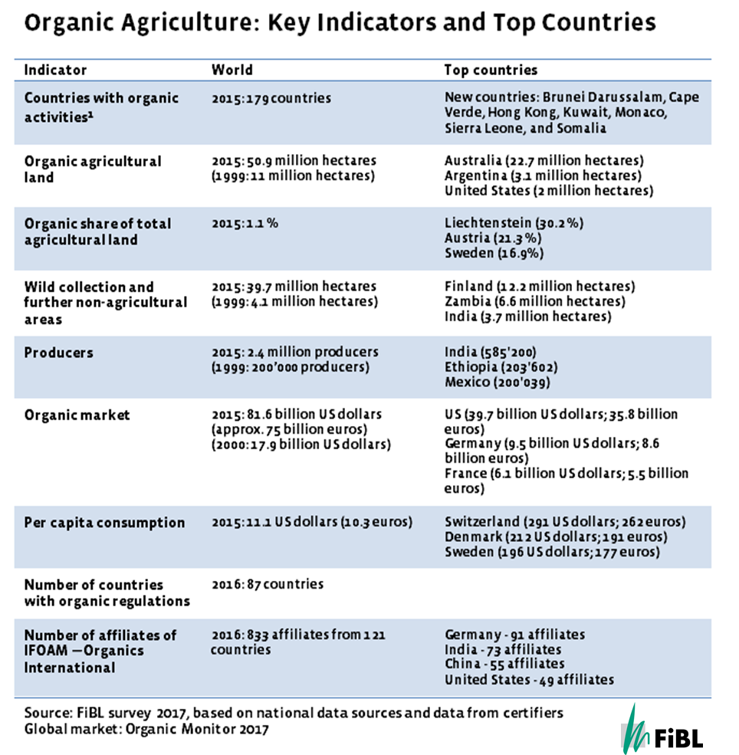

Graphs

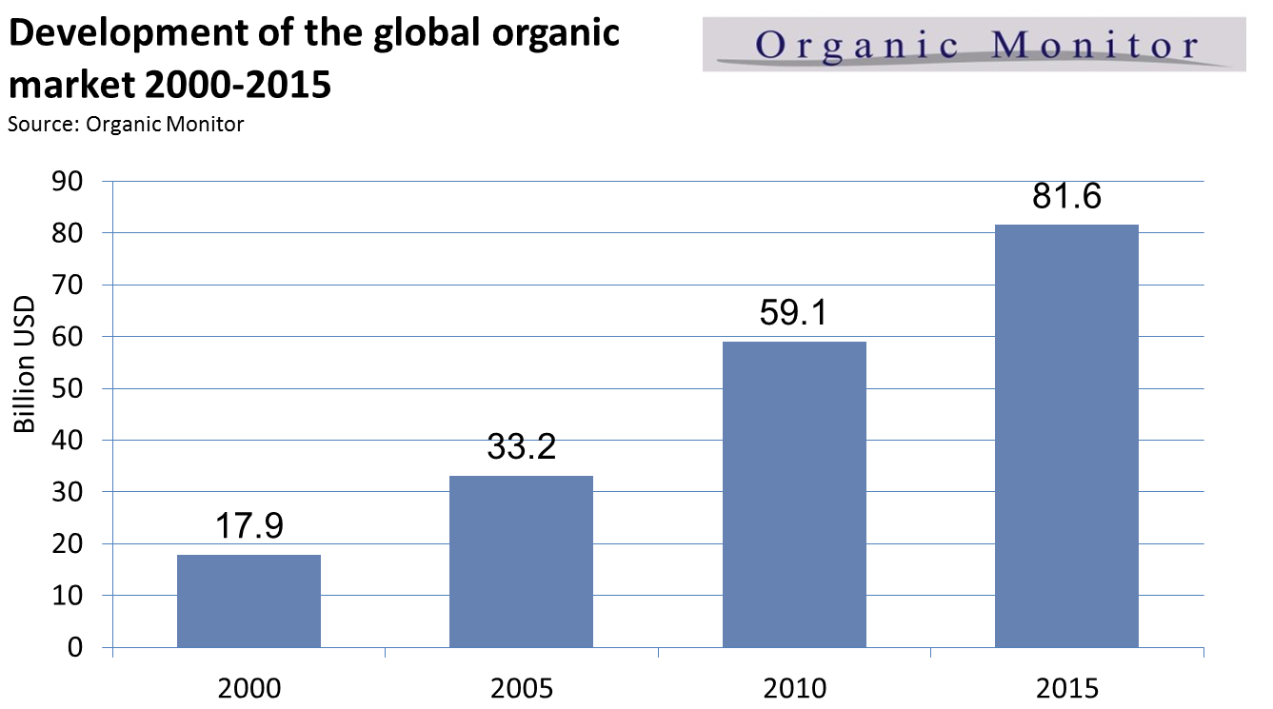

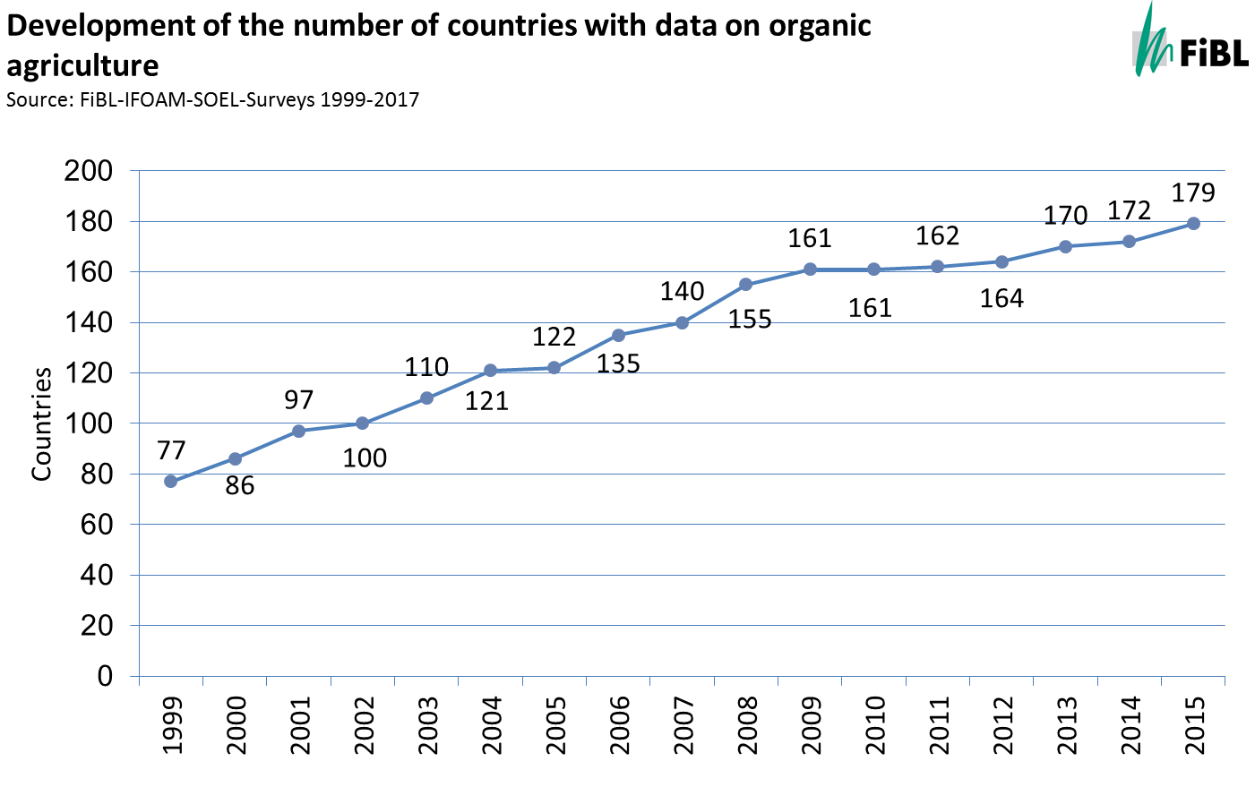

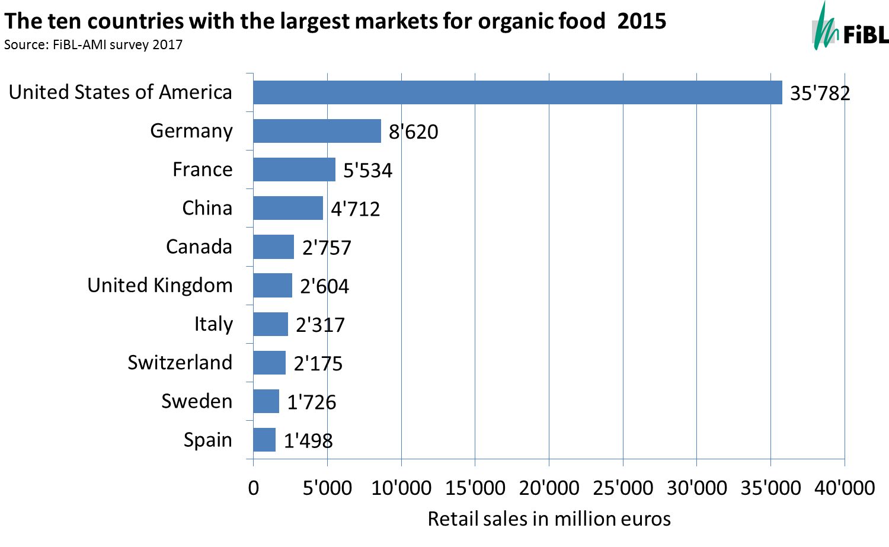

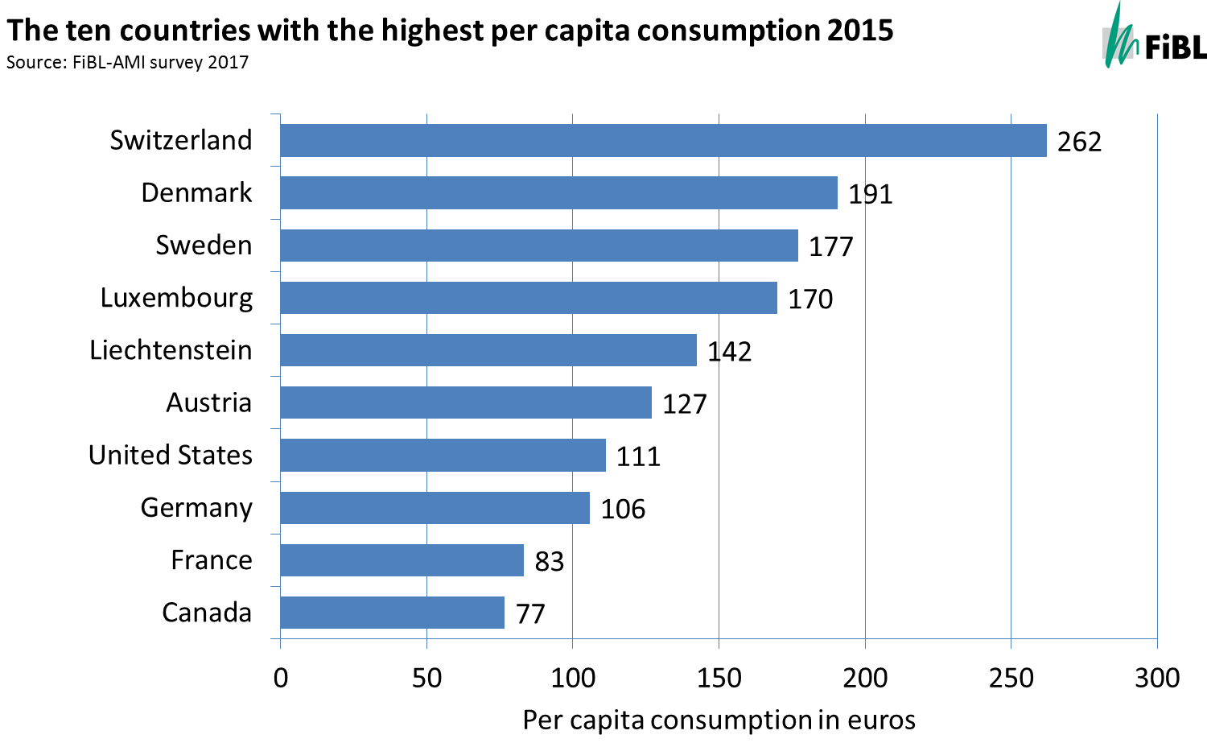

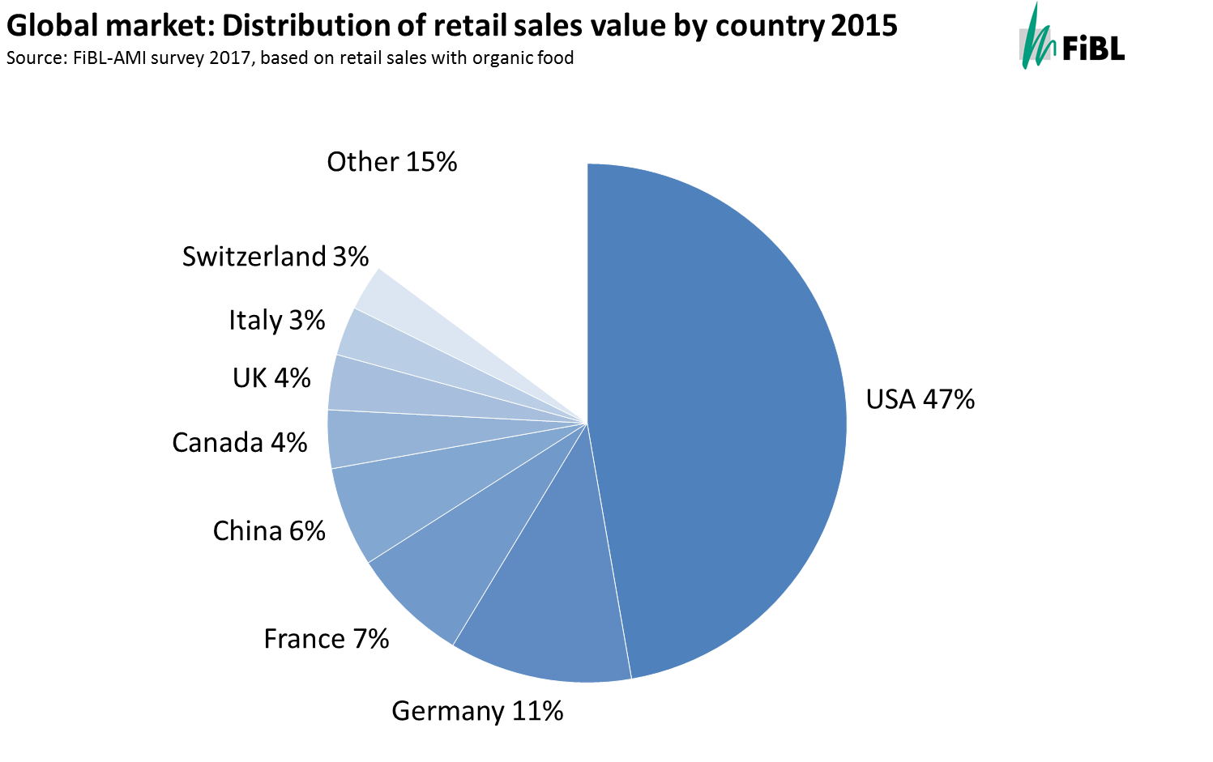

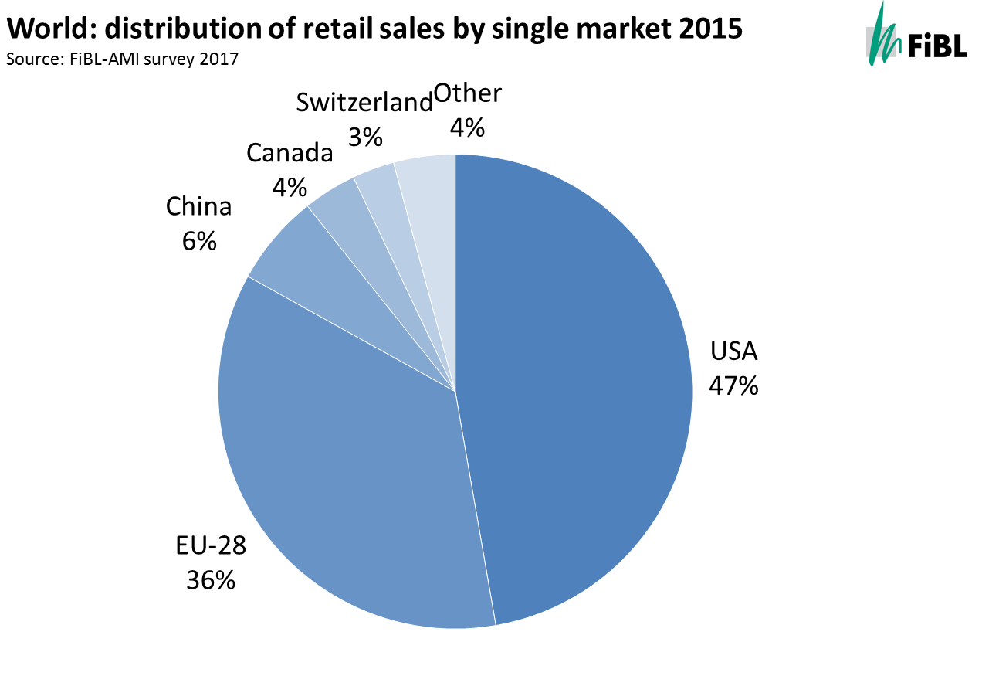

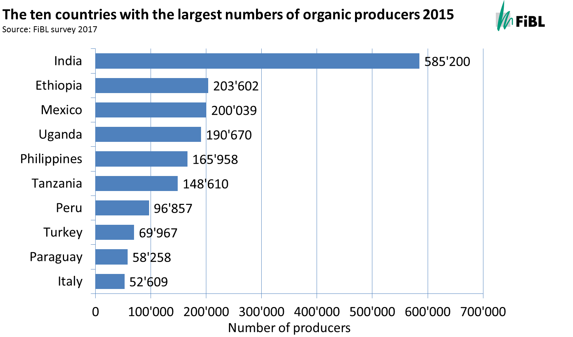

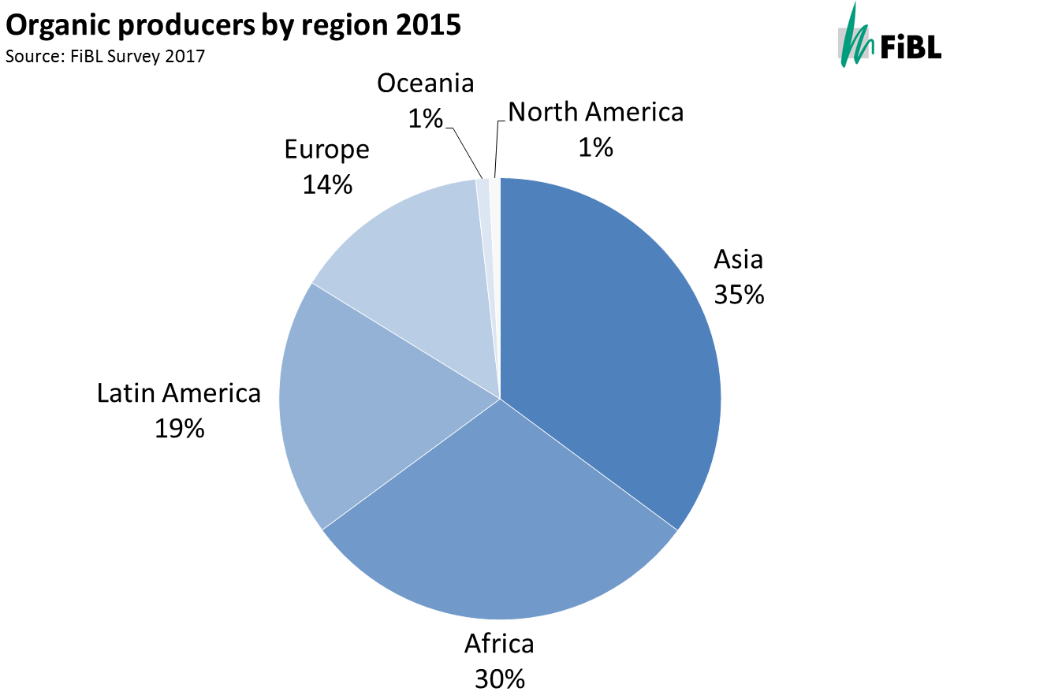

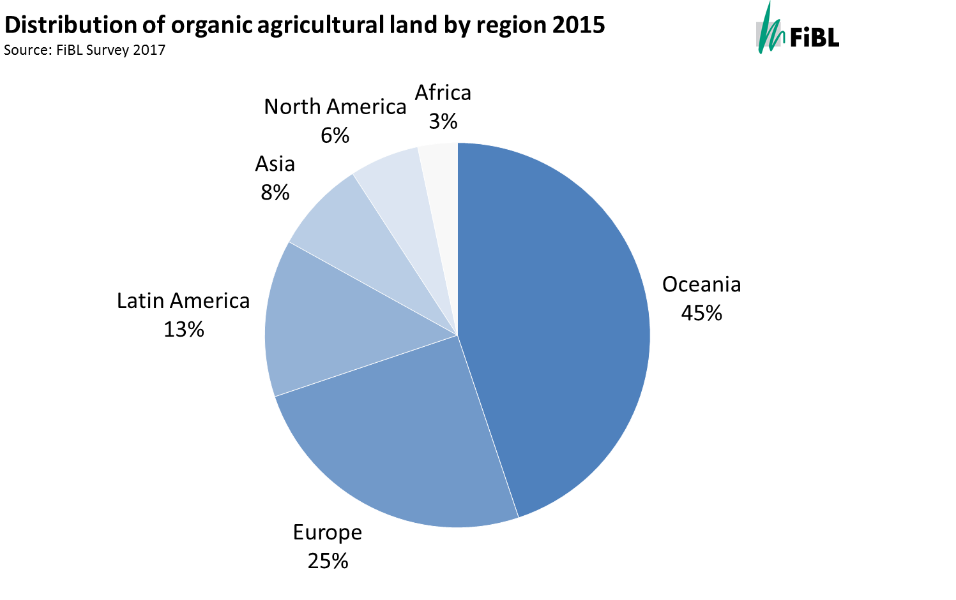
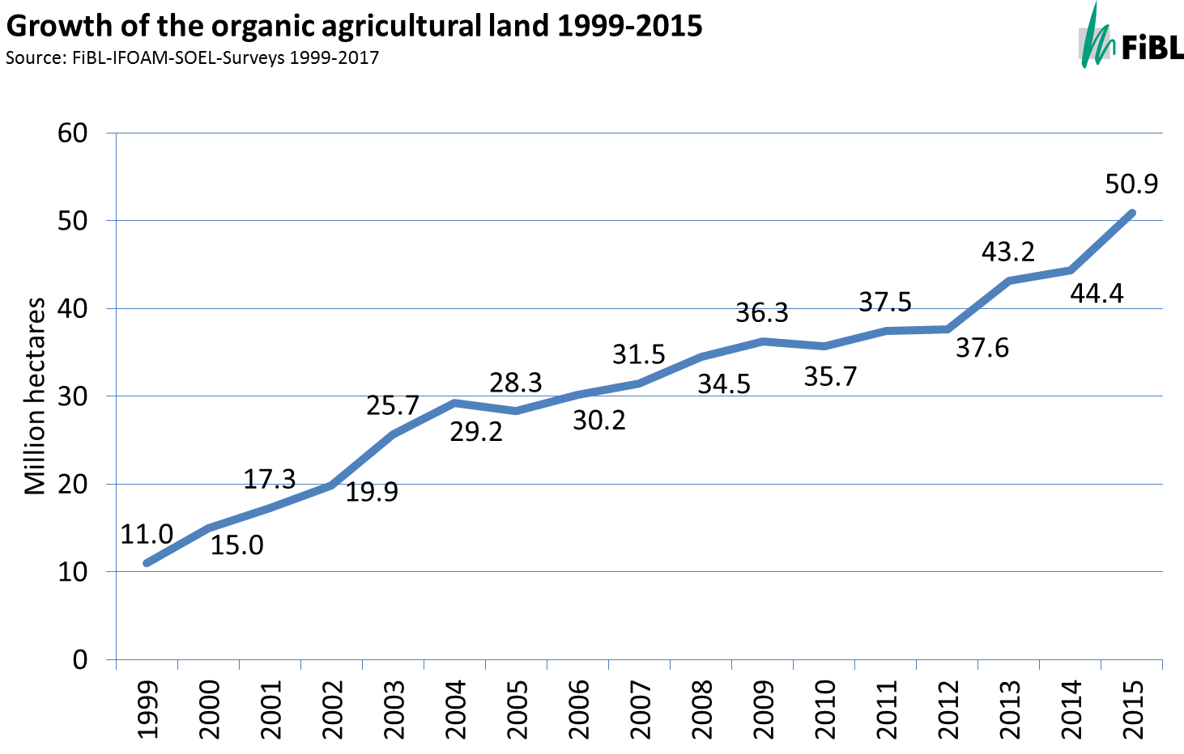

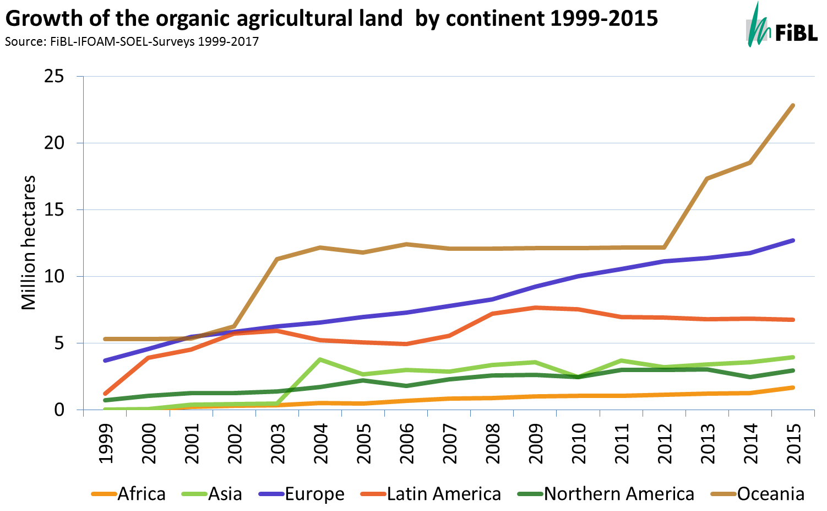

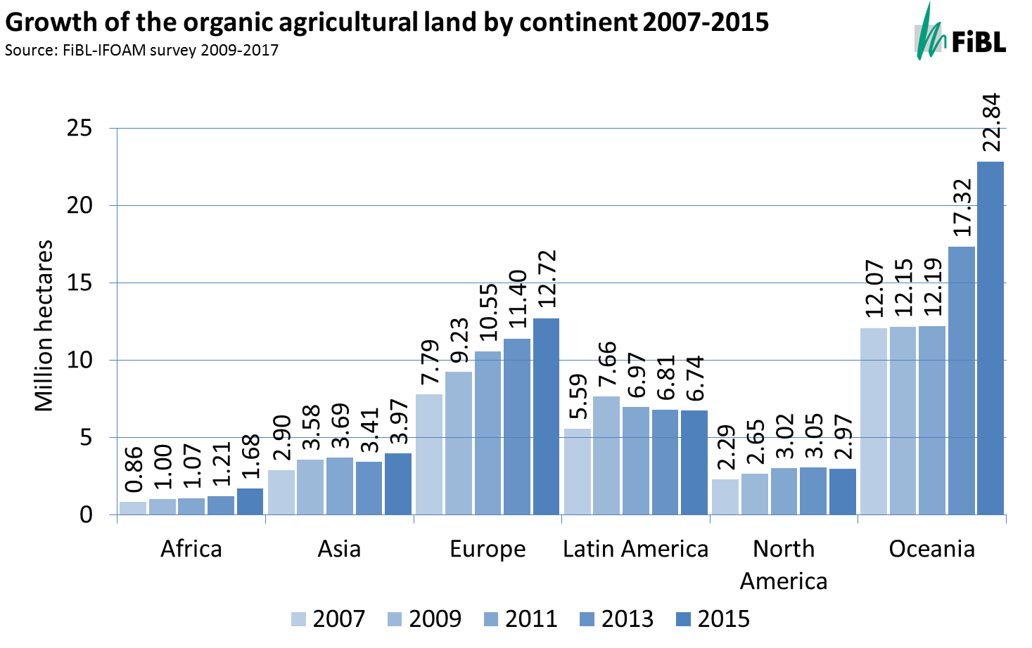

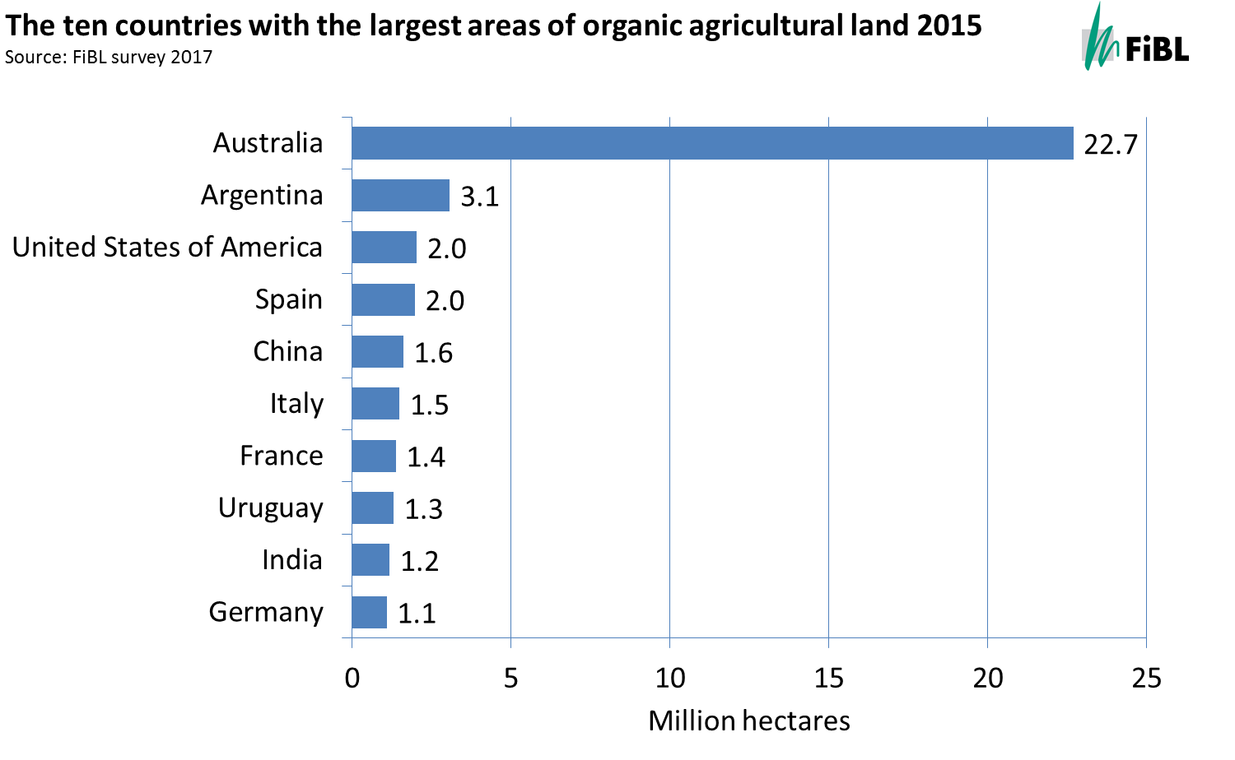
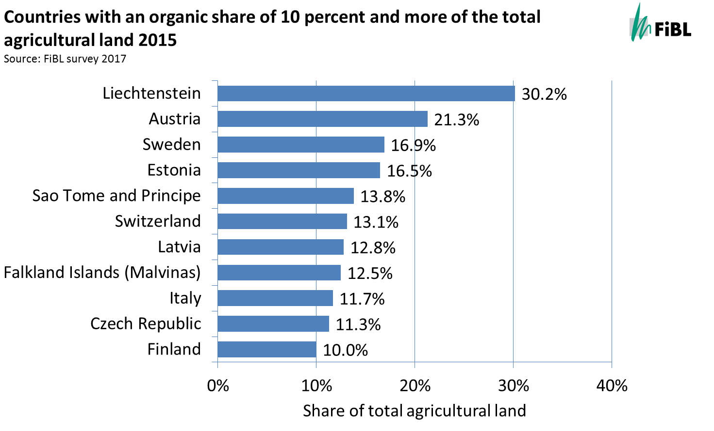

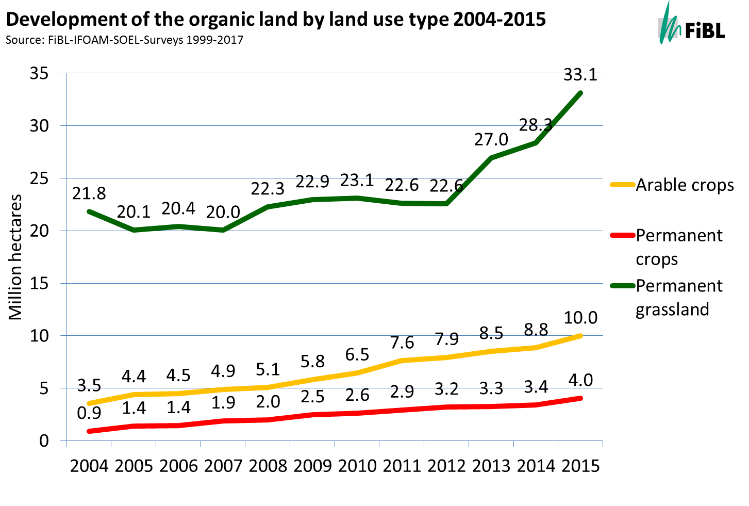

Infographics

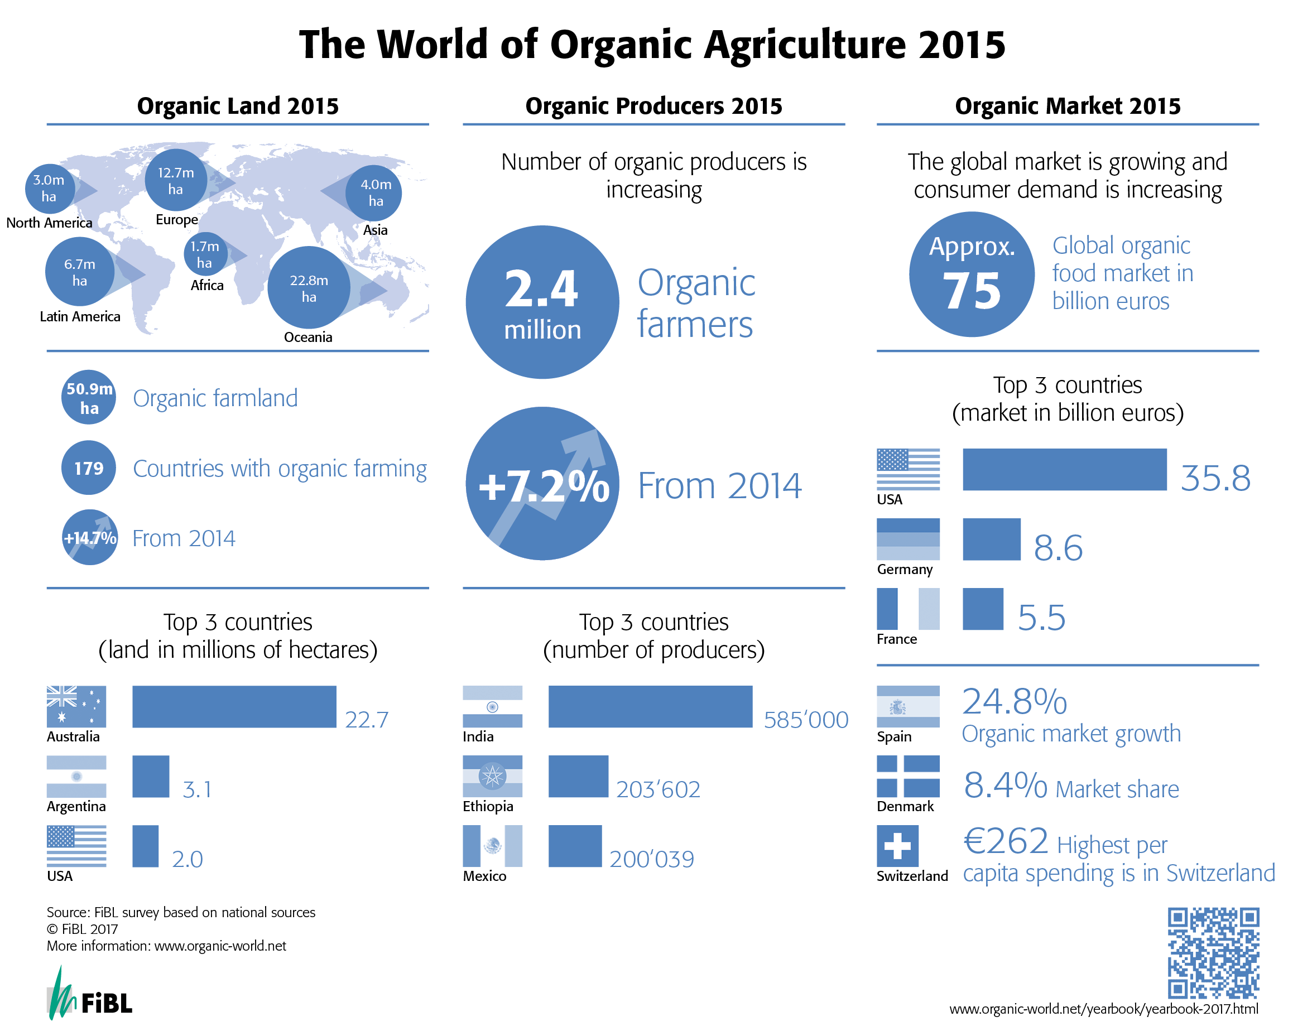
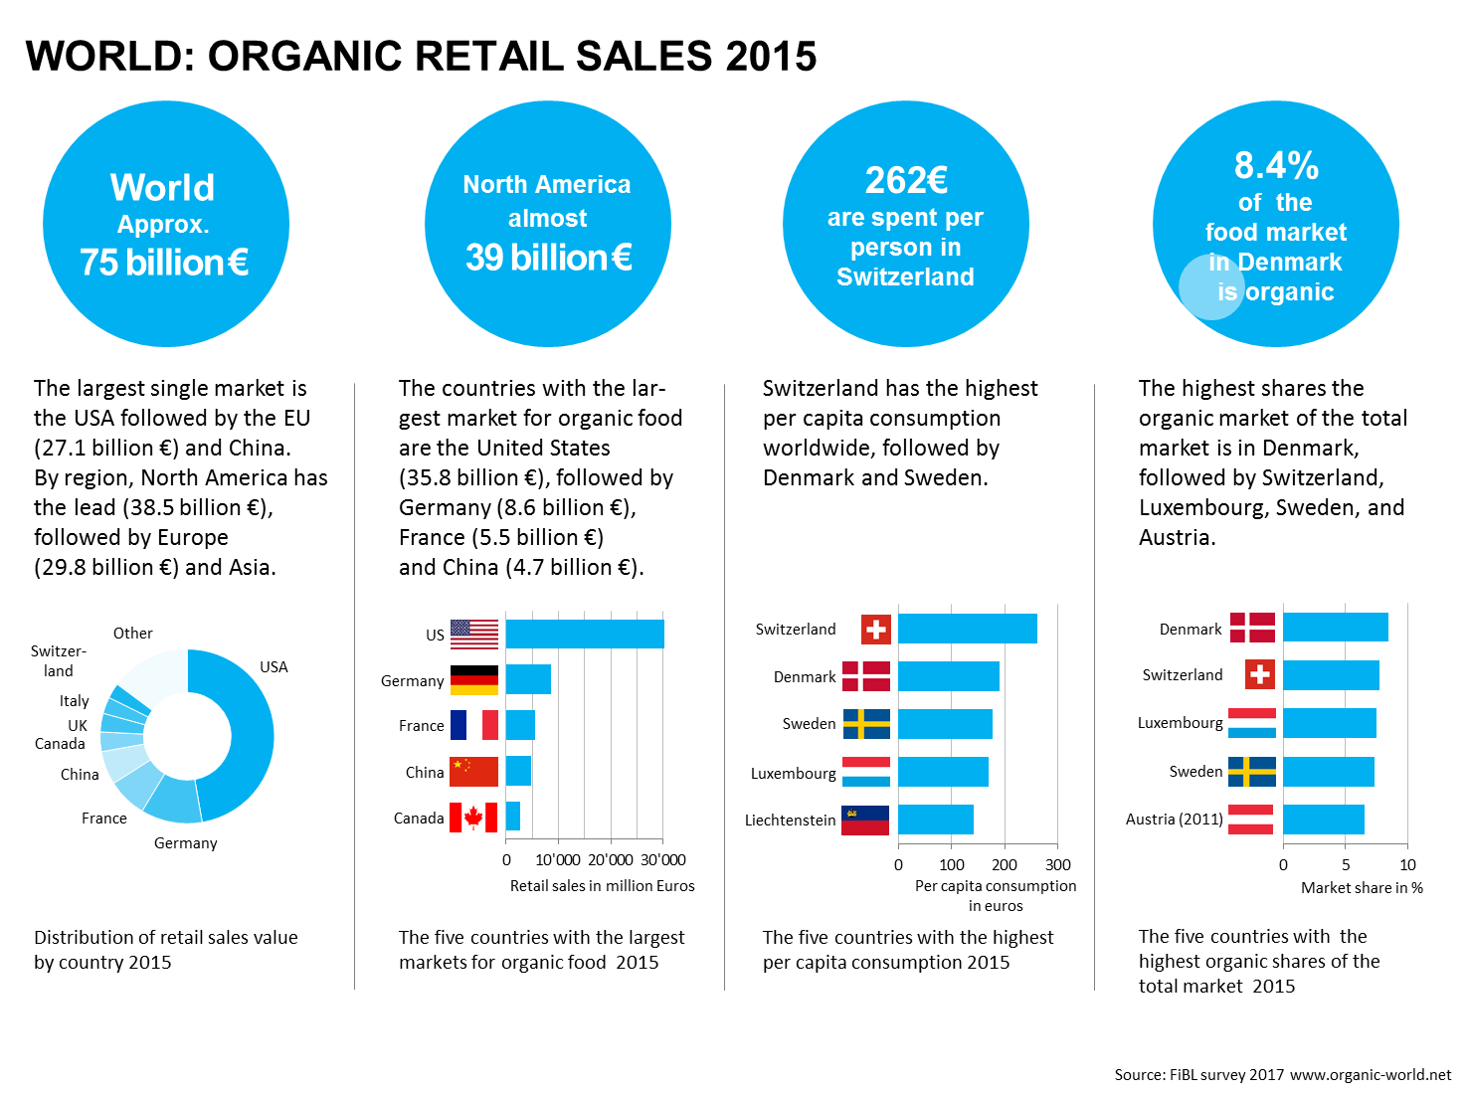

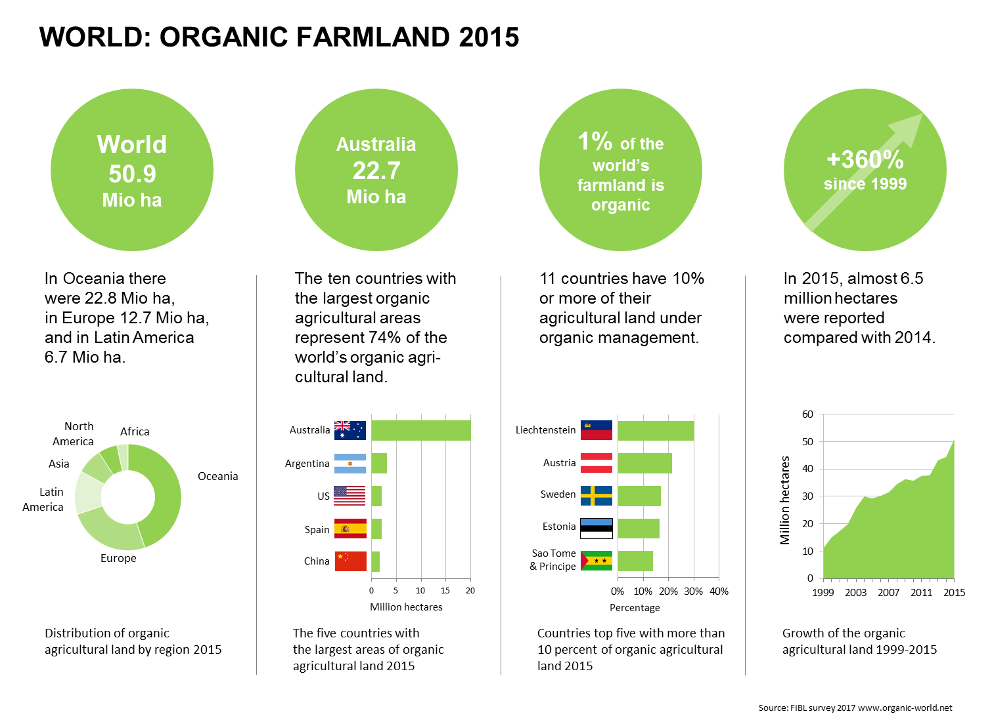
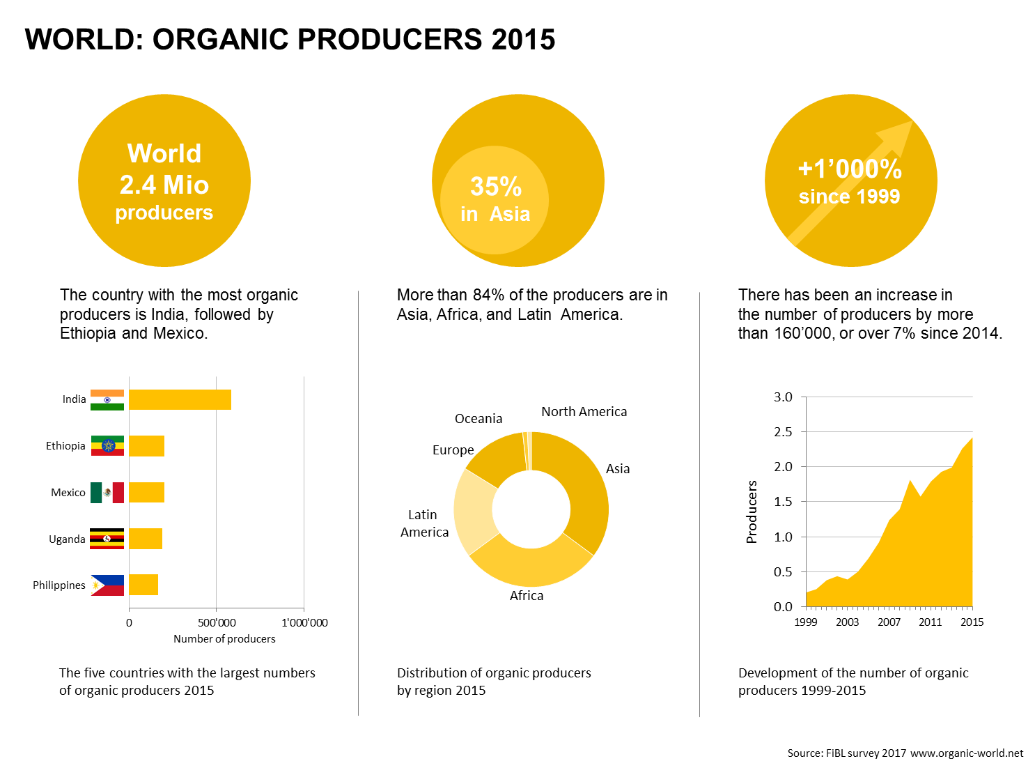

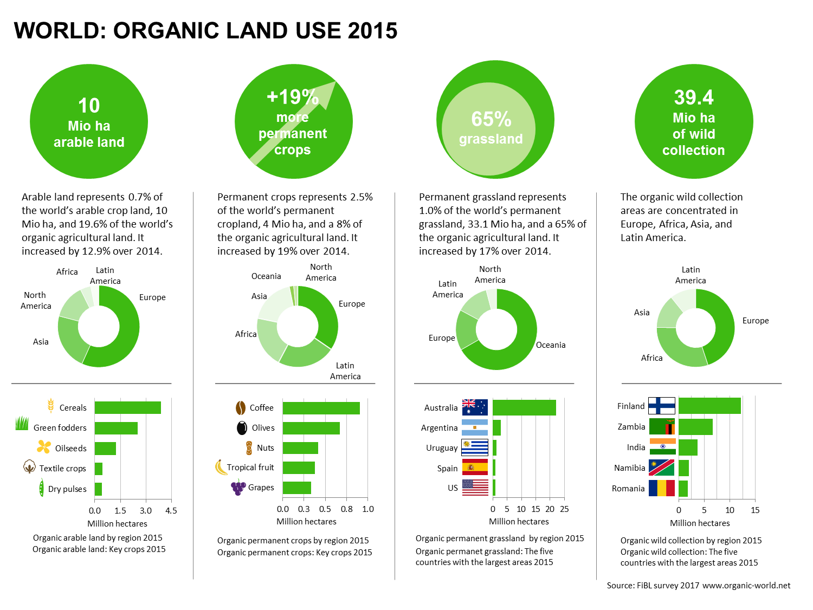

Further sessions on organic markets at BIOFACH 2017

Wednesday, February 15, 2017:
The World of Organic Agriculture at BIOFACH 2017
4 pm to 4.45 pm, Hall Shanghai (NCC East), BIOFACH Congress

The European market for organic food at BIOFACH 2017
5 pm to 5.45 pm, Room Copenhagen, (NCC East), BIOFACH Congress

Sourcing from Central and Eastern Europe - risks and benefits
4 pm to 5.30 pm, Room Budapest (NCC East), BIOFACH Congress

Thursday, February 16, 2017
Global Organic Market Overview - facts, trends and opportunities
10 am to 11.30 am, Room Istanbul (NCC East), BIOFACH Congress

www.biofach.fibl.org/en/biofach-2017.html

