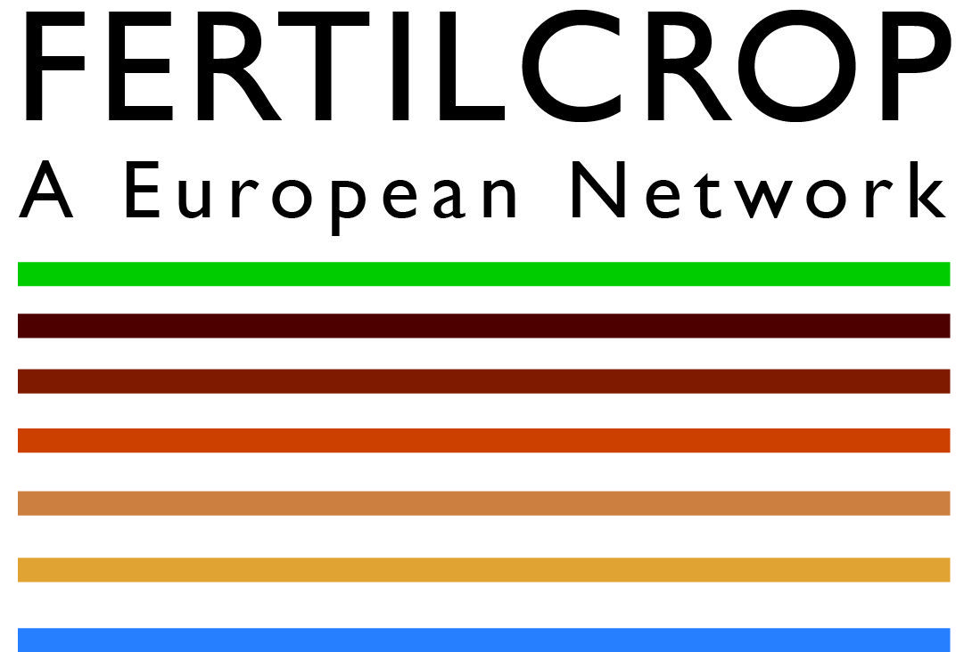
Media release

European research project on soil fertility launched

Under the leadership of the Research Institute of Organic Agriculture (FiBL) the European research project “Fertility building in organic cropping systems” (FertilCrop) has commenced. Twenty institutions in 13 European countries will work together on this three-year project on sustainable cropping methods.

(Frick, 11 March 2015) Soil fertility is key in organic agriculture, a production system that refrains from the use of chemically-synthesized fertilizers and pesticides. Soil fertility on organic farms is primarily supported by organic fertilizers, reduced tillage, and proper use of green manure crops: soils become more stable and more humus-rich, soil micro-organisms are more active and plant roots have better access to nutrients.
Reduced tillage is as yet not very common in organic agriculture as many farmers are afraid the system might create intense weed pressure. Without regular ploughing, especially the persistent rhizomatous weeds such as thistles, couch grass and dock increase significantly. They are difficult to control in organic systems as the use of synthetic herbicides is not permitted.
Higher yields under reduced tillage cropping
Therefore, more research on reduced tillage cropping is called for. As part of the FertilCrop project, FiBL together with other European researchers and agricultural advisors is now carrying such development work forward. To this end a range of different crop rotations, fertilizer use practices and variations of soil cultivation will be tested on farms. The ambitious goals of this work include higher yields, greater soil fertility, improved soil structure and fewer weeds. Reduced soil tillage can also decrease energy use and reduce emissions of greenhouse gases from soils.
The FertilCrop project involves close cooperation of experts in the areas of weed control, soil physics and biology, plant nutrition, green manures, composting, climate change and modelling. Improved cropping methods, new techniques and decision-making aids will be developed for practitioners. “We expect the close cooperation between farmers and researchers to yield environmentally-friendly and, in particular, locally adapted cropping systems that combine science with practical expertise”, explains Andreas Fliessbach, the project manager at FiBL.
The groundwork: TILMAN-ORG
The FertilCrop project builds on its predecessor TILMAN-ORG, which ran from 2012 to 2014, involving some of the same research partners. Both the research focus of the newly launched project and the approach it takes are unusual. Its focus is on interrelationships, such as between crop yields and weed growth or between good soil structure and high soil microbial activity. All the partners will draw on already existing field experiments. The abundant data will be fed into computer-based advisory and decision support models with a view to producing easy-to-apply tools for farmers. Participating farmers will learn to confidently assess soil fertility and use the computer-based decision support systems.
Partners in 13 European countries join forces in interdisciplinary work
Over the project’s three-year term, 20 research partners in 13 European countries will collate and evaluate data from 18 field trials and case studies. This will combine the expertise of advisors, farmers and researchers.
The FertilCrop project is financed jointly by national funding bodies. These are involved in CORE Organic Plus (Coordination of European Transnational Research in Organic Food and Farming Systems), an ERA-NET action. The European ERA-NET scheme is aimed at national and regional programme organisers and managers, such as research ministries and national research institutions. For Switzerland, the Swiss Federal Office for Agriculture (FOAG) is the lead institution.

FiBL contacts
- Andreas Fliessbach, FertilCrop Coordinator, FiBL, Tel. +41 (0)62 865 72 25,
e-mail andreas.fliessbach@fibl.org
- Helga Willer, FertilCrop Communication, FiBL, Tel. +41 (0)62 865 72 07,
e-mail helga.willer@fibl.org
Further information
Detailed descriptions of the project, project partners and individual work packages can be found on the project homepage at www.fertilcrop.net.
This media release and more information on FertilCrop is available at www.fibl.org/en/media.

