ANALYSIS OF THE SYMBIOTIC SYSTEM BEAN-RHIZOBIA UNDER WATER STRESS CONDITIONS IN GREENHOUSE

Antonio M. DE RON^{1*}, A. Paula RODIÑO¹, Manuel RIVEIRO²
¹Biology of Agrosystems, MBG-CSIC, Pontevedra, Spain
²EEA Baixo Miño-CIAM, Salceda de Caselas, Pontevedra, Spain.
Presenter (*amderon@mbg.csic.es).

Introduction
The symbiotic system common bean-rhizobia is often influenced by the availability of water in the soil. Water stress supposes a reduction of the biomass of the plant, of P absorption, of nitrogen fixation and nodulation (Muñoz-Perea et al. 2007). The sensitivity of nitrogen fixation to drought in legumes is variable, and depends mainly on the type of nitrogen compound synthesized in the nodules. The common bean responds with an accumulation of ureides with a negative effect on the nodules and nitrogen fixation. The objective of this work was to analyze how the water stress affects the plant-rhizobia symbiotic relationship and its effect on yield traits.

Material and Methods
In this work we have used 10 common bean landraces and breeding lines, some of them tolerant to drought, that were inoculated with 10 strains of Rhizobium (eight local and two reference ones, R. tropici CIAT899 and R. etli CFN42) (Table 1) in controlled greenhouse in a factorial trial under two conditions: irrigated and water stress. The landraces, belonging to the germplasm collection at the MBG-CSIC, were selected from a previous experiment to see their performance under drought conditions. The breeding lines were provided by several institutions. Aerial and root dry matter of the plant, and number and dry matter of nodules were evaluated and the variation detected in these characters was analyzed by ANOVA.

Table 1. Genetic material studied
Common bean | Rhizobia
PHA-0155  PHA-0432  PHA-0471  PHA-0483  PHA-0683  PMB-0220  PMB-0222  PMB-0244  PMB-0285  PMB-0286 | SLL2  CIAT899  CFN42  EXIC  EXIB  EG  EF  EPOB  APAFI  LTMF

Results and Discussion
They were significant differences between the different genotypes for all variables. No significant differences in treatment-strain interaction and treatment-strain-genotype interaction were observed, due to the specificity of binding strain-genotype. Thus, they are strains that increase the yield of certain genotypes, but do not have the same effect on other genotypes (Rodiño et al. 2011). In the non-water stress trial and within each genotype, the values ​​of aerial dry matter vary significantly between different strains used, highlighting the landraces PHA-0155, PHA-0483 and the breeding line PMB-0222 and the local strain APAFI. This specificity strain-genotype is important to find the strain that optimize the yield of improved landraces (Hungria et al. 2006). The water stress suppose generally a 32% of aerial dry matter reduction, but PHA-0471 and PMB-0220 increase their aerial dry matter in this conditions, when were inoculated with strain R. tropici CIAT 899. The nodule number and nodule dry matter showed high variability and PMB-0285 and PMB-0286 were the genotypes with high nodule number. They are strain-genotype combinations that have a high number of nodules, multiplying for six the average values of the variety. The nodular dry matter vary depending on the genotype, the inoculated strain and the environment, and can be observed different groups: 1) plants with large nodules and no correlation with aerial biomass; 2 and 3) (with different nodulation performance) when the nodular and aerial biomass is correlated and 4) plants with low nodulation and no correlated with the aerial biomass (Figure 1). The water stress causes in the plants a reduction in the number of root hairs, thereby reducing the number of nodules per plant. In this work, the reduction in the number of nodules was 57%. The combination strain EPOB-PHA-0471 achieved the maximal nodulation in these conditions. The nodule dry matter increases significantly under conditions of water stress. The genotypes with a high nodular biomass were PHA-0683 and PHA-0483 and the local strains that induce a greater nodule biomass were EF and EPOB. PHA-0683 presents a great uniformity in the caliber of your nodules, regardless of the nodule number and with a significant correlation with aerial biomass (Figure 1).
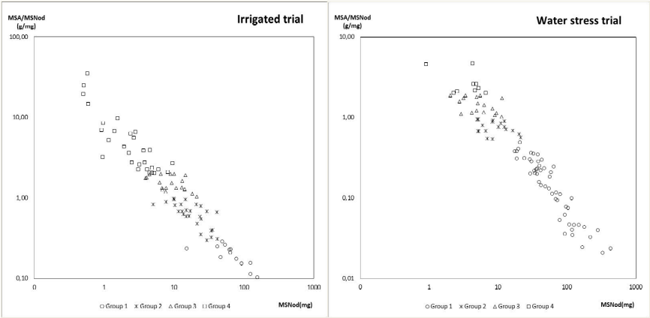

Figure 1. Nodule dry matter in relation to the aerial dry matter under irrigated and drought stress conditions

References
Hungria M, Franchini JC, Campo RJ, Crispino CC, Moraes JZ, Sibaldelli RNR, Mendes LC, Arihara J. 2006. Nitrogen nutrition of soybean in Brazil: contribution of biological N2 fixation and N fertilizer to grain yield. Can. J. Plant Sci. 86: 927-939
Muñoz-Perea CG, Teran H, Allen RG, Wright JL. 2007. Water use efficiency among dry bean landraces and cultivars in drought-stressed and non-stressed environments. Euphytica 155: 393-402
Rodiño AP, De La Fuente M, De Ron AM, Lema MJ, Drevon JJ, Santalla M. 2011. Variation for nodulation and plant yield of common bean genotypes and environmental effects on the genotype expression. Plant Soil 346: 349-361

