Press release

Taste of the Ukrainian Carpathians at the Salone del Gusto 2014
For the first time ever, the Taste of the Ukrainian Carpathians Trademark was presented to a large international audience at the Salone del Gusto – Terra Madre from October 24-27 in Turin. Over 220,000 visitors visited the Salone, many of them tasting the regional, authentic and tasty products from the Ukrainian Carpathians.
(Frick 31.10.14) As part of the Swiss-Ukrainian Organic Market Development Project, funded by the Swiss State Secretariat for Economic Affairs (SECO) and implemented by FiBL, four Ukrainian companies, all licensees of the trademark, promoted and sold their products, including tasty herbal teas, traditional jams, exclusive essential oils and fresh birch juice.

Overwhelming interest
Interest in the Carpathian-labelled products on display was overwhelming, not only because 2014 is the International Year of Family Farming. Visitors were very appreciative of the taste and authenticity of these regional products. “Our participation at the Salone del Gusto – Terra Madre 2014 enabled us to present our exclusive food products and our trademark and to promote the great culinary heritage of the Ukrainian Carpathians”, said Michailo Stovpiuk, President of the Trademark, and one of the four exhibitors. The exhibiting companies were Elitphito Ltd. from Ivano-Frankivsk (http://elitphito.com), Gals Ltd. from Chernivtsi (www.galsltd.com.ua), Pan-Eko from Zakarpattya (www.pan-eko.com), and the Pure Flora Association from Ivano-Frankivsk (http://carpathian.if.ua).

Exchange of ideas and positive feedback
Prior to their participation at the Salone del Gusto – Terra Madre 2014, the delegation of 4 licensees and Members of the Board of the Taste of the Ukrainian Carpathians Trademark actively participated at the 3-day international forum entitled “Origin, Diversity and Territories”, which was held in Turin. The forum was led by Diversités & Développement and FiBL. The event was supported by a range of agricultural , developmental and environmental organisations who see the promotion of regional and diverse foods as an essential part of their mission. These included: the Food and Agriculture Organization of the United Nations FAO, United Nation Industrial Development Organisation UNIDO, Slow Food Switzerland, French Agricultural Research Centre for International Development CIRAD, Latin American Center for Rural Development RIMISP, Territorios con Identidad Cultural, Plataforma Diversidad Biocultural y Territorios, and REDD Switzerland. Over 130 experts and practitioners from four continents exchanged and shared their knowledge and savoir faire of local and typical food products. These exchanges helped the Ukrainian partcipants see how they can strengthen the governance and management of the Taste of the Ukrainian Carpathians Trademark and gave the Board Members some new and inspiring ideas and tips. Elena Cooke, communications expert with the UNIDO, and a trainer at the Forum, thought that “the trademark of the Ukrainian Carpathians is very convincing, thanks to a clear and ‘very Ukrainian’ logo and unambigious communication”.

Further information
Taste of the Ukrainian Carpathians Trademark - www.tuca.com.ua

Salone del Gusto – Terra Madre 2014, Torino, Italy: www.salonedelgusto.it/
International Forum on Origin, Diversity and Territories: www.origin-for-sustainability.org/en/

Swiss-Ukrainian Organic Market Development Project 2012 - 2016: www.ukraine.fibl.org
International Year of Family Farming 2014: http://www.fao.org/family-farming-2014/en/
FiBL contacts
Tobias Eisenring, FiBL, Phone +41 79 775 92 17, tobias.eisenring(at)fibl.org
Sergii Gunko, FiBL, Phone + 38 050 356 10 48, sergii.gunko(at)fibl.org
Download of this media release
This media release is available at www.fibl.org/en/media.html.

Picture
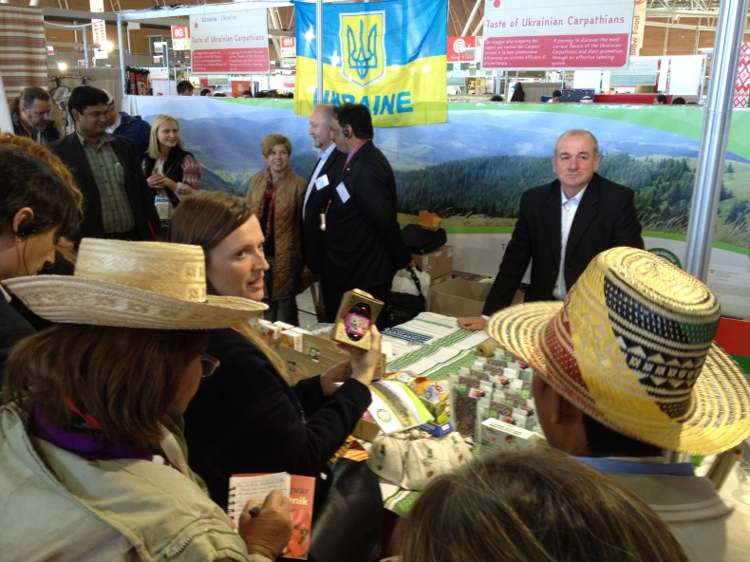

The Taste of the Ukrainian Carpathians stand at the Salone del Gusto – Terra Madre 2014 (picture Tobias Eisenring)
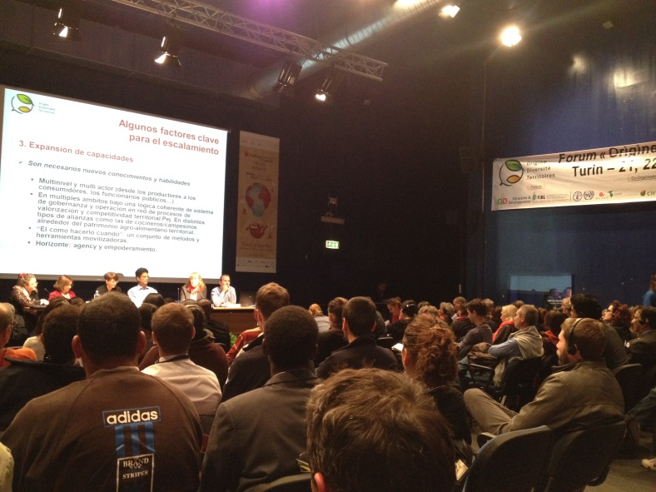

International Forum on Origin, Diversity and Territories, Turin October 21-23, 2014 (picture Tobias Eisenring)

