Medienmitteilung

Media release

Global analysis shows that organically farmed lands
contribute to climate change mitigation
(Frick, 2 October 2013) Organically farmed lands emit less nitrous oxide and take up greater amounts of atmospheric methane, thus contributing to climate change mitigation. This is the result of an evaluation of 19 comparative studies from around the globe conducted by a team of experts at the Research Institute of Organic Agriculture (Forschungsinstitut für biologischen Landbau, FiBL) and the University of Hohenheim. The results of this meta-analysis have now been published in the online version of the Science of the Total Environment journal.
A global analysis of 19 studies has shown that area-scaled nitrous oxide emissions from organically managed soils are on average 492 kg CO2 eq. per hectare and year lower than those from non-organically managed soils. Moreover, uptake of atmospheric methane on organically farmed lands is slightly higher.

However, yield-scaled nitrous oxide emissions are higher under organic management. This is due to the lower crop yield levels under organic management in the studies evaluated for this meta-analysis. To equalize yield-scaled nitrous oxide emissions a yield increase of about 9% under organic management would be necessary. On the other hand, the present study only assessed soil-derived emissions on agricultural land and did not take into account emissions arising for example in fertilizer production or farm-waste management.

The study’s lead investigator Andreas Gattinger at FiBL considers the study’s findings a positive contribution to the further development of organic farming. «The fact that organically managed soils emit lower quantities of nitrous oxide appears to be primarily due to soil quality. In contrast, nitrous oxide emissions on non-organic lands appear to be primarily linked to the quantities of nitrogen fertilizers applied», says Gattinger. The team of authors does however emphasize that additional research is needed, especially in an international context, in order to substantiate the findings of the present study. No such comparative studies on GHG emissions have as yet been conducted in southern hemisphere regions.

Such studies are needed to optimize agricultural management systems in terms of their greenhouse gas emissions and to transfer results to different soils, regions and cropping systems.
The study was conducted as part of the Carbon Credits for Sustainable Land Use Systems (CaLas) project with support from the Mercator Foundation Switzerland.

The study
Skinner, C, A. Gattinger, A. Mueller, P. Mäder, A. Fliessbach, R. Ruser, and U. Niggli 2014. Greenhouse gas fluxes from agricultural soils under organic and non-organic management – a global meta-analysis. Science of the Total Environment, 468-469, 553-563.

A copy of the study may be obtained from Andreas Gattinger on request.

Access the media release and images at www.fibl.org/en/media.html

Contact
Andreas Gattinger, Climate Coordinator, Soil Science Division, Research Institute of Organic Agriculture (Forschungsinstitut für biologischen Landbau, FiBL), Switzerland, Tel. +41 62 865 0418, e-mail andreas.gattinger@fibl.org
Adrian Krebs, Media Spokesperson, Tel. +41 79 500 88 52, adrian.krebs@fibl.org

Images
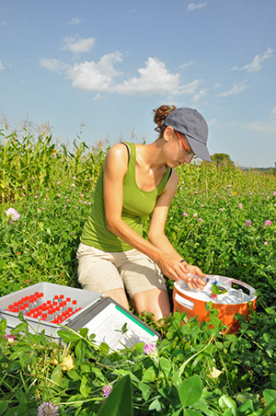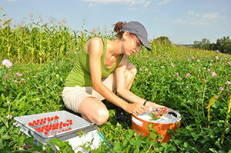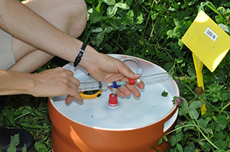
Caption:
FiBL researcher Maike Krauss measures greenhouse gas emissions as part of an experiment at Frick, Switzerland.

