Media release

FiBL supports change with agroecology and organic agriculture in the tropics

Organic agriculture and agroecology show promise in achieving sufficient yields and income, and help lower negative costs to the public. FiBL summarises the latest scientific evidence in its policy dossier "Cultivating change with agroecology and organic agriculture in the tropics". It offers 11 opportunities for change for decision-makers, policymakers, and experts in international cooperation.
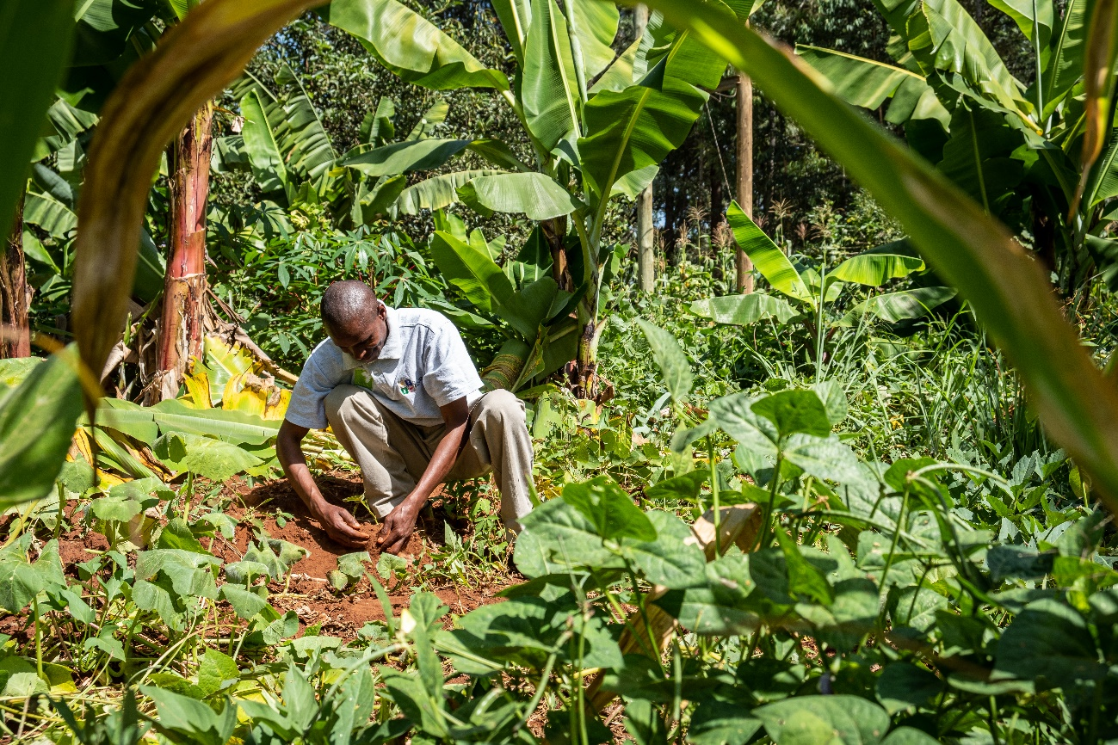
Organic farmer, Patrick Maive, in Kianjugu, Murang'a county, Kenya, visually assesses his soils on fertility and texture levels. (Photo: Biovision, Joost Bastmeijer)

(Frick, 09.02.2024) Despite technological advancements in food systems since the green revolution, current food systems are failing to meet the needs of both society and the environment. Nowhere are the challenges and hidden costs of “business as usual” food systems more evident than in the tropics, where disproportionate food insecurity, malnutrition, and impacts of climate change pose significant threats. These obstacles are expected to escalate into the future due to climate change, demographic shifts, political instability, conflicts, and increased demands on natural resources.
Benefits of agroecology and organic
To address these issues, it is crucial to explore promising alternative approaches for achieving the Sustainable Development Goals. FiBL’s policy dossier “Cultivating change with agroecology and organic agriculture in the tropics: Bridging science and policy for sustainable production systems”, based on 88 scientific publications, demonstrates that these approaches can contribute to a transformation of production systems in the tropics. The publication illustrates that agroecology and organic systems:
    - show promise in achieving yields that are on par with conventional;
    - can improve household income and livelihood resilience compared to conventional, especially in diverse systems and with price premiums;
    - help lower negative externalities and costs to the public, which will be increasingly important as climate change impacts worsen;
    - positively contribute to both climate adaptation and mitigation via smaller carbon footprints and increased carbon storage, helping farms better adapt to climate change;
    - help combat the biodiversity crisis, improve soil health and water quality and encourage the adoption of crop-livestock systems;
    - help improve food security and nutritional outcomes and reduce exposure to harmful pesticides.

Organic is not a luxury approach
Beate Huber, Vice-chairwoman of the Management Board and Head of the Department of International Cooperation summarises the main messages of the policy dossier as, “Organic agriculture and agroecology are often seen as a luxury approach for the rich countries. Our compilation of research findings in the tropics demonstrate that organic agriculture and agroecology can play an important role in improving the livelihoods in the Global South”.
Although the evidence in favour of agroecology and organic is quite compelling, their full benefits cannot be realised in most countries due to political and institutional barriers and lock-ins. Overcoming present and future challenges will require educated and empowered decision-makers, policymakers and experts involved in international cooperation who support and develop strategies for transitioning to agroecology and organic. The policy dossier is aimed at these stakeholders and offers 11 opportunities for change, with the goal of connecting scientific insights with practical implementation.
The policy dossier was developed as part of the Knowledge Centre for Organic Agriculture and Agroecology in Africa (KCOA) and Farming Systems Comparison in the Tropics (SysCom) projects. This comprehensive dossier will soon be accompanied by a short policy factsheet that concisely highlights the key information for policymakers. This will be made available in English, German and French.

Policy Dossier
Full policy dossier in FiBL Shop: https://www.fibl.org/en/shop-en/2000-tropics-policy-dossier
Session at Biofach
The key messages from the publication will be discussed at Biofach during the session: “Competitive organic farming systems in the tropics: Findings from long-term research” which will take place on Thursday, 15.02.2024 from 14:15 to 15:00 in room Istanbul (NCC Ost | Level 2 | Room Istanbul).
FiBL contacts
    - Lauren Dietemann, Communication, FiBL Switzerland
Phone: +41 62 865 04 08, e-mail lauren.dietemann@fibl.org
    - Laura Kemper, Communication, FiBL Switzerland
Phone: +41 62 865 17 11, e-mail laura.kemper@fibl.org
    - Beate Huber, Head of the Department of International Cooperation, FiBL Switzerland
Phone +41 62 865 04 25, e-mail beate.huber@fibl.org
Supporters
    - German Cooperation, GIZ
    - Liechtenstein Development Service (LED)
    - Swiss Agency for Development and Cooperation (SDC)
    - Coop Sustainability Fund
    - Biovision Foundation

Links
    - SysCom project description: https://www.fibl.org/en/themes/projectdatabase/projectitem/project/506
    - KCOA Project description: https://www.fibl.org/en/themes/projectdatabase/projectitem/project/1816
    - Website FiBL: www.fibl.org
This media release online
This media release and pictures can be accessed online at www.fibl.org/en/info-centre/media.html.
About KCOA
The KCOA project, funded by the GIZ, works towards closing knowledge gaps to promote food systems that create food security and respect the Earth’s environmental limits. The project has established five knowledge hubs, implemented across Africa.
www.kcoa-africa.org

About SysCom
The SysCom project, which is funded by LED, SDC, Coop and Biovision, aims to establish a scientific basis for discussions on the performance and potential of conventional and organic agricultural production systems in the tropics. It has been running since 2007 in three tropical countries – Bolivia, India and Kenya.
www.systems-comparison.fibl.org/index.html

About FiBL
The Research Institute of Organic Agriculture FiBL is one of the world's leading research institutions in the field of organic agriculture. FiBL's strengths are interdisciplinary research, joint innovations with farmers and the food industry as well as rapid knowledge transfer. The FiBL Group currently includes FiBL Switzerland (founded in 1973), FiBL Germany (2001), FiBL Austria (2004), ÖMKi (Hungarian Research Institute of Organic Agriculture, 2011), FiBL France (2017) and FiBL Europe (2017), which is jointly supported by the five national institutes. Around 400 employees work at the various locations.
www.fibl.org

