Media release
Fungi in the field: Soil inoculation with fungi can reduce the need for additional fertilizers and pesticides while increasing yields
Farmland often harbours a multitude of pathogens which can attack plants and reduce yields. A Swiss research team comprised of Agroscope, the Universities of Basel and Zurich as well as FiBL has now shown that inoculating soil with mycorrhizal fungi can help maintain or even improve yields without the use of additional fertilizers or pesticides. In a large-scale field trial, plant yield increased by up to 40 percent.
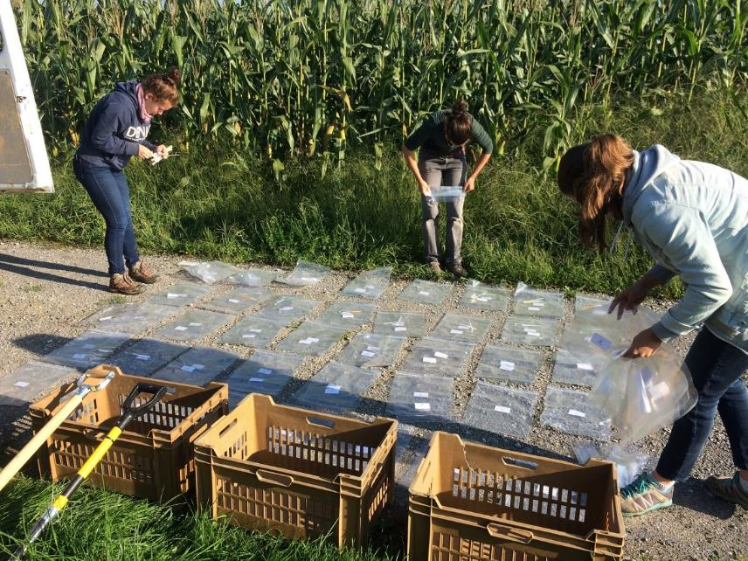
Researchers preparing the harvest of the maize plants from the mycorrhiza field trial. (Photo: FiBL, Natacha Bodenhausen)

(Frick, 30 November 2023) Intensive use of fertilizers and pesticides on fields reduces biodiversity and pollutes the environment. There is therefore great interest in finding sustainable ways to protect yields without the use of agricultural chemicals. One example of alternative biologicals is mycorrhizal fungi, which are beneficial organisms that help plants acquire nutrients.
Yields improved by up to 40 percent
A team of researchers from the universities of Zurich and Basel, Agroscope and the Research Institute of Organic Agriculture FiBL has now shown for the first time on a large scale that the application of mycorrhizal fungi in the field works. The fungi were mixed into the soil before sowing crops on 800 trial plots at 54 maize farms in northern and eastern Switzerland. “On a quarter of the plots, the mycorrhizal fungi enabled up to 40 percent better yields. That’s huge,” says the study’s co-lead Marcel van der Heijden, a soil ecologist at the University of Zurich and at Agroscope. But there’s a catch: on a third of the plots, the yield did not increase and in some cases even decreased. The research team was initially unable to explain why this happened.
Pathogens in the soil
In their search for the cause, the researchers analysed a variety of chemical, physical and biological soil properties, including the biodiversity of soil microbes. “We discovered that the inoculation functioned best when there were lots of fungal pathogens already in the soil,” says co-first author Stefanie Lutz from Agroscope, the federal centre of competence for agricultural research. “The mycorrhizal fungi act as a kind of protective shield against pathogens in the soil that would weaken the plants.” As a result, the normal yield can be maintained in fields where without mycorrhizal fungi there would have been losses. In contrast, mycorrhizal fungi had only a minor effect on fields that were not contaminated with pathogens. “The plants there are strong anyway and grow excellently. The use of mycorrhizal fungi in such cases brings no additional benefits,” says the other first author Natacha Bodenhausen from FiBL.
Vaccination success can be predicted
The aim of the study, funded by the Gebert Rüf Foundation, was to be able to predict the conditions under which mycorrhizal inoculation works. “With just a few soil indicators – mainly soil fungi – we were able to predict the success of inoculation in nine out of 10 fields, and thus could also predict the harvest yield even before the field season,” says the study’s co-lead Klaus Schläppi of the University of Basel. “This predictability makes it possible to target the use of the fungi in fields where they will work. That’s a crucial element for developing these technologies into a reliable agricultural method,” says Schläppi.
Further research is still required to find out the easiest way to spread the fungi over large areas. Nevertheless, “the results of this field trial represent a big step toward more sustainable agriculture,” concludes Marcel van der Heijden.

Contacts
- Natacha Bodenhausen, Department of Soil Sciences FiBL Switzerland
Phone +41 62 865 72 99, E-mail natacha.bodenhausen@fibl.org
- Stefanie Lutz, Agroecology and Environment Agroscope
Phone +41 58 480 07 44, E-mail stefanie.lutz@agroscope.admin.ch
Supporters
- Gebert Rüf Stiftung
Partners
- University of Basel
- University of Zurich
- Agroscope
Video
- youtube.com: Video ”Impact Clip: Microbiome diagnostics for sustainable agriculture”
Citation
Stefanie Lutz, Natacha Bodenhausen et al. Soil microbiome indicators can predict crop growth response to large-scale inoculation with arbuscular mycorrhizal fungi. Nature Microbiology, 29 November 2023. DOI:10.1038/s41564-023-01520-w
https://www.nature.com/articles/s41564-023-01520-w
This media release online
This media release including images can be accessed online at https://www.fibl.org/en/info-centre/media.html.

About FiBL
The Research Institute of Organic Agriculture FiBL is one of the world's leading research institutions in the field of organic agriculture. FiBL's strengths are interdisciplinary research, joint innovations with farmers and the food industry, and rapid knowledge transfer. The FiBL Group currently includes FiBL Switzerland (founded in 1973), FiBL Germany (2001), FiBL Austria (2004), ÖMKi (Hungarian Research Institute of Organic Agriculture, 2011), FiBL France (2017) and FiBL Europe (2017), which is jointly supported by the five national institutes. FiBL employs some 400 staff at its various locations. www.fibl.org

