Media release
Global organic market: Unprecedented growth in 2020
Organic retail sales grew by 14 billion euros and exceeded the 120-billion-euro mark
The latest data on organic farming worldwide will be presented by the Research Institute of Organic Agriculture FiBL and IFOAM – Organics International together with BIOFACH, the world’s leading trade fair for organic food. The statistics yearbook “The World of Organic Agriculture” will be launched on Tuesday, 15 February 2022, from 12 to 1 pm (CET).
(Frick, 15 February 2022) Organic farmland and retail sales both continued to show strong growth worldwide, according to data from 190 countries (data as of the end of 2020). Published by FiBL and IFOAM – Organics International, the 23rd edition of “The World of Organic Agriculture” shows the positive trend seen in past years continued into 2020. This annual survey on global organic agriculture is supported by the Swiss State Secretariat for Economic Affairs (SECO), the Sustainability Fund of Coop Switzerland, and NürnbergMesse, organisers of the BIOFACH trade fair.
The global organic market continues to grow
Against the backdrop of the pandemic, the global market for organic food showed its highest growth ever in 2020, exceeding 120 billion euros – a total increase of 14 billion euros. The United States continued to be the leading market (49.5 billion euros), followed by Germany (15 billion euros) and France (12.7 billion euros). In 2020, many major markets showed extraordinarily strong growth rates; the German market, for example, grew by more than 22 percent! Swiss consumers spent the most on organic food (418 euros per capita in 2020), and Denmark continued to have the highest organic market share, with 13 percent of its total food market. The global COVID-19 pandemic resulted in a significant increase in demand for organic products in many countries, but there were also challenges: “The effects of the pandemic are visible in retail sales data. As people stayed home and began to cook more often and health, environment and climate change have become big issues, organic retail sales increased rapidly. However, at the same time, in the food service sales decreased in many countries”, says Helga Willer, who is in charge of the yearbook at FiBL.
3.4 million organic producers worldwide
In 2020, 3.4 million organic producers were reported, an increase of 7.6 percent compared to 2019. India continued to be the country with the most organic producers (1.6 million). The majority of small-scale producers are certified in groups based on an internal control system.
Steady increase of organic farmland
Almost 75 million hectares were organically managed at the end of 2020, representing a growth of 4.1 percent or 3 million hectares compared to 2019. Australia had the largest organic agricultural area (35.7 million hectares), followed by Argentina (4.5 million hectares) and Uruguay (2.7 million hectares). Organic area increased across all continents in 2020. Half of the global organic agricultural land is in Oceania (35.9 million hectares). Europe had the second largest area (17.1 million hectares), followed by Latin America (9.9 million hectares).
Ten percent or more of farmland is organic in 18 countries
In 2020, 1.6 percent of farmland around the world was organic. However, many countries have far higher shares: Liechtenstein had the largest organic share of total farmland (41.6 percent), followed by Austria (26.5 percent) and Estonia (22.4 percent). In 18 countries, 10 percent or more of all agricultural land is organic.
Global organic data shows ongoing engagement with transparency in the organic sector
“Global organic statistics have proven useful for international development cooperation programs and supporting strategies for organic agriculture and markets, and they are crucial for monitoring the impact of these activities. This publication shows our ongoing engagement with transparency in the organic sector”, says Louise Luttikholt, Executive Director of IFOAM – Organics International.
Knut Schmidtke, Director of Research, Extension & Innovation at FiBL Switzerland, adds: “Organic agriculture secures our future and does so worldwide: the Yearbook underlines the international importance of organic agriculture for a sustainable as well as climate-adapted food policy and reflects people's trust in organically produced food.”

More information
“The World of Organic Agriculture” – How to order/download
The book can be ordered (30 euros + postage; affiliates of IFOAM – Organics International: 20 euros) or downloaded at shop.fibl.org (item number 1344). Graphs and infographics can be downloaded at www.organic-world.net/yearbook/yearbook-2022.html.
Book citation
Willer, Helga, Jan Trávníček, Claudia Meier, Bernhard Schlatter (Eds.) (2022): The World of Organic Agriculture. Statistics and Emerging Trends 2022. Research Institute of Organic Agriculture FiBL, Frick, and IFOAM – Organics International, Bonn. Available at www.organic-world.net/yearbook/yearbook-2022.html.
Online database
Tables and interactive infographics with details on crops, markets, and international trade, as well as explanations about the data can be found on FiBL’s statistics website statistics.fibl.org.
Contacts
- Helga Willer, FiBL, Ackerstrasse 113, 5070 Frick, Switzerland
Phone +41 (0)79 218 06 26, helga.willer@fibl.org, www.fibl.org
- Louise Luttikholt, IFOAM – Organics International, Charles-de-Gaulle-Strasse 5, 53113 Bonn, Germany
Phone +49 (0)1575 769 11 01, l.luttikholt@ifoam.bio, www.ifoam.bio
Session “The World of Organic Agriculture – Statistics and Emerging Trends” on February 15, 2022 (online)
Tuesday, 15 February 2022, 12:00 to 1:00 pm CET,
- Louise Luttikholt, IFOAM – Organics International: Introduction and presentation of program and speakers, Moderator
- Helga Willer, FiBL: Overview on global figures, importance of statistics
- Xhona Hysa, IFOAM – Organics International: Global overview on policies and regulations
- Eduardo Cuoco, IFOAM Organics Europe: Developments in Europe, linking market figures to policies
- Amarjit Sahota, Ecovia Intelligence, UK: The global market for organic food
Registration: www.biofach.de/registration-sneak
This media release online
This media release and graphs can be accessed online at https://www.fibl.org/en/info-centre/media.html.
About FiBL
The Research Institute of Organic Agriculture FiBL is one of the world’s leading institutes in the field of organic agriculture. FiBL’s strengths lie in its interdisciplinary research, innovations developed jointly with farmers and the food industry, and rapid knowledge transfer. The FiBL Group currently includes FiBL Switzerland (founded in 1973), FiBL Germany (2001), FiBL Austria (2004), ÖMKi (Hungarian Research Institute of Organic Agriculture, 2011), FiBL France (2017) and FiBL Europe (2017), which is jointly supported by the five national institutes. FiBL employs some 300 staff at its various locations.
www.fibl.org

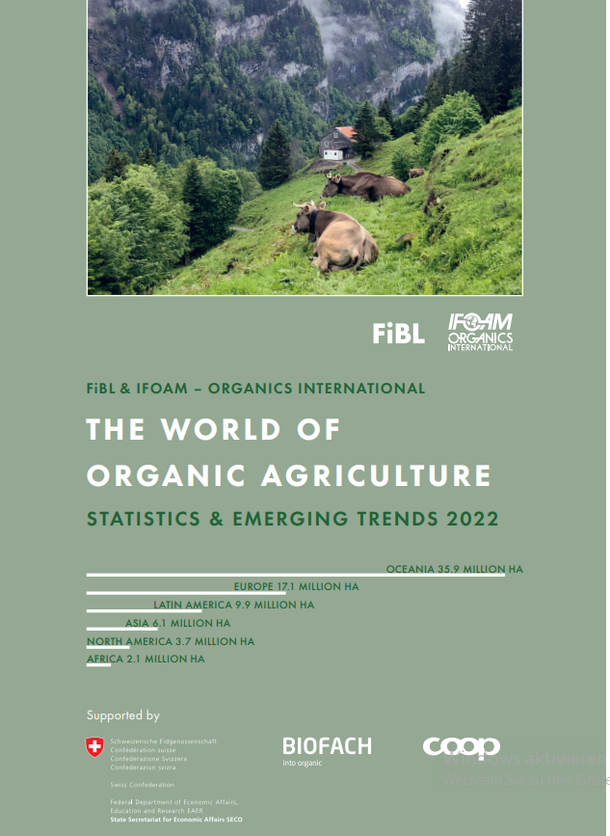
Yearbook "The World of Organic Agriculture" at a glance
About "The World of Organic Agriculture"
The yearbook “The World of Organic Agriculture” (342 pages) presents the results of the annual survey on organic agriculture worldwide and has numerous tables, graphs, maps and infographics. It contains reports by experts on the organic sector and information on emerging trends across all regions as well as selected countries. It also provides background information on standards and legislation, policy support, and the global market for organic food. Further information and download link are available at www.organic-world.net/yearbook/yearbook-2022.html.
Data collection
The data on organic agriculture is collected annually by FiBL in collaboration with many partners from around the world. The results are published jointly with IFOAM – Organics International. The activities are supported by SECO, the Coop Sustainability Fund, and NürnbergMesse, organisers of the BIOFACH trade fair.
Book citation
Willer, Helga, Jan Trávníček, Claudia Meier, Bernhard Schlatter (Eds.) (2022): The World of Organic Agriculture. Statistics and Emerging Trends 2022. Research Institute of Organic Agriculture (FiBL), Frick, and IFOAM – Organics International, Bonn. Available at www.organic-world.net/yearbook/yearbook-2022.html.
“The World of Organic Agriculture” – How to order/download
The book can be ordered (30 Euros + postage; affiliates of IFOAM – Organics International: 20 Euros) or downloaded at shop.fibl.org (order number 1344).
Online database
The data is available online at statistics.fibl.org.

Organic Agriculture: Key Indicators and Top Countries 2020
Indicator | World | Top countries
Countries with organic activities | 2020: 190 countries
Organic agricultural land | 2020: 74.9 million hectares  (1999: 11 million hectares) | Australia (35.7 million hectares)  Argentina (4.5 million hectares)  Uruguay (2.7 million hectares)
Organic share of total agricultural land | 2020: 1.6 % | Liechtenstein (41.6 %)  Austria (26.5 %)  Estonia (22.4 %)
Increase of organic agricultural land 2019/2020 | 3 million hectares (ha); +4.1 % | Argentina: 781´000 ha (+21 %),  Uruguay; 589´000 ha (+28 %)  India: 359´000 ha (+16%)
Wild collection and further non-agricultural areas | 2020: 28.5 million hectares (ha)  (1999: 4.1 million hectares) | Finland (5.5 million ha)  Namibia (2.6 million ha)  Zambia (2.5 million ha)
Producers | 2020: 3.4 million producers  (1999: 200’000 producers) | India (1’599’010)  Ethiopia (219'566)  Tanzania (148'607)
Organic market | 2020: 120.6 billion euros  (2000: 15.1 billion euros) | US (49.5 billion euros)  Germany (15.0 billion euros)  France (12.7 billion euros)
Per capita consumption | 2020: 15.8 euros | Switzerland (418 euros)  Denmark (384 euros)  Luxembourg (285 euros)
Number of countries/ territories with organic regulations | 2020: 76 (fully implemented)
Number of affiliates of IFOAM – Organics International | 2020: 714 affiliates | Germany: 79 affiliates  China: 46 affiliates  USA: 41 affiliates  India: 40 affiliates
Source: FiBL survey 2022, based on national data sources, data from certifiers and IFOAM – Organics International

Infographics
