Media release
Jürn Sanders is the new president of FiBL Europe
The new president of FiBL Europe is Jürn Sanders. He will take office on June 14, 2022, succeeding Beate Huber. The agronomist, political scientist and economist has been advising the EU Commission and various national and regional governments on agricultural and food policy since 2007.
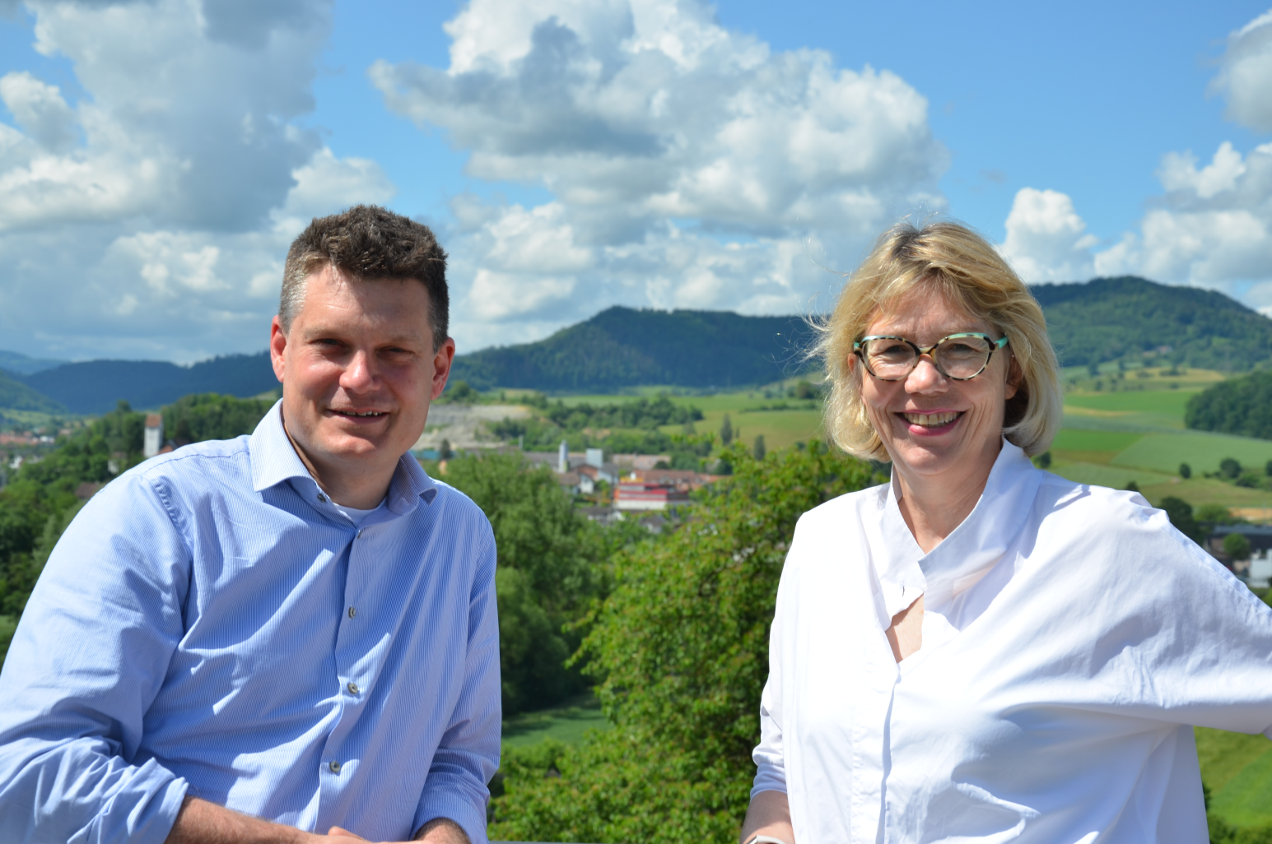
Jürn Sanders and Beate Huber. (Source: FiBL, Andreas Basler)
(Frick, 14.06.2022) On June 14, 2022, Jürn Sanders will succeed Beate Huber as President of FiBL Europe, the institute that represents the national institutes of the FiBL Group (FiBL Switzerland, FiBL Germany, FiBL Austria, FiBL France and the Hungarian Research Institute of Organic Agriculture ÖMKi) at the European level. Huber previously held the presidency for two years and now sits on the three-member FiBL Switzerland Board of Directors since April 1, 2022.
As an expert on the politics and economics of organic agriculture, Jürn Sanders has been advising the EU Commission and various national and regional governments on their agricultural and food policies since 2007. Having already worked at FiBL Switzerland for ten years from 2001 to 2010, Sanders returned to FiBL at the beginning of 2022 as Head of the Department of Socioeconomics. In between, he headed the "Environment and Sustainability" research group at the Thünen Institute for Business Administration in Germany from 2007 to 2021.
Sanders’ predecessor, Beate Huber, is pleased with his unanimous nomination by the Board and by Sanders’ commitment: “Jürn Sanders’ thematic focus is European agricultural policy. With his expertise, he will strengthen the interests of the FiBL Group's national institutes and organic farming research in Brussels.”
Commenting on his election, Sanders himself says: “I am very much looking forward to this responsibility. We are facing the great challenge of transforming food systems, and FiBL Europe can play an important role in this. We may have a decade left to develop viable solutions for more climate protection and biodiversity conservation. It is therefore all the more important now to develop powerful concepts across Europe and implement them together,”.
FiBL Europe was founded in 2017 with the aim of representing the FiBL Group as the leading research, advisory and development organization for organic agriculture in Brussels. A major focus is to bring the competencies as well as the knowledge that the researchers have gained through their many years of work at the various national institutes into European agricultural policy. In this way, the FiBL Group is actively shaping the agriculture of tomorrow.
Contact
Seraina Siragna, Head of Corporate Communications & Media Spokesperson at FiBL Switzerland, Tel +41 62 865 63 90, E-Mail seraina.siragna@fibl.org
This media release online
You can find this media release online at www.fibl.org/de/infothek/medien.html.
About FiBL
The Research Institute of Organic Agriculture (FiBL) is one of the world’s leading institutes in the field of organic agriculture. FiBL’s strengths lie in its interdisciplinary research, innovations developed jointly with farmers and the food industry, solution-oriented development projects and rapid knowledge transfer from research into practice. The FiBL Group currently includes FiBL Switzerland (established in 1973), FiBL Germany (2001), FiBL Austria (2004), ÖMKi (Hungarian Research Institute of Organic Agriculture, 2011), FiBL France (2017) and FiBL Europe (2017), which is jointly funded by the five national institutes. More than 300 staff are employed at the various locations. fibl.org
About FiBL Europe
FiBL Europe is based in Brussels and was founded in 2017 to represent the four national FiBL institutes (FiBL Switzerland, FiBL Germany, FiBL Austria, FiBL France) and the Hungarian Research Institute of Organic Agriculture ÖMKi at the European level. The Board of FiBL Europe is composed of the Board of Directors of the national institutes. In its work, the FiBL Europe team can draw on the support and expertise of the Board as well as on the expertise of the more than 300 FiBL researchers working on organic and sustainable agricultural practices in a wide range of scientific disciplines. FiBL Europe is the main research network for organic and sustainable farming and food systems and acts as a focal point for the expertise of the national FiBL institutes. It provides applied research, extension and training. fibl.org/en/locations/europe

