Media release
FiBL unveils new campus
Last week the Research Institute of Organic Agriculture FiBL opened its gates for three days to welcome visitors eager to explore the new FiBL Campus. The event showcased not just the new buildings but also the institute’s staff and their invaluable work for the future of organic farming.
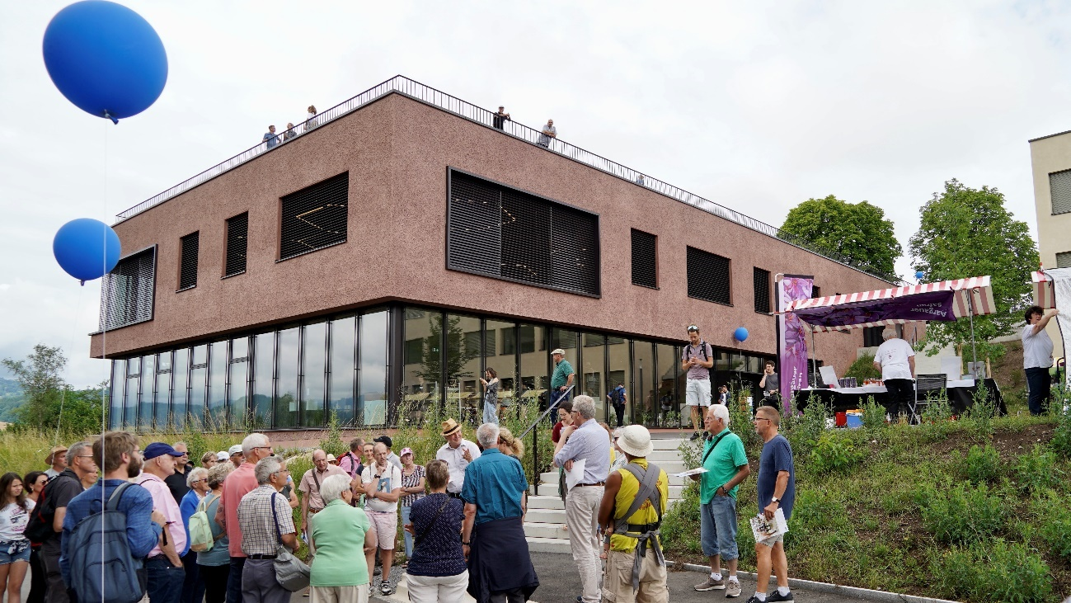
On the Open Day on 26 June 2022 FiBL presented its new campus and varied activities to the broader public. (Source: FiBL: Thomas Alföldi)
(Frick, 28 June 2022) At long last the time had come again: last week FiBL opened its gates to the public. Held for the first time in four years, the event spanned a full three days. The institute used the opportunity to present its new campus. This was expanded in recent years by a new research greenhouse and laboratory buildings, new animal housing built to the latest standards and taking all animal welfare aspects into account and, finally, a new conference building with a restaurant and a new office building. The last buildings were occupied in December 2021 and were now ceremoniously inaugurated.
On Thursday evening, invited policymakers and partner organisation guests attended an official inauguration ceremony. Friday, in contrast, was devoted to practitioners, the FiBL connect event being hosted for the very first time. On Sunday, finally, FiBL invited the broader public to explore the FiBL Campus.
Official inauguration ceremony – an evening with insights and prospects
On Thursday, 23 June 2022, FiBL welcomed some 100 invited guests to inaugurate the new buildings. Irène Kälin, President of the Swiss National Council, gave the keynote address. Born in the canton of Aargau, which is also the home canton of Frick and thus of FiBL Switzerland, Kälin underscored the major contributions of the institute to agriculture and left no doubt that organic produce is rightly on people’s tables and on the political agenda, for this is the form of farming that places the least pressure on the planet and best underpins healthy food systems. Further welcoming addresses by FiBL Foundation Council President Martin Ott, Swiss Federal Office for Agriculture Director Christian Hofer and Bernard Lehmann, chair of the United Nations High Level Panel of Experts on Food Security and Nutrition and member of the FiBL Foundation Council, also highlighted FiBL’s national and international relevance.
FiBL further presented five of its numerous ongoing projects, vividly demonstrating the institute’s interdisciplinarity and diversity. In addition, ten young researchers took the stage to present their projects drawn from the institute’s specialised divisions. Finally, Knut Schmidtke, FiBL Director of Research, Extension & Innovation, gave fascinating insights into the institute’s present activities and took a look at its future prospects in research and extension.
FiBL connect – a day for practitioners
On Friday, 24 June 2022, the institute hosted FiBL connect for the first time – a promising new format devoted entirely to the practicalities of farming. This event was designed to serve both farmers and present and future extensionists and researchers in food and farming. Some 150 participants profited from a rich programme involving numerous mini-panels, presentations, technical excursions and tours addressing a wide range of topics of relevance to organic production. These included the impacts of climate change on organic farming and the linkages between animal husbandry and carbon neutrality. Tours visited the fruit-growing research facility and the parasitology lab.
Networking is a further key purpose of FiBL connect. The event allowed participants to engage directly with FiBL’s experts and with current and future colleagues. This gave them ample opportunity to forge valuable contacts and weave networks. Barbara Früh and Bernadette Oehen, FiBL connect organisers and co-heads of FiBL’s Department of Extension, Training & Communication, are delighted that the event was such a resounding success. “FiBL connect brought together researchers, practitioners and young talents. Their exchanges were intense,” Früh notes, and Oehen adds: “In response to the many participants who gave very positive feedback we will continue to develop the format and will host the next FiBL connect event in two years.”
Open Day – a feast of experience for old and young
On Sunday, 26 June 2022, FiBL threw wide its doors to the general public on its Open Day. From 10:00 onwards the FiBL Campus was full of life. The many booths, thematic tours and panel discussions attracted numerous visitors. These were just as diverse as FiBL’s work: active farmers looking in from the neighbouring canton, students from Ticino, members of a vineyard association, scientists from Germany, interested policymakers and families from the region.
FiBL’s staff introduced some 3,000 visitors to the world of organic farming. Throughout an eventful day they gained fresh knowledge, enjoyed best organic food and gained hands-on experience kneading seedballs or practicing milking with artificial udders. FiBL’s Open Day had much to offer for all – old and young.
Contact
Seraina Siragna, Head of Corporate Communications & Media Spokesperson at FiBL Switzerland, Tel +41 62 865 63 90, E-Mail seraina.siragna@fibl.org
This media release online
You can find this media release online at: www.fibl.org/de/infothek/medien.html.
Further images for download
Images of all three events are available here:
- Inauguration ceremony, 23 June 2022: https://biomedia.picturepark.com/s/A2vQt16H
- FiBL connect, 24 June 2022: https://biomedia.picturepark.com/s/SEG25dcM
- Open Day, 26 June 2022: https://biomedia.picturepark.com/s/MBxzOD5D
About FiBL
The Research Institute of Organic Agriculture (FiBL) is one of the world’s leading institutes in the field of organic agriculture. FiBL’s strengths lie in its interdisciplinary research, innovations developed jointly with farmers and the food industry, solution-oriented development projects and rapid knowledge transfer from research into practice. The FiBL Group currently includes FiBL Switzerland (established in 1973), FiBL Germany (2001), FiBL Austria (2004), ÖMKi (Hungarian Research Institute of Organic Agriculture, 2011), FiBL France (2017) and FiBL Europe (2017), which is jointly funded by the five national institutes. More than 350 staff are employed at the various locations. www.fibl.org

