Media release
Towards improved sustainability of palm oil – Can organic certification boost positive environmental and social impact of palm oil?
Palm oil production has more than doubled over the past ten years. Today, palm oil is the most used plant-based oil worldwide. Thanks to the high-yielding oil palms, palm oil is cheaper than competing oils. Its neutral taste, heat stability and broad versatility for food manufacturing makes this oil highly attractive for the industry. Yet, as the fast expansion of palm oil in many cases goes hand in hand with deforestation, biodiversity losses and land tenure conflicts, the question is if palm oil is indeed more sustainable when organically produced?
(Frick, 28 February 2019) This question was at the centre of a special event held on 14 February at the Biofach organic trade fair congress in Nuremberg, Germany, attracting more than 120 participants. For the first time, the Research Institute of Organic Agriculture (FiBL) presented the results from the ‘palm oil assessment project’ financed by Coop and the Swiss State Secretariat for Economic Affairs (SECO). Both entities are committed to promoting more sustainable palm oil production systems.
Coop’s palm oil vision
“An internal evaluation of the situation relating to around 1’300 products containing palm oil, which are sold under Coop´s own brands, led to the conclusion that the company should make an important step forward and go beyond only using palm oil certified by the Roundtable on Sustainable Palm Oil (RSPO)”, says Raphael Schilling, Sustainability Project Manager at Coop. “That's why Coop has developed a new, radical palm oil vision. Concretely, Coop will use also in conventional Coop own-brand products Bio Suisse certified organic palm oil or substitute palm oil with other fats and oils, ideally of local origin.” To clarify to what extent organically certified palm oil helps ensure better environmental and social impact, FiBL was engaged to assess and compare different organic and conventional palm oil producers in Africa and South America.
SECO’s interest in sustainable palm oil
“Palm oil production is an important driver for rural development in many of our focus countries”, says Monica Rubiolo, Head of Trade Promotion at SECO. “It provides essential income to many thousand small-scale farmers in tropical countries. And, from an economic perspective, oil palm production is highly attractive, being less risky than other crops and with constant yields for up to thirty years.” By co-financing FiBL’s assessment work, SECO expects to gain meaningful insight on how to improve the sustainability of palm oil production through sound business models and supporting framework conditions.
Methodology to differentiate and compare sustainability effects
As part of the palm oil assessment project, FiBL experts visited and assessed eight palm oil producers in Africa and South America. “In order to have a sample that allowed us to assess relevant differences among the existing business models, we involved three organically certified companies that are also RSPO-certified, one that has organic and a fair trade certification, three companies that have no certification at all, and a conventional company that is RSPO-certified”, states Thomas Bernet, project leader at FiBL. “As a means to compare companies’ sustainability performance, we developed together with FiBL’s Socio-economic Department the so-called ‘palm oil hotspot analysis’. With this qualitative tool, each company was assessed with regard to 22 ‘sustainability hotspots’, relating to land use, oil quality, social impact, and environmental impact.”
Key assessment findings
FiBL’s assessment shows that all four organically certified palm oil companies score very well on almost all sustainability criteria. “Organically certified companies not only protect the environment by not using any chemical inputs, but they also create important employment and income opportunities in their production regions, for both company staff and supplying farmers,” state FiBL experts. “Compared to conventional palm oil companies, organically certified companies pay significantly higher palm fruit prices to their farmers and provide important additional benefits, including loans, capacity building activities, harvesting tools, and social projects”. Project findings also reveal important synergies between the companies’ own plantations and the outgrower schemes with supplying farmers. The study also shows that the RSPO standard is adding value to organic certification. “We see that the RSPO has very interesting requirements that are not covered by organic certification,” says Paul van den Berge, another FiBL expert involved in the study. “RSPO audits help ensure that palm oil producers are transparent about their pricing and management systems, invest into conservation area protection and monitoring, and comply with all labour laws not only for their own staff but also supplying farmers and companies.”
At the end of March, once the final project report is available, both Coop and SECO will discuss potential follow-up activities. For FiBL, it is clear that organically produced palm oil is an important means to promote rural development in the tropics, even more so as oil palms require 2.5 to 5 times less land than any other oil crop to produce the same amount of oil.

Contacts
FiBL
- Thomas Bernet, thomas.bernet@fibl.org
- Paul van den Berge, paul.vandenberge@fibl.org
Coop Switzerland
- Raphael Schilling, raphael.schilling@coop.ch
State Secretariat for Economic Affairs SECO
- Monica Rubiolo, monica.rubiolo@seco.admin.ch
Links
- Assessment project ‘Organic and Fair Palm Oil Production’
- Coop startet Palmöl-Offensive
- Flächenerträge von Schweizer Rapsöl und Palmöl im Vergleich
Photos
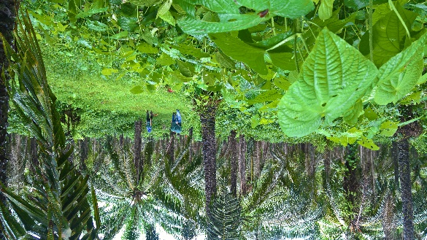
Even when cultivated in plantations, organic palm oil production systems involve a meaningful plant diversity. Picture of an Agropalma plantation in Brazil. (Photo: FiBL, Thomas Bernet)
Organic palm oil companies generate vital income for small-scale farmers, paying prices that are around 20 percent above local prices. Picture of a supplier of the company Serendipalm in Ghana. (Photo: FiBL, Thomas Bernet)
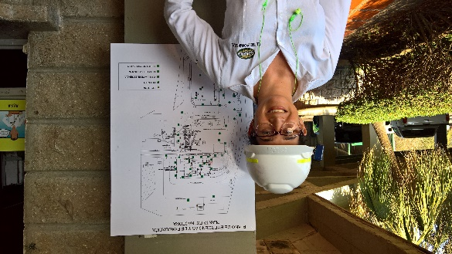
Palm oil mills generate important job opportunities in rural areas, especially for young people. Picture of an employee of the company Daabon in Colombia. (Photo: FiBL, Thomas Bernet)
This media release online
This media release and pictures can be accessed online at www.fibl.org/en/media.html.
About FiBL
The Research Institute of Organic Agriculture FiBL is one of the world’s leading institutes in the field of organic agriculture. FiBL’s strengths lie in its interdisciplinary research, innovations developed jointly with farmers and the food industry, and rapid knowledge transfer. FiBL employs some 300 staff at its various locations.
- Homepage: www.fibl.org
- Video: www.youtube.com/watch?v=U84NrJlORFc

