Media release February 13, 2019

Global organic area reaches another all-time high

Nearly 70 million hectares of farmland are organic

The latest global data on organic farming worldwide will be presented by the Research Institute of Organic Agriculture (FiBL) and IFOAM – Organics International at BIOFACH, the world’s leading trade fair for organic food, in Nuremberg, Germany. The statistical yearbook “The World of Organic Agriculture” will be launched on Wednesday, February 13, 2019, from 4:00 to 4:45 pm in Hall Shanghai, NCC East.

(Frick/Nuremberg, February 13, 2019) The year 2017 was another record year for global organic agriculture. According to the latest FiBL survey on organic agriculture worldwide, the organic farmland increased substantially, and the number of organic producers and organic retail sales also continued to grow, reaching another all-time high, as shown by the data from 181 countries (data as of the end 2017). The 20th edition of the study “The World of Organic Agriculture” published by FiBL and IFOAM – Organics International shows a continuation of the positive trend seen in the past years. The annual survey on organic agriculture worldwide is supported by the Swiss State Secretariat for Economic Affairs (SECO), the International Trade Centre (ITC), the Sustainability Fund of Coop Switzerland, and NürnbergMesse, the organizers of the BIOFACH fair.

The global organic market continues to grow worldwide and has reached 97 billion US dollars

The market research company Ecovia Intelligence estimates that the global market for organic food reached 97 billion US dollars in 2017 (approx. 90 billion euros). The United States is the leading market with 40 billion euros, followed by Germany (10 billion euros), France (7.9 billion euros), and China (7.6 billion euros). In 2017, many major markets continued to show double-digit growth rates, and the French organic market grew by 18 percent. The Swiss spent the most on organic food (288 Euros per capita in 2017). Denmark had the highest organic market share (13.3 percent of the total food market).

Almost three million producers worldwide

In 2017, 2.9 million organic producers were reported, which is 5 percent more than in 2016. India continues to be the country with the highest number of producers (835’200), followed by Uganda (210’352), and Mexico (210’000).

Record growth of the organic farmland: 20 percent increase

A total of 69.8 million hectares were organically managed at the end of 2017, representing a growth of 20 percent or 11.7 million hectares over 2016, the largest growth ever recorded. Australia has the largest organic agricultural area (35.6 million hectares), followed by Argentina (3.4 million hectares), and China (3 million hectares). Due to the large area increase in Australia, half of the global organic agricultural land is now in Oceania (35.9 million hectares). Europe has the second largest area (21 percent; 14.6 million hectares), followed by Latin America (11.5 percent; 8 million hectares). The organic area increased in all continents.

Ten percent or more of the farmland is organic in fourteen countries

Globally, 1.4 percent of the farmland is organic. However, many countries have far higher shares. The countries with the largest organic share of their total farmland are Liechtenstein (37.9 percent), Samoa (37.6 percent), and Austria (24 percent). In fourteen countries, 10 percent or more of all agricultural land is organic.

Global organic statistics show the contribution of organic agriculture to the Sustainable Development Goals

According to Dr. Monica Rubiolo from SECO and Joseph Wozniak from ITC “global data on organic production and markets are of high relevance for policy makers and contribute to understanding the importance of organic farming in the different countries.”

“This publication shows our ongoing engagement with transparency in the organic sector” say Professor Urs Niggli, FiBL director, and Louise Luttikholt, IFOAM – Organics International Executive Director. And they add “This publication also demonstrates the contribution of organic agriculture to the Sustainable Development Goals. Overall, the yearbook shows the potential organic farming has to contribute to a sustainable future!”

More information

Order book and download

The printed version of “The World of Organic Agriculture” (30 Euros + postage; affiliates of IFOAM – Organics International: 20 Euros) can be ordered and downloaded at https://shop.fibl.org/ (order number 2020) and <https://shop.ifoam.bio/>.

“The World of Organic Agriculture” as well as graphs and infographics can be downloaded at [www.organic-world.net/yearbook/yearbook-2019.html](http://www.organic-world.net/yearbook/yearbook-2019.html)

Online database

Tables with more details on crops, markets, and international trade, as well as explanations can be found on FiBL’s new statistics website <https://statistics.fibl.org>.

Contacts

* Dr. Helga Willer, FiBL, Ackerstrasse 113, 5070 Frick, Switzerland  
  Phone +41 (0)79 218 06 26, [helga.willer@fibl.org](mailto:helga.willer@fibl.org), [www.fibl.org](http://www.fibl.org)
* Louise Luttikholt, IFOAM – Organics International, Charles-de-Gaulle-Strasse 5, 53113 Bonn, Germany  
  Phone +49 (0)160 8041557, Fax +49 (0)228 9265099, [l.luttikholt@ifoam.bio](mailto:l.luttikholt@ifoam.bio), [www.ifoam.bio](http://www.ifoam.bio)

Programme of the session “The World of Organic Agriculture – Statistics and Emerging Trends”

Wednesday, February 13, 2019, 4:00 to 4:45 pm, Hall Shanghai (NCC East), NürnbergMesse, Nürnberg

* Louise Luttikholt, IFOAM – Organics International, Moderator
* Dr. Monica Rubiolo, Swiss State Secretariat for Economic Affairs (SECO), Switzerland
* Dr. Helga Willer, FiBL: The adventure of 20 years of data collection on organic agriculture
* Julia Lernoud, FiBL: Latest data on organic agriculture worldwide
* Beate Huber, FiBL: Standards and regulations
* Amarjit Sahota, Ecovia Intelligence, UK: The global market for organic food

More information at [www.biofach.fibl.org/en/biofach-2019.html](http://www.biofach.fibl.org/en/biofach-2019.html)

Supporters

* Swiss State Secretariat for Economic Affairs (SECO)
* International Trade Centre (ITC)
* Coop Sustainability Fund, Coop Switzerland
* NürnbergMesse, the organizers of the BIOFACH fair

The views expressed in this press release can in no way be taken to reflect the official opinions of SECO, ITC, or NürnbergMesse.

Reference

Helga Willer and Julia Lernoud (Eds.) (2019): The World of Organic Agriculture. Statistics and Emerging Trends 2019. Research Institute of Organic Agriculture (FiBL), Frick and IFOAM – Organics International, Bonn. Available at [www.organic-world.net/yearbook/yearbook-2019.html](http://www.organic-world.net/yearbook/yearbook-2019.html)

This media release online

This media release and graphs can be accessed online at [www.fibl.org/en/media.html](http://www.fibl.org/en/media.html).

About FiBL

The Research Institute of Organic Agriculture FiBL is one of the world’s leading institutes in the field of organic agriculture. FiBL’s strengths lie in its interdisciplinary research, innovations developed jointly with farmers and the food industry, and rapid knowledge transfer. FiBL employs some 300 staff at its various locations.

Homepage: [www.fibl.org](http://www.fibl.org)

Yearbook "The World of Organic Agriculture"

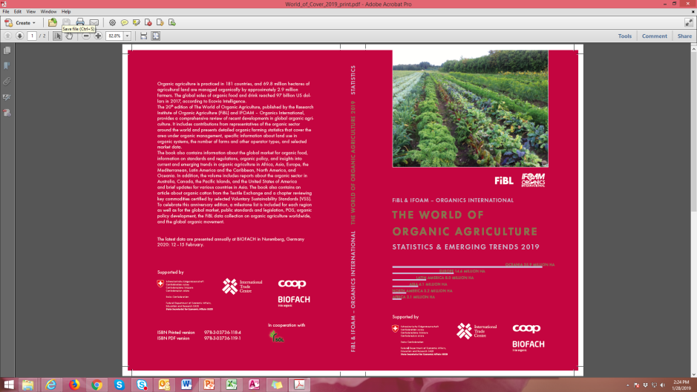About "The World of Organic Agriculture"

The yearbook (352 pages) presents the results of the annual survey on organic agriculture worldwide and has numerous tables, graphs, maps, and infographics. Furthermore, it contains reports authored by experts on the organic sector and emerging trends in all regions and selected countries. In addition, background information on standards and legislation, policy support, and the global market for organic food is provided. The book also contains an article about organic cotton and a chapter reviewing key commodities certified by selected Voluntary Sustainability Standards (VSS). Further information and download is available at [www.organic-world.net/yearbook/yearbook-2019.html](http://www.organic-world.net/yearbook/yearbook-2019.html).

Data collection

The data on organic agriculture is collected annually by the Research Institute of Organic Agriculture FiBL in collaboration with many partners from around the world. The results are published jointly with IFOAM – Organics International. The activities are supported by the Swiss State Secretariat for Economic Affairs (SECO), the International Trade Centre (ITC), the Coop Sustainability Fund, and NürnbergMesse, the organizers of the BIOFACH fair.

Quote

Helga Willer and Julia Lernoud (Eds.) (2019): The World of Organic Agriculture. Statistics and Emerging Trends 2019. Research Institute of Organic Agriculture FiBL, Frick, and IFOAM – Organics International, Bonn

Order book and download

The printed version (30 Euros + postage; affiliates of IFOAM – Organics International: 20 Euros) can be ordered at <https://shop.fibl.org/chen> (order number 1076) and <https://shop.ifoam.bio/>. At [www.organic-world.net/yearbook/yearbook-2019.html](http://www.organic-world.net/yearbook/yearbook-2019.html), the book is available for free download.

Online databases

The data is available online on <https://statistics.fibl.org>.

**Pick up your copy at BIOFACH in Hall 1, Stands 1-553 (FiBL) and 1-451 (IFOAM – Organics International)**

Key indicators

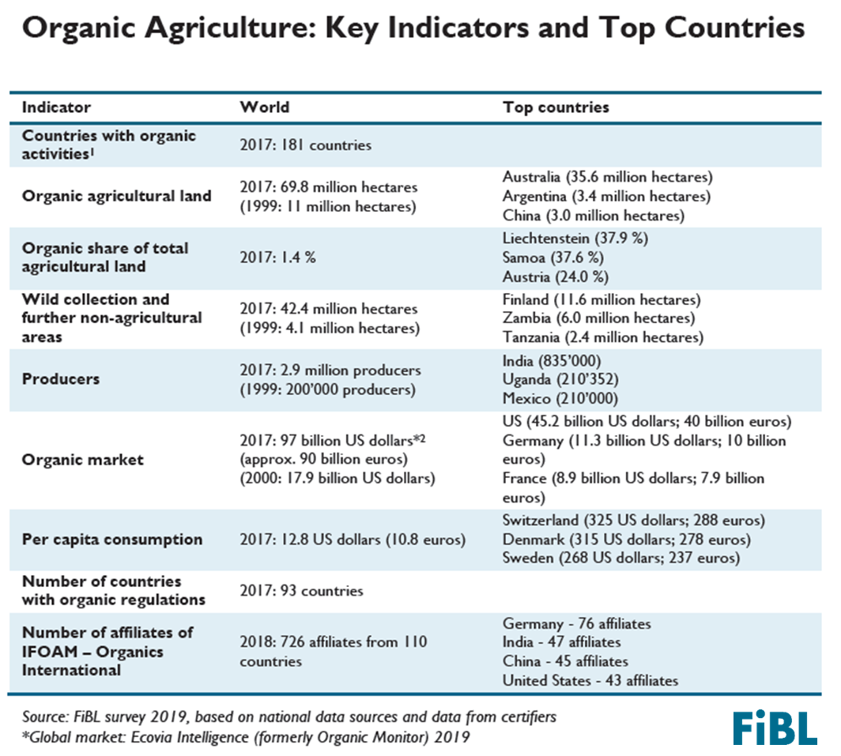

[1][2]

Graphs

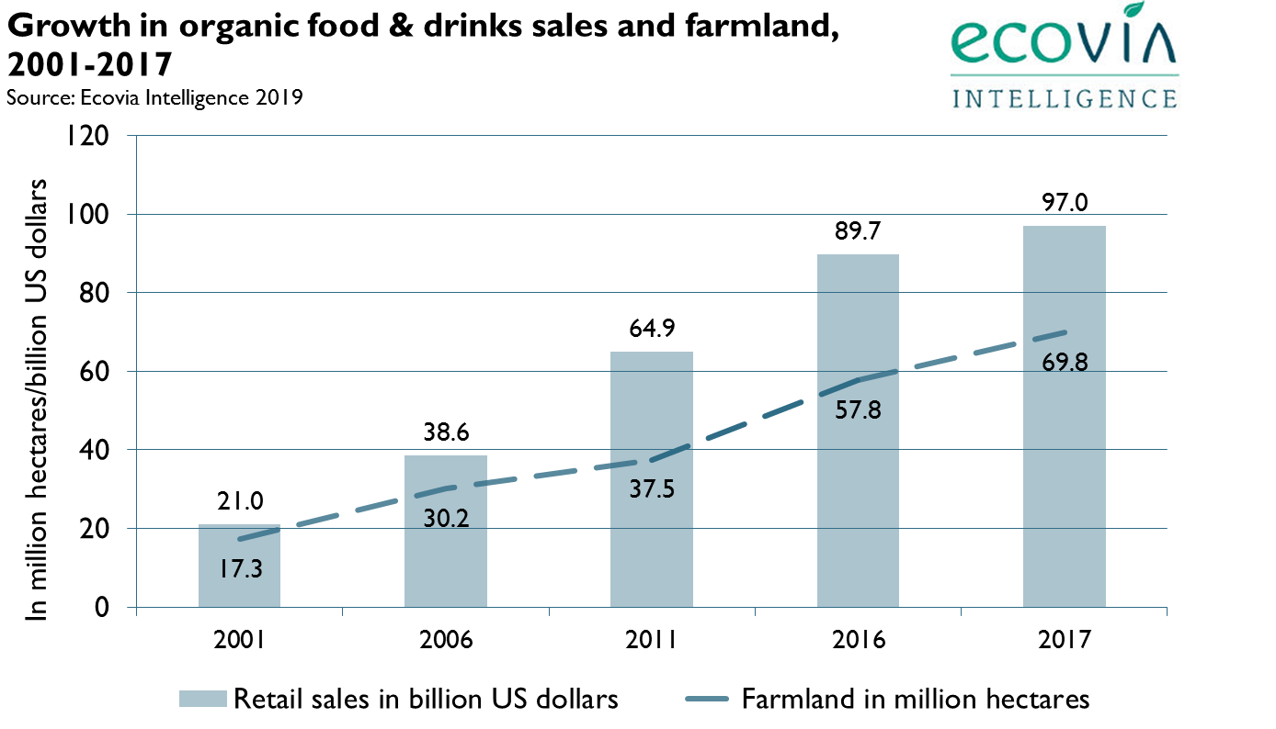

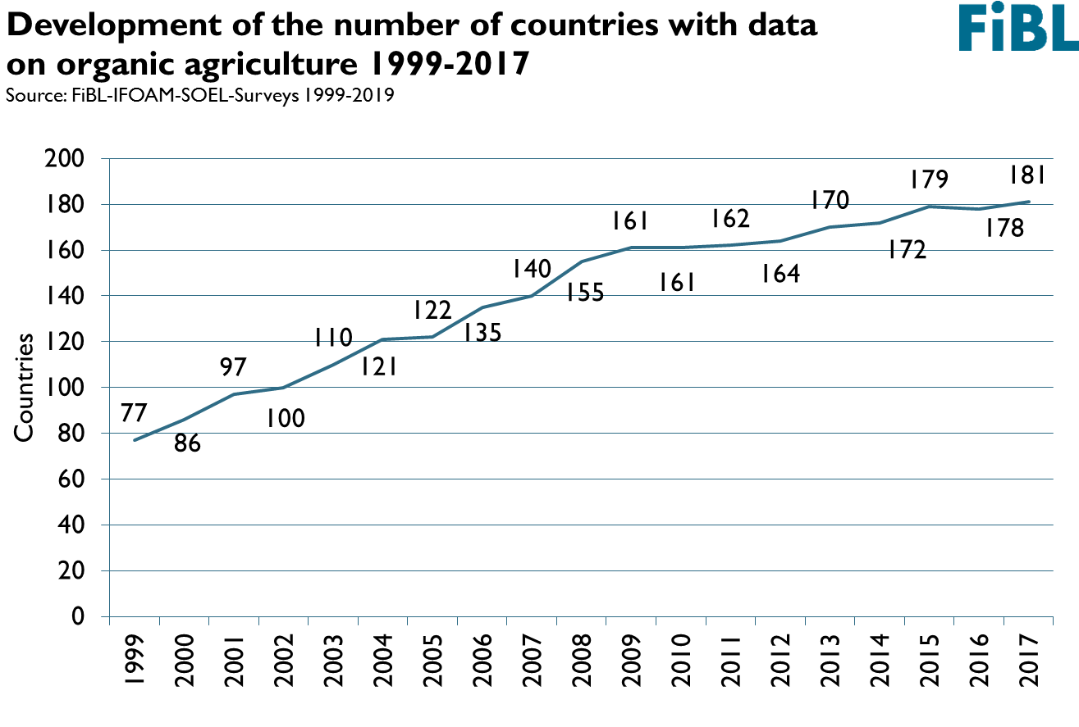





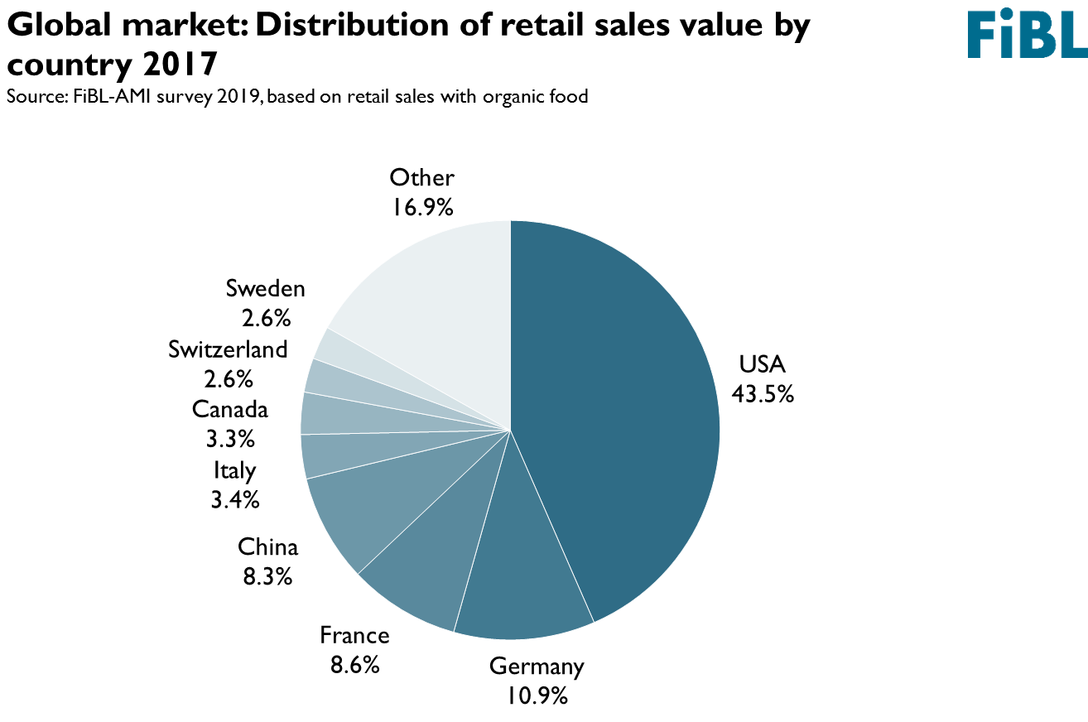

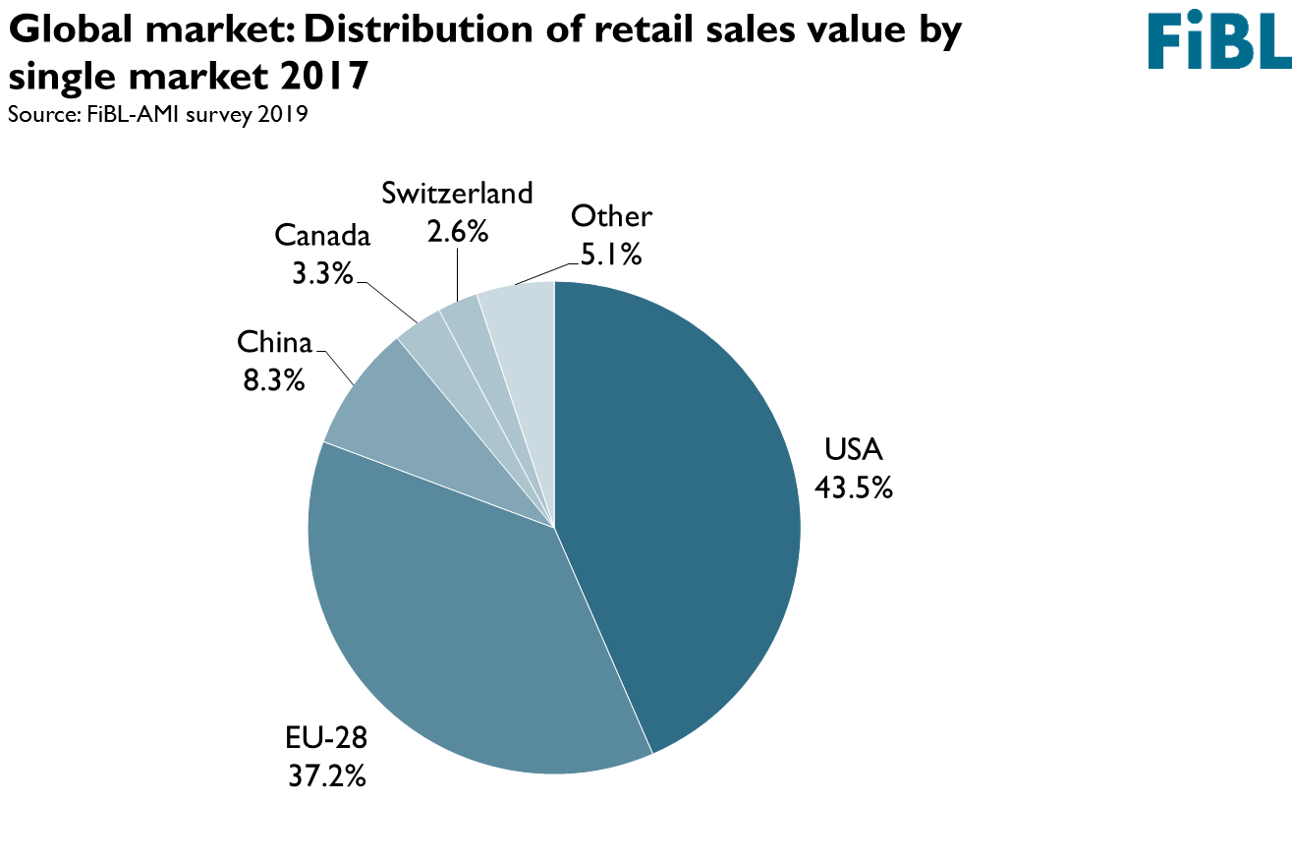



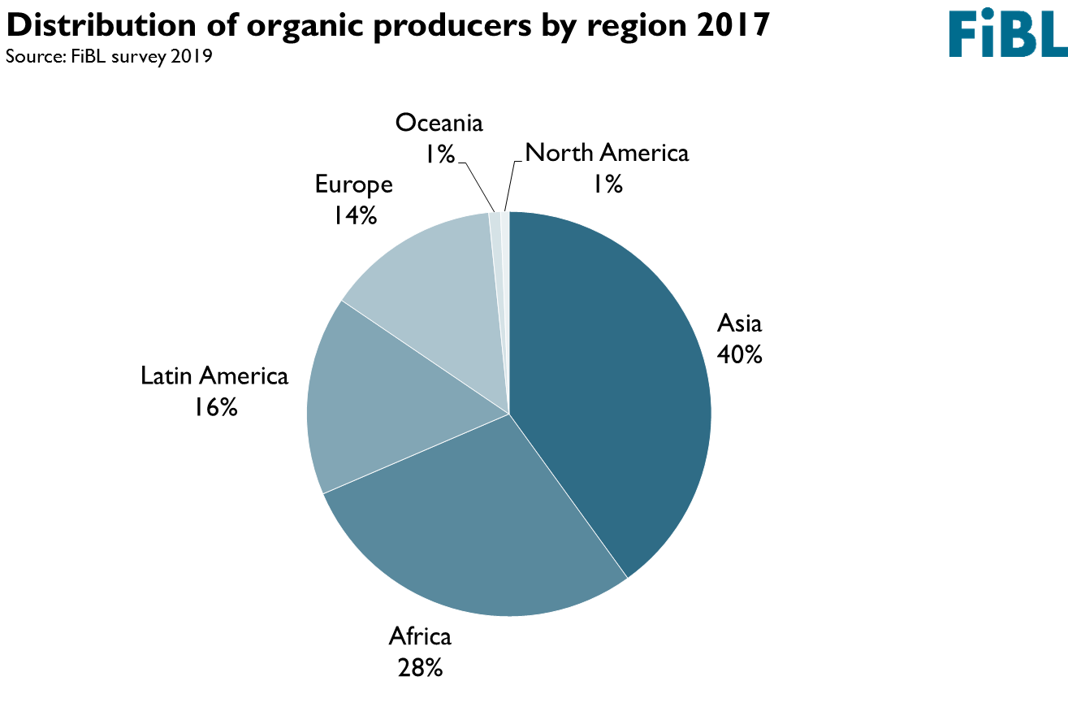

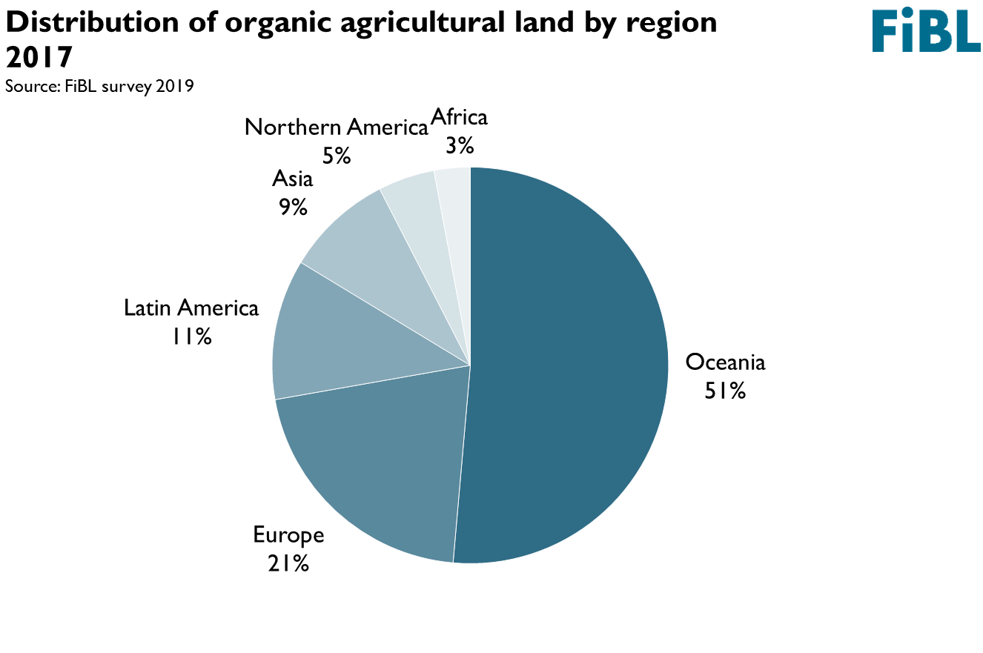



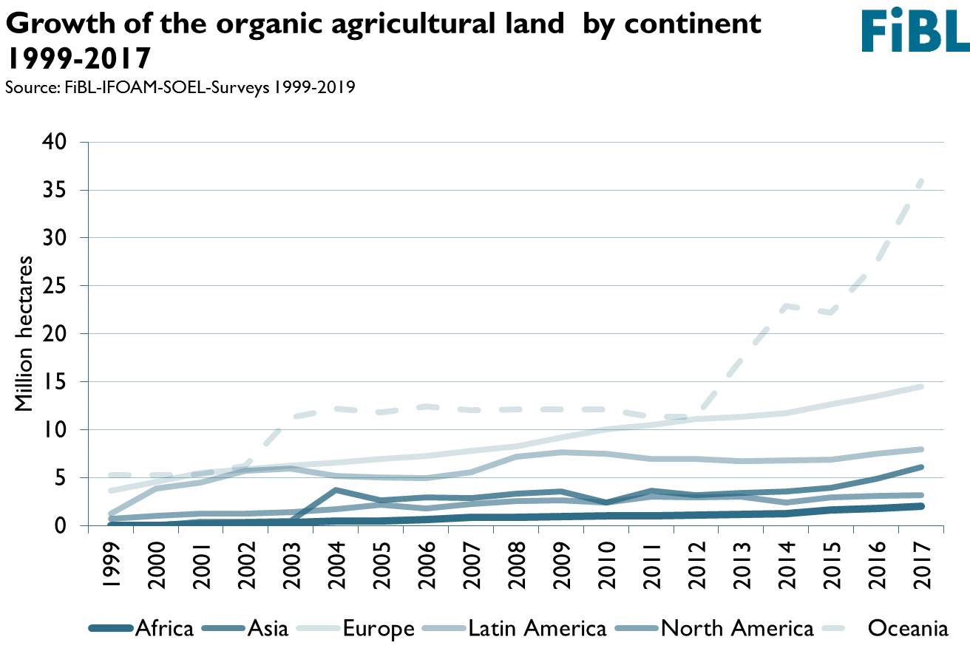

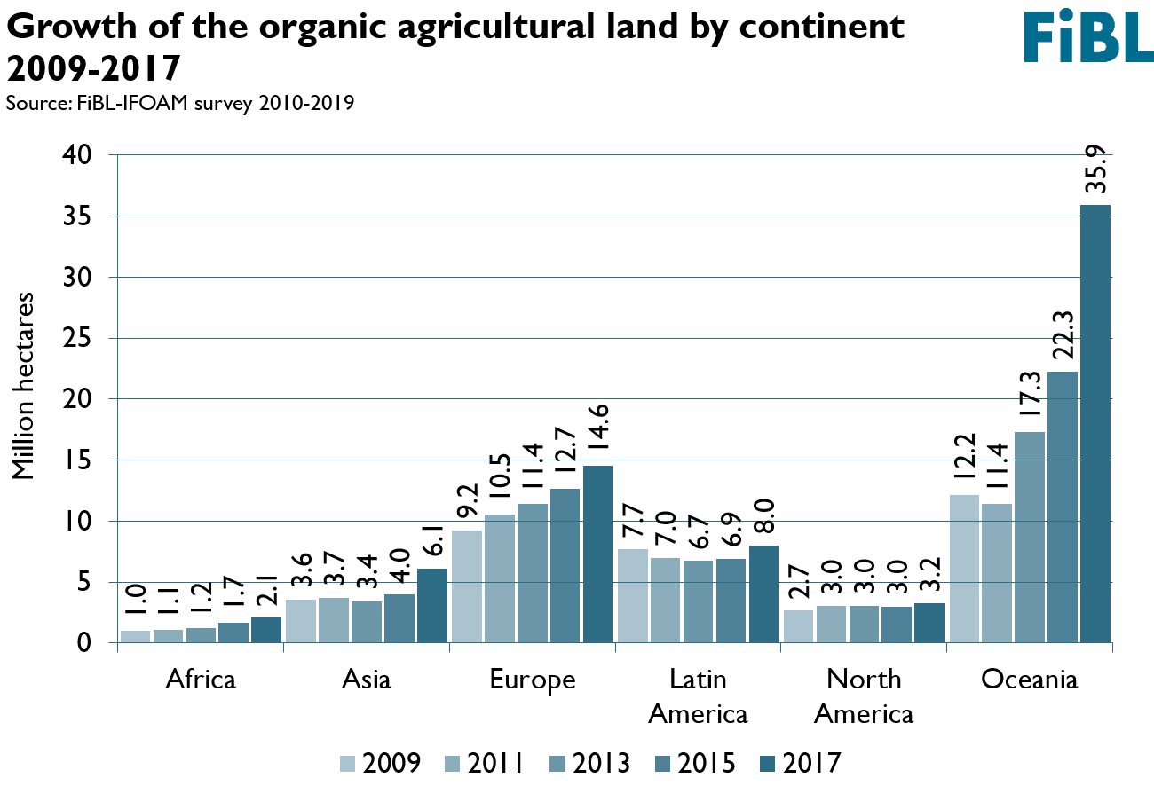





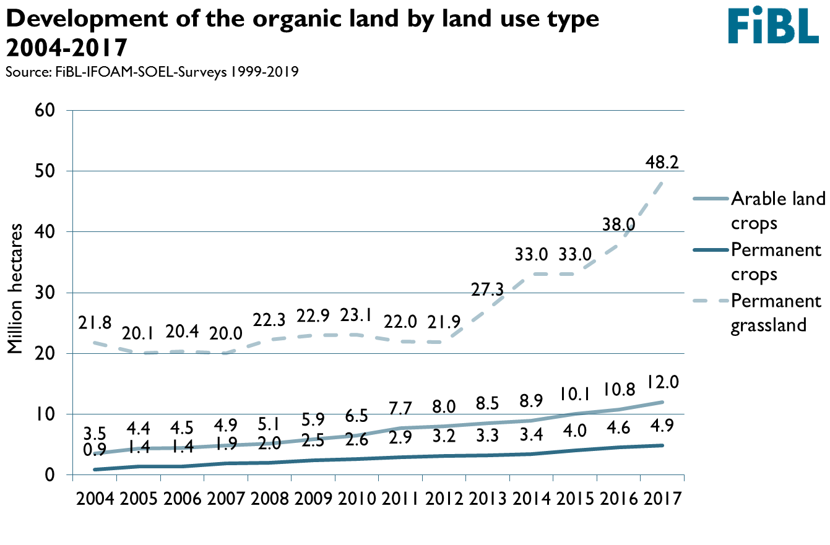

Infographics

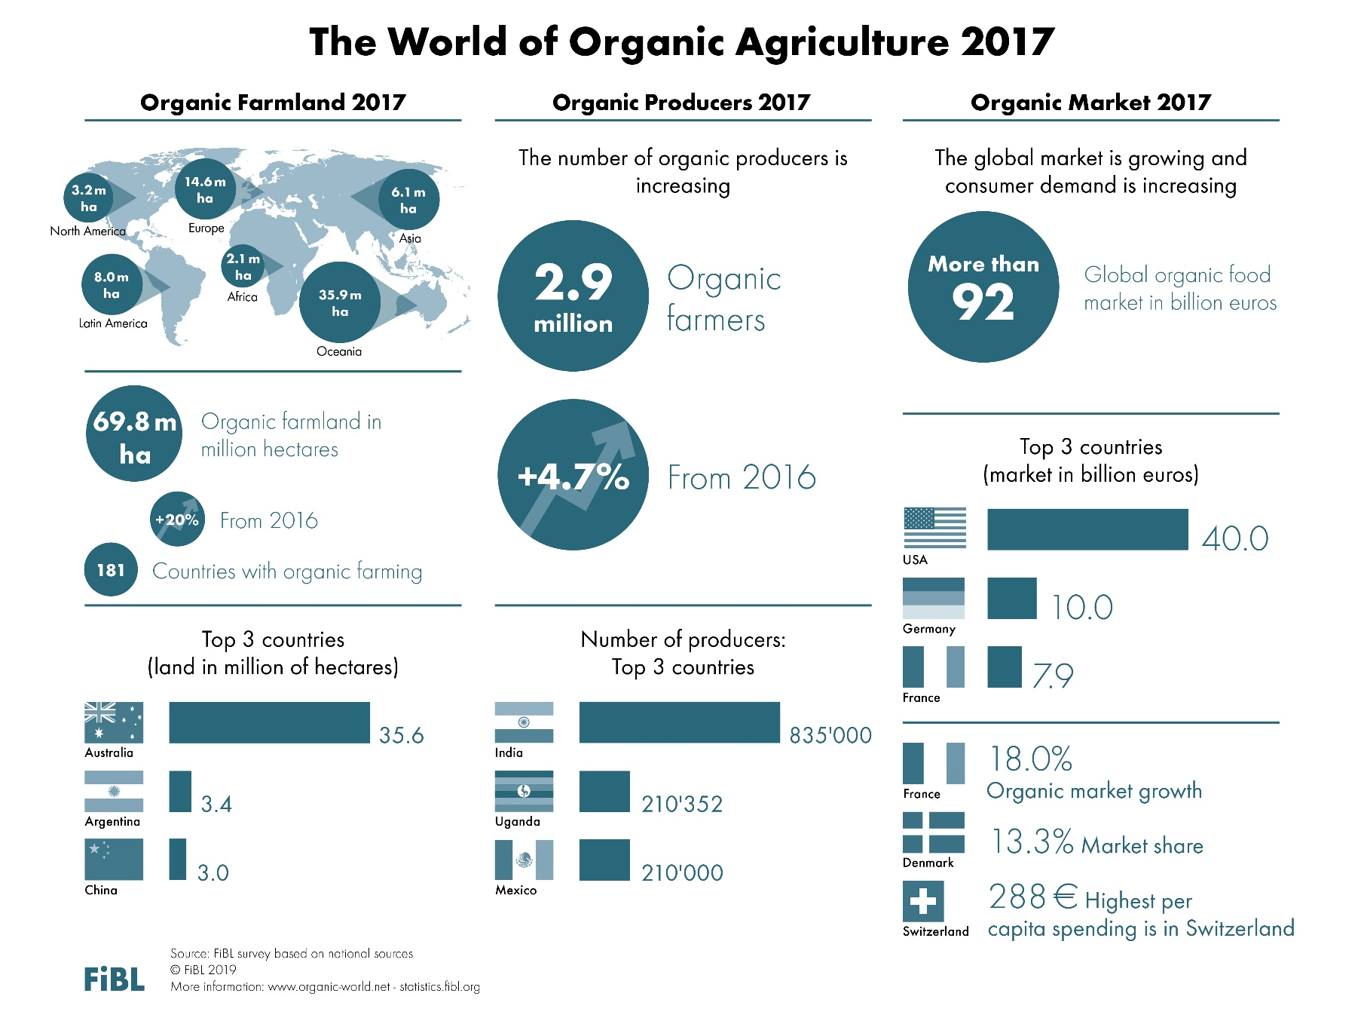

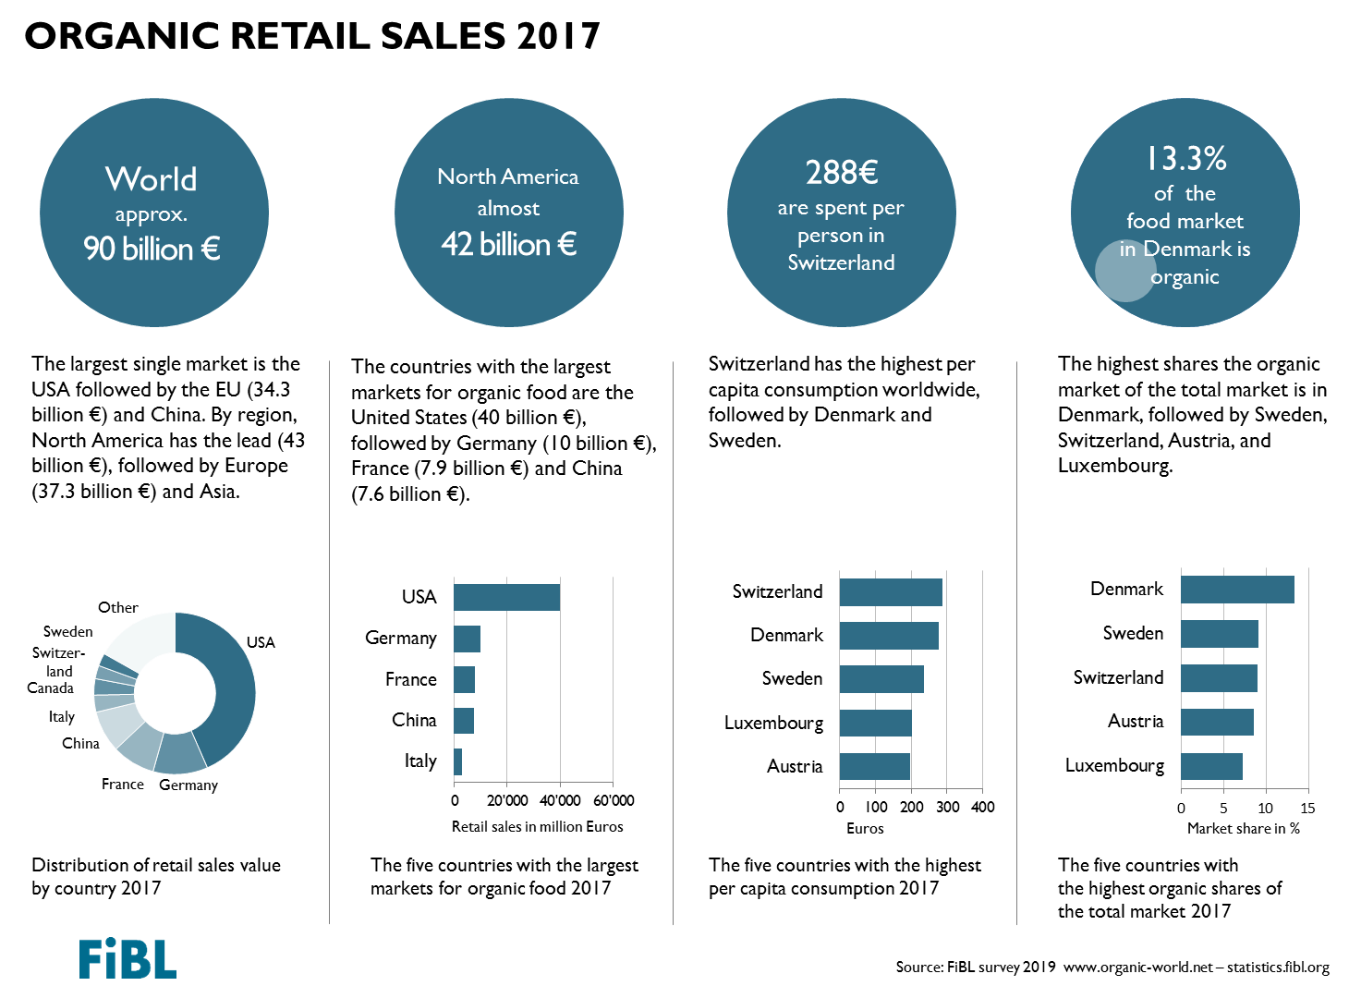

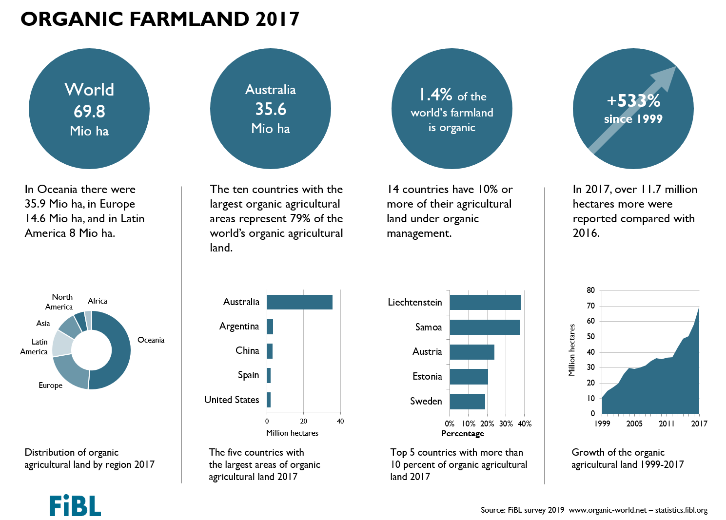

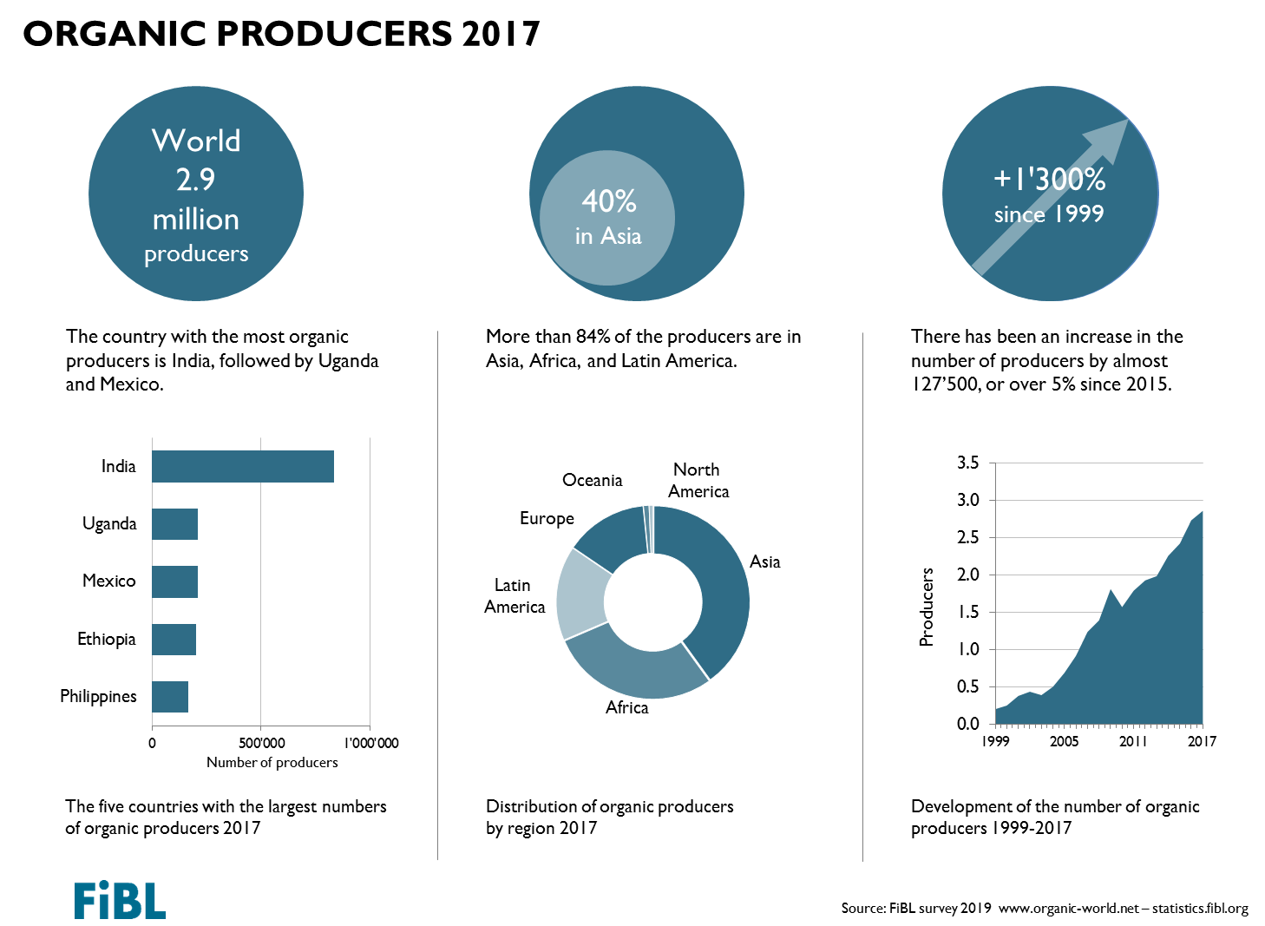

Sessions related to the topic at BIOFACH 2019

Wednesday, 13 February 2019

* The World of Organic Agriculture at BIOFACH 2019  
  4 pm to 4:45 pm, Hall Shanghai (NCC East)
* The European market for organic food at BIOFACH 2019  
  5 pm to 6 pm, Hall Shanghai, (NCC East)

Thursday, 14 February 2019

* Global Organic Market Overview - facts, trends and opportunities  
  10 am to 11:30 am, Hall St. Petersburg (NCC East)

[www.biofach.fibl.org/en/biofach-2019.html](http://www.biofach.fibl.org/en/biofach-2019.html)

1. Where the designation "country" appears in this book, it covers countries and territories, see UNSTAT website http://unstats.un.org/unsd/methods/m49/m49regin.htm.
2. According to the Central European Bank, I euro corresponded to 1.1297 US dollars in 2017.