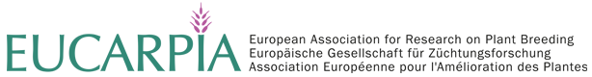

In order to establish a European network we would like to ask the participants and all persons, who might not be able to attend the meeting but still interested to join the newly established
EUCARPIA working group on Implementing Plant Microbe Interaction into Plant Breeding
To please provide following information to be distributed at the first workshop on the 25th and 26th June 2015.

Title
First name
Last name
Position
Organisation
Address
Zip code
City
Country
e-mail
Webpage
Interest in joining the working group
Member of Eucarpia (Sections)
Member of ECO-PB
Topic of research related to breeding for plant microbe interaction

Related publications

Can you recommend other persons ?
(please provide name, organisation, e-mail)
Remarks

Please send mail till 30th April 2015 to monika.messmer@fibl.org indicating EUCARPIA in the heading!

